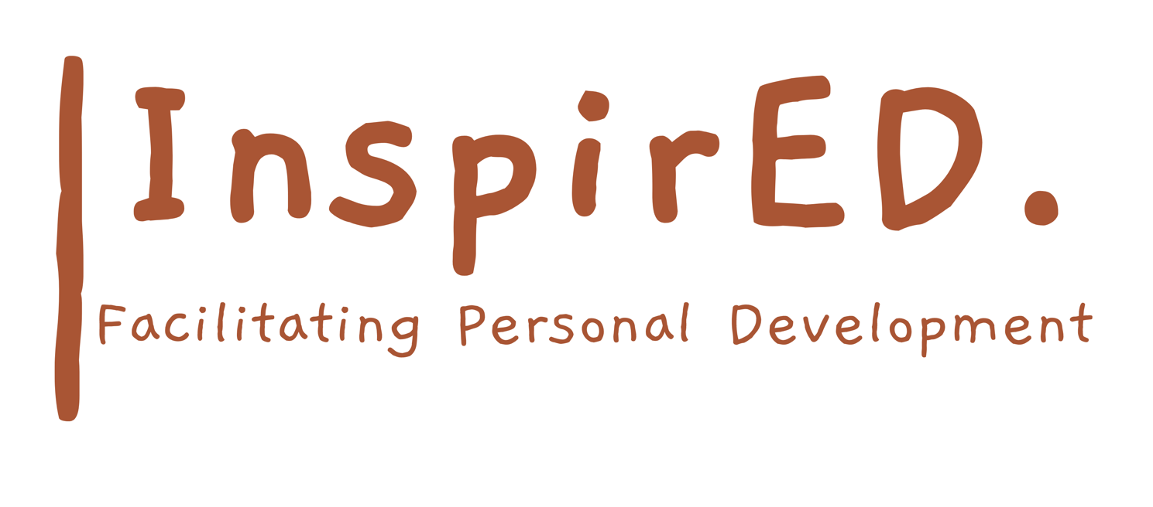

No Smoking policy

Date of issue: September 2024
Date for renewal: September 2026
Author: Philip Parker

Introduction
InspirED PD is a responsible employer and takes its obligations to their employees very seriously. This is why we have set out this policy to help us ensure the health, safety and welfare of our employees and people within our care to help us comply with our legal duties. Smoking does not only cause serious damage to the health of smokers, but research has also shown that second hand smoke causes cancers, heart and respiratory diseases in non-smokers as well.

- Section 2(2)(e) of the Health and Safety at Work Act 1974 places a duty on employers to provide a safe and healthy working environment.
- Section 2(2) of the Health Act 2006 prohibits smoking in all public premises including workplaces and vehicles.

Aims of the Policy

This policy aims to:
- Provide a safe and healthy working environment for all staff and visitors;
- Comply with all of the requirements imposed by law;
- Guarantee the right of non-smokers to breathe air free of smoke;

Restrictions on Smoking
- Smoking is not permitted in any of the Company’s premises or entrances at any time by any person irrespective of their status in, or business with, the Company.
- Staff must not leave the premises to smoke.
- All visitors, customers, contractors and deliverers are required to abide by the no smoking policy. Staff must inform all of the above of the policy although it must be stressed that staff should not put themselves at any risk in furtherance of this policy.
- Smoking is not permitted in any company vehicles or in any vehicles being used or hired for Company business.
- Smoking on Company premises or in Company vehicles constitutes an offence under the Health Act. In the unlikely event that a member of staff does not comply with the Company’s No Smoking Policy disciplinary action will be taken in accordance with the Company’s disciplinary policy.

