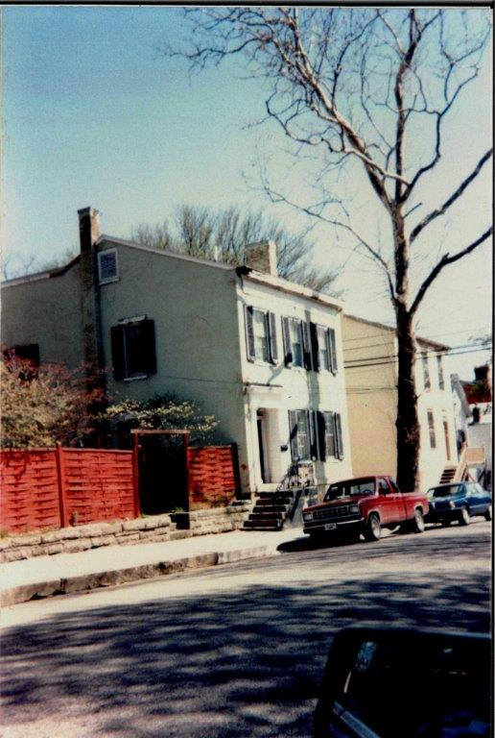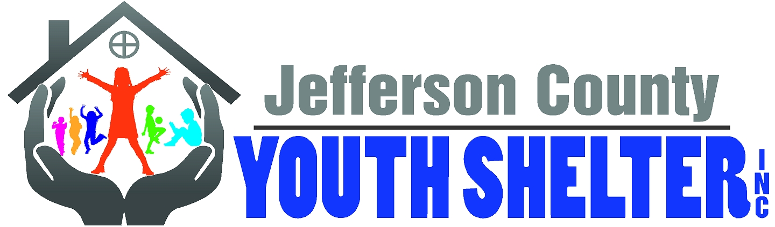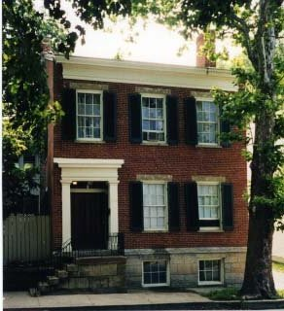

HISTORY of JEFFERSON COUNTY YOUTH SHELTER, INC.
An Indiana Youth Service Bureau

Jefferson County Youth Shelter, Inc. began as a grass roots movement by concerned citizens of Jefferson County, Indiana and incorporated in the State of Indiana as a nonprofit agency in 1984.

On September 17, 1983, a group of concerned citizens of Jefferson County, Indiana met to “share experiences and information regarding youth in the area that have a particular need for shelter other than the County Jail”. Karin Kreeger Hamilton served as the jail matron when her husband was Sheriff in the 1980’s and often watched over children who were in the jail (unlocked) for safekeeping because there was no other place for them to go-when their parents could not care for them and foster care was not an option. Karin realized that the area needed a youth shelter so she turned to the Pilot Club, of which she was a member, for assistance in addressing the situation. From that dream, the Jefferson County Youth Shelter became a reality.

The Madison Area Pilot Club, Probation and Welfare Departments, Salvation Army, League of Women Voters along with many other concerned citizens, was instrumental in the formation and continuing success of the shelter. In 1984, the Pilot Club made an initial contribution toward the establishment of the youth shelter. The originating Board of Director Officers was Dr. Robert Boyd, President; Dr. John Hossler, M.D., Vice President; Gail Sims, Treasurer and Marni Todd, Secretary. Incorporation was signed January 25, 1984 by Karin Hamilton, Rochelle House and Dee Gauger. On May 17, 1985, the Ross House, pre-1840, at 212 East Street was purchased to become the youth shelter.

Before the Shelter opened, if placement for youth was needed outside of their homes, they were sent out of the county, not placed at all or worse yet, housed in the county jail. On April 1, 1987, the Jefferson County Youth Shelter opened in southeast Indiana, for male and female children ages 6-18 years of age; offering both short-term emergency shelter and long term care. Since opening the shelter, we have served over 2,000 youth.

The original mission of the Shelter was to provide a safe, structured and nurturing residential environment which empowered youth with the lifelong skills necessary to be successful within their families, achieve their maximum potential in life, and avoid further involvement in the juvenile justice system.

The Shelter provides a structured, family-like environment. Many of the services provided for our children, include routine medical and dental care, clothing, hygiene essentials, group and individual counseling, tutoring, independent living skills and recreational activities. The majority of our residents return to live with their families, but some go on to foster homes, treatment facilities, or other residential programs.

Monetary donations provide a portion of our operating expenses. In-kind donations help provide various needed items used to serve our youth. All donations are tax exempt under section 501(c)3 of the Internal Revenue Code.

The Shelter is licensed by the Indiana Department of Child Services. The Shelter is regulated by the Indiana State Board of Health and the Indiana State Fire Marshal.

The Shelter is a proud member of IARCCA, an Association of Children and Family Services; the Indiana Youth Services Association, and the Madison Area Chamber of Commerce.

The Shelter is governed by a volunteer board of directors consisting of a minimum of ten members which include government, education, business, and service and community representatives. The board of directors meets ten times per year and the Executive Director of JCYS reports directly to the board.

Jefferson County Youth Shelter has been serving as Jefferson County's Youth Service Bureau since 1995. As an Indiana Youth Service Bureau, the agency's programming focuses on prevention as a main component in delivering services. All programs operate from research based practices
proven to be effective with specific clientele served, and fulfill the mission of JCYS, "to provide
services that promote the well-being and healthy development of youth and families in a safe environment."

In 1995, Youth As Resources (YAR) was officially launched, becoming the second program of the Jefferson County Youth Shelter. This program enables youth to work with adults to raise and distribute funds to youth groups interested in completing worthwhile community service projects. YAR believes that all young people can — and do — use their skills, energy, and creativity to contribute positively to their communities.

Also in 1995, the Big Brother Big Sister Program became the third program under the Jefferson County Youth Shelter umbrella. This program matched needy young people with competent, caring adults in mentoring relationships. In January 2006 BBBS branched off as a stand-alone non-profit agency.

In June 2000, the Family Help Line became the fourth program of the Jefferson County Youth Shelter. This was a referral program that assisted anyone in the community with information and direction on available services. This was a “hotline” service. This program ceased to exist when the 211 system was implemented.

In 2006, the Jefferson County Youth Shelter, Inc. changed its name to Pathways Youth Shelter & Family Services. This change allowed the organization to incorporate new programs and better share its vision with the community.

During that same year, Pathways expanded services, adding two additional programs. In March of 2006, Pathways formed Southeastern Indiana Voices for Children (SEIVC) which advocates for the best interest of children through the Court Appointed Special Advocate (CASA)/Guardian Ad Litem (GAL) volunteer programs in the two counties of Jefferson and Ripley. In January 2011, SEIVC branched off as a stand-alone nonprofit agency.

In August 2006, the doors opened to the Pathways Learning Center, an alternative educational
setting for credit recovery and high school preparatory courses for 7-12th grade students challenged by the traditional school setting and/or at risk of not completing their education. The Court Assisted Resolution to School Suspension (CARSS) program is a short term alternative to out-of-school suspensions for 6-12th graders was operated from the 2006/07 school year until the end of the school year in 2011; services terminated due to state and local budget cuts. Currently we are in the process of re-implementing the CARSS Program with the collaboration of Madison Consolidated Schools.

In February 2007, we acquired a TransParenting License Agreement. This is a court mandated program in the state of Indiana that works with parents in the process of divorce. TransParenting Classes are provided to help ease the transition of divorce on the children involved. We continue to support this program.

Continuing to meet the needs of the community and surrounding counties, Pathways received a grant for the Safe Place program in July 2008. This program compliments the Pathways Youth Shelter and provides access to immediate help and support for all young people in crisis through a network of safe place locations throughout the community. In 2011, the Switzerland County Community Foundation funded expansion of Safe Place services into its county. Sites now total 38, both stationary and mobile in both counties with plans for further expansion. Pathways is also working to establish the Host Homes Program for runaway/homeless youth in surrounding rural counties.

In January 2009, Pathways added Community Partners for Child Safety Program, allowing Pathways to serve children and families throughout the six counties of the Department of Child
Services’ Region 15. This community home-based prevention service paired staff with families to
help connect them with community resources, learn new skills and stabilize the home environment in an effort to prevent child abuse and neglect. This program ended in June 2013, due to non-renewal of contract.

In 2011, Pathways received funding to implement the “Speak Up Be Safe” Program. This is an educational abuse prevention program for 1st- 6th grade students. Presentations were conducted in our Southwestern Jefferson County School Corporation. Continued funding was not sought.

In January 2012, Pathways continued to expand its community based services; being contracted as a provider of Homemaker/Parent Aid and Home-based Family Centered Casework Services. Homemaker/Parent Aid is a program that links families in need with supportive services, as well as educating them with good parenting skills. Pathways has a continuing contract for this program. Home-based Services is a program attempting to help clients to help themselves; however due to reorganization of our agency, this contract was relinquished.

On September 10, 2012, the Executive Director and Board of Directors decided to suspend services of the Pathways Youth Shelter. However, the other programs of Pathways continued to operate.

In March of 2013, we were contracted to perform services for Choices, Inc. These services link families with needed supportive services. We continue to be affiliated with this program.

In June 2013, a new Executive Director was appointed and after much discussion with the Board of Directors, it was decided that Pathways Youth Shelter should proceed with re-licensing as an emergency shelter. Due to changes within the Department of Child Services, the shelter will now serve youth ages 10 – 18 years of age.

In July 2013, Pathways received a Coalition Against Substance Abuse Grant for the “Keep A Clear Mind Program”. This program started in our local schools for 6th graders in November. The program educates and encourages abstinence from tobacco, alcohol and marijuana and deals with “making the right choices”.

In September 2013, Pathways began collaboration with our local school system, Madison Consolidated Schools, which provides social work/counseling services to the Madison Alternative Program (MAP).

In October 2013, Pathways became associated with the QPR Suicide Prevention Program and now provides a certified trainer for our community. Classes are available upon request.

As of November 6, 2013, the state licensing agency stated that we will be re-licensed but the date has not yet been confirmed.

As of February 3, 2014 the shelter license was re-instated and as of March 19, 2014 the shelter re-opened and was ready to receive youth.

The agency is now led by Executive Director, Troy Hedges. He has been with the organization since 2007 and possesses hands on experience in all programs. Troy also has a strong passion to provide the best care and best programs to empower our youth to become responsible and productive members of our community.

On August 18, 2014, Pathways was awarded a Capacity Building Coaching Grant from Indiana Youth Institute. The grant was for 150 hours and runs through June 2015

In September 2014, Pathways continued their collaboration with the Madison Alternative Program.

As of December 31, 2014, the shelter served 33 youth for a total of 399 days of care in 2014.

In August 2015, Pathways again continued their collaboration with the Madison Alternative Program.

On November 19, 2015, the board of directors met in a special meeting to vote on the return of using our legal name and approving a new logo. This action was needed due to Dockside Services being bought by a company by the name of Pathways. It was felt that this would cause much confusion. It was a unanimous vote to go back to using Jefferson County Youth Shelter, Inc. with its new logo starting January 1, 2016.

As of December 31, 2015, the shelter had served 63 youth for a total of 914 days of care in 2015. The Safe Place and Keep A Clear Mind Programs served 3680 youth and the Alternative Program served 270 youth.

2016 started as a very busy year serving many youths. On July 24, 2016, the shelter suspended services due to a lack of staffing. After much hard work and many interviews, the shelter began serving youth again on November 28, 2016. On September 22, 2016, while the shelter was without youth, the bedrooms were repainted. New bunkbeds were then installed. On October 6, 2016, the half-court basketball court was upgraded to a concrete court.

In 2017, the Jefferson County Youth Shelter celebrated its 30th anniversary on April 1st. From there, the shelter took a temporary hiatus due to staffing starting on July 19th, and reopened its doors on October 1st. As of the end of 2017, the shelter has served ___ youth for a total of ___ days of care in 2017.

2018 has been a year of upgrades. So far, the shelter installed new carpet upstairs where the bedrooms are located on January 15th. On May 8th, the shelter installed a new basketball goal for exercise and recreation for the kids. The kitchen received an upgrade to the stove range on May 25th, and a major upgrade for the shelter was purchased on June 5th in the form of a Dodge Dart to have recreation trips for the children. In October 2018, new carpet was installed downstairs.

