

2025 Annual Report to the Community

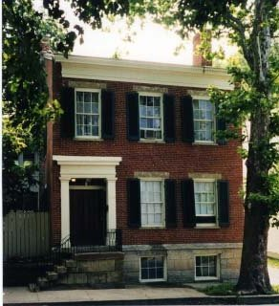

2025 Board of Directors
Joshua White, President
Cody Lewis, Vice President
Shane Thornberry, Treasurer
Brandon Frye, Secretary
Katy Lowe Schneider, Member
Angie Pelsor, Member
Jill Mires, Member

Current JYCS Employees
Troy Hedges, Executive Director
Lauren Mix, Business Manager
Danielle Roszczysnki, Education Director
Sarah White, Case Manager
Chandler Roszczynski, School Intervention Coordinator
Laken Wall, School Intervention Coordinator
Cori Dawson, Safe Place Coordinator/Marketing
Kathy Brunner, Shelter Coordinator
Furana Cowger, Youth Care
Sasha Harmon, Youth Care
Blaike Powell, Youth Care
Kylean Lacey, Youth Care
Samantha Markin, Youth Care
Traci Miller, Youth Care
Joshua Molina, Youth Care
Heaven Pope, Youth Care
Maisie Riley, Youth Care
Brandon Holcomb, Youth Care

About Jefferson County Youth Shelter
Jefferson County Youth Shelter provides 24-hour emergency care for youths, aged 10 to 18 years, within a residential home of 10 beds, for both males and females, referred primarily through the Indiana Department of Child Services and County Juvenile Probation Departments. JCYS receives a per diem rate from the state to fund residential placements and meets all regulations for operation as an emergency youth shelter, by providing housing, meals, medical care, as well as other services to meet the needs of the youth during their stay. Our residential shelter program is one of only a few facilities in Southeastern Indiana offering emergency care. Criteria for admittance include juvenile delinquency issues and/or abuse and neglect situations. Avoiding a disruption in the child's education and existing services is a large advantage of the services we provide. Youth are able to remain within their home community and receive services with their family to work toward successful reunification.
The Jefferson County Youth Shelter is a registered 501(c)3 non-profit organization.

Programs and Services 2025 update
Youth Shelter
Youth Served: 50
From Jefferson Co: 40
Days of Service: 1,192
Average Youth Per Month: 3.04

Safe Place
Safe Place is a national youth outreach program that educates thousands of young people every year. Safe Place initiative involves the whole community to provide safe havens and resources for youth in crisis. Safe Place creates a network of "Safe Place locations" - youth friendly businesses, schools, libraries, YMCAs and other appropriate public buildings that display the distinctive yellow and black Safe Place sign. These Safe Place sites extend the doors of the youth emergency shelter or youth service agency throughout the community. Youth are easily able to access immediate help wherever they are. In 2023 the JCYS reached over 2,000 youths in Jefferson County and surrounding areas through school presentations and outreach programs.
Youth Served: 3

School Intervention Program
JCYS aids with the School Intervention program at Madison Consolidated Schools and Southwestern Schools teaching life skills and assisting the school counselor with at-risk youth in our community. We are able to do this through funding with Indiana Youth Services Association.
Youth Served: 120

Comparison of pre and post outcome School Intervention Program surveys from 1/1/2025 to 12/31/2025

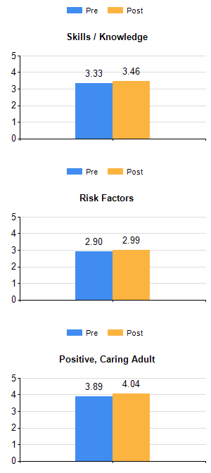
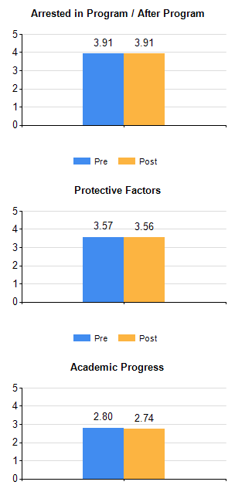

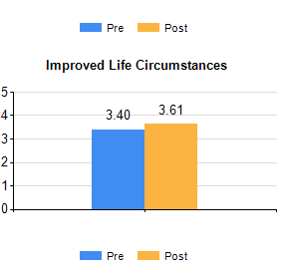

2025 Financial Review

Total Revenue in 2025
$716,050.82

Contribution revenue- $48,302.90
Grant Revenue- $22,250.00
Contract revenue-$645,031.21
Miscellaneous income- $466.71

Total Expenditures for 2025
$643,368.10

Program expense- $42,742.45
Employee expense- $516,354.63
Operating expense- $75,551.47
Repair & Maintenance- $8,719.55
Miscellaneous Expense- $0

2025 Donors
Less than $500
Madison Animal Clinic
James and Kaaren Tatera Kathy Claggett
Eric and Virginia Thorstensen Fisher, James & Anna
Jacobs Security Solutions James and Wanda Welch
Phillips, Cynthia Phyllis Demoss
Thomas and Helen Pietrykowski Thomas Cheatham
Any Sports Chris and Natalie Hill
Imel, Donald & Joyce Aaron's Rent A Center
Alison Frazier Ann Gaddie
Bear's Furniture Gallery Brenda Holbrook
Gary & Sue Kemper Goldsmith, Mary
Jenner Law Office John & Rita Hess
Lonnie and Judith Collins Microdome Computers
Morgan Hamilton Scott, Gregory Steven Thurnall
The Heritage Trail Conservancy, Inc Ward, Kenneth
Weber Warren Lewis William and Priscilla Torline
Zapp, John & Linda Barnes, Steve & Delores
Rita Moore Phillips, Gary & Frances
Gene and Sarah Green Orrill, Kevin & Marlene
Williams, Laura Hanover Presbyterian Church
Blaine S. Goode Clapham, Donald
Coldwell Banker/Harrell Associates Dionne, David & Sandra
Eston & Cindy Long Gary and Shari Stites
Hodges, Daniel & Laura Jefferson County Land Title
Jill and Nicholas Geiger Joseph & Ann Hess
Law, Doug & Rebecca Lisle, James & Margaret
Maria Armbrecht Mary Rene Madison-Roche
Melvin & Sandra Skiles Playhouse Café
Rags 2 Wrenches Sage, Chuck & Heidi
Sara and James Schafer Sharon Hess
Skiles, William & Judy Sloffer, Sam & Linda
Smoots, Cynthia Steven Fleenor
Tisbest Philanthropy Trinity United Methodist Church
Walro, Michael & Ann William McCubbin
Thornsberry, Shane & Natalie Edna Hess
HOS Coffee Shop Jefferson Co. Goodwill Conservation Club
Priscilla Branham Rivertown Chiropractic, LLC
America's Charities Rachel Tucker
Ted & Marni Todd Kroger Community Rewards Foundation
First Baptist Church Terry and Karen Pyles
Veronica Watson Alcorn, Sage, Schwartz & Magrath, LLP
Auxier Gas Service, Inc. Baird Foundation, INC
Casa of Jefferson County Clanton Family
Cotton Mill, LLC Crawley Heating & Cooling, LLC.
Elston, James & Carla Farmers Bank of Milton
Gauger, Robert & Karla Madison Dental Health Partners
Pets Doc Veterinary Clinic Terry's Heating & Cooling
Kathy Wildman O.S.F. Mission Activities Pimlott, Robert & Alanagh
Sisters of St. Francis. Prince of Peace Catholic Schools
Lee Roszczynski Paula Bell Sutter, David
The Honorable Judge Mote Treasurer of Jefferson County Wirt Mission Circle Domino's Joas Law LLC

$500-$2000

American Legion Post # 9 Barbara Hearn Bulk Truck and Transport Service, Inc.
Doug and JoAnne Spiller Eckert, Thomas & Mary First Financial Bank German American Bank
Madison Area Chamber of Commerce Kindness Jefferson County Steinhardt Restoration LLC
Madison Precision Product Suzanna D Komlosi Canida DDS, Robert
MadTix LLC Arvin Sango Foundation, Inc. Hoying, Kenneth
$2000 and above
Calvary Baptist Church Morgan & Nay Funeral Centre Centra Credit Union
Clerk Treasurer of the City of Madison Alfred & Nellie Jones Memorial Fund
Community Foundation of Madison Schroeder Foundation Bethany Legacy Foundation

2025 Grants, Foundations, Endowments, and Charitable Funds
Alfred and Nellie Jones Memorial Fund
Bethany Legacy Foundation
Community Foundation of Madison and Jefferson County
Schroeder Foundation Fund


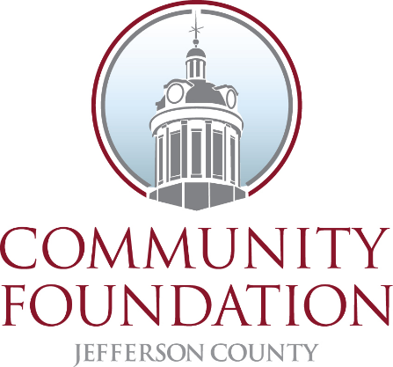

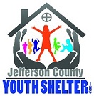

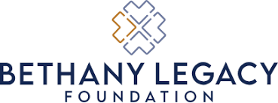

The Jefferson County Youth Shelter would like to thank this great community for all the support over the years
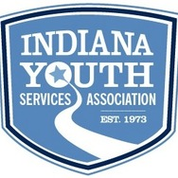
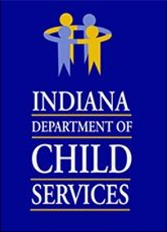

Purpose – To provide support and services for youth and their families.
Vision – To be recognized as a financially sustainable community provider of protective, restorative and preventive services for youth and families.
Mission – To promote the well-being and healthy development of youth and families in a safe environment.
Core Values
- Empathy – we strive to understand each person’s individual situation so that we may provide needed support.
- Respect – we consistently treat everyone with fairness and respect.
- Integrity – we strongly adhere to sound ethical standards within every transaction of our organization.
- Passion – we steadfastly uphold and sustain our mission with energy, loyalty and dedication.
- Success – we strive to improve the lives of the children & families we serve

Contact Information
Jefferson County Youth Shelter
212 East Street
P.O. Box 444
Madison, IN 47250
(812) 265-3777

