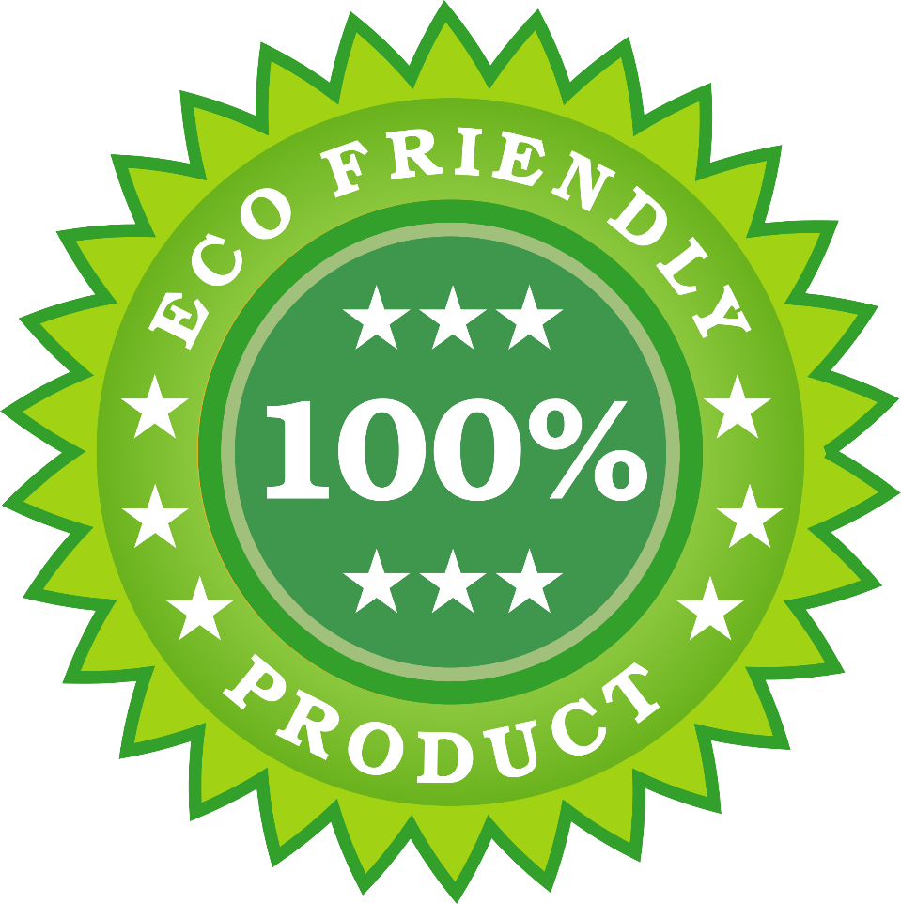

Getting a Grip on Green Products
by David Kozlowski

Knowing what makes an interior product Green rather than greenwashed is a key step toward environmentally sound facilities.
Talk of green buildings and products seems to be everywhere, creating a swirl of information that is causing some confusion over what green means. Varying definitions abound. And facility executives looking for “the” answer are likely to be frustrated.
This is a particular problem for green interiors because of the large number of green products that make up the interior — everything from wallboard to desktops. Even though their numbers have diminished, pseudo-green products and greenwash marketing claims do exist.
Because there is no simple test for what is green, facility executives often have to use their own judgment on which products might be greener than others. To do this most effectively, they need to understand some basic underpinnings of just what makes green green.
Defining Green
From the broadest perspective, sustainability means meeting the needs of the current generation without compromising the needs of future generations, says David Mueller, vice president of marketing for Interface Architectural Resources. “To accomplish this, we need to be creating more sustainable workplaces.”
What does that mean? Mueller says that means to use products manufactured in the most sustainable way possible and to design workplaces that deliver value for the customer for last the longest possible time and support the well being of the occupants.
The first question that usually comes to mind for green experts is what is the product made of. But what makes a product green is not the presence or absence of a single item, such as recycled content or volatile organic compounds (VOCs). But what makes a product green is often more than just recycled content and VOCs. It’s also a combination of attributes, including the source of the raw materials, the energy to manufacturer and deliver the product, and the durability of the product.
“You can create something with no emissions and completely recyclable, but it may last only one day,” Mueller says. “How sustainable is that? If you’re not working on all the fronts and still call yourself sustainable, then you don’t know what you’re talking about.”
To illustrate the complexity of specifying green products, consider the issues of recycled product content and recyclability.
Typically, products containing the highest amount of post-consumer and post-industrial recycled content generally fall into the category of green products. Products that can be recycled back into the same or similar product also can be considered green.
Recycled content will range in today’s green products from much less than half to 100 percent, says Paul Murray, corporate environmental manager for Herman Miller. “The content is one attribute to consider,” he says, “but so is ease of disassembly. This can make it easier to recycle.”
“If a manufacturer is using the by-products of another industry rather than virgin material, it shows not only good environmental awareness but also good economic sense, especially when the by-product or waste is identical to virgin material,” says Chris Beyer, national marketing manager for Georgia Pacific Gypsum.
But the issue of recycled content isn’t clear cut. Even if a product uses virgin material, the manufacturer may produce it in a way that is no more environmentally harmful than another manufacturer using recycled material.
Making Green, Green
But attributes, such as low VOCs and recycled content, are really just part of the big green picture. How a product is made can be as important from a green perspective as the product itself. The process involves everything from the raw materials to getting the product to the market.
Carpet and Rug Institute (CRI) President Werner Braun says that carpet mills have improved their manufacturing process. He says 85 percent of post-industrial waste is recycled back into the process; greenhouse gas emissions from manufacturing have been capped at 1990 levels, despite a 40 percent production increase; and 46 percent less water is used per square yard now than in 1990.
“The industry has met the requirements of the Kyoto Protocol,” he says.
The greening of the manufacturing processes is evolving into a science and is growing in importance among suppliers and specifiers. Finding a way to accurately and easily document a product’s life cycle has become a major goal of the industry, says Penny Bonda, chair of the U.S. Green Building Council’s committee on LEED (Leadership in Energy and Environmental Design) for Commercial Interiors, or LEED CI, and director of communications for EnviroDesign Works. This process of documentation, called the life-cycle analysis (LCA), is a difficult one. The LCA involves an investigation of what the product is made of, how much energy is used to produce it and the impact of obtaining the raw materials. Those issues just scratch the surface. Getting a complete picture of a product’s environmental impact over its entire life cycle is difficult, time-consuming and expensive.
Determining an LCA rating also requires making value judgments. Is it better to use more energy and create more pollution by transporting environmentally benign materials or to use locally available but less benign materials? Is a material that lasts longer but can’t be easily recycled better than a material that doesn’t last as long but can be recycled?
While an LCA for every product is not achievable now, and may never be, the discussion of these analyses are moving manufacturers in a green direction, says Anita Snader, marketing manager for the environmental program for Armstrong.
A result of this discussion has been to spur the creation of tools that can help facility executives make tough decisions on green products.
There are catalogs of green products that have simplified the process for users. “Green Spec” may be the most respected among them. BuildingGreen Inc., which puts out the catalog, relies on several well-established green criteria and assembled some of the greenest products available.
There also is a free software program from the federal government, called Building for Environmental and Economic Sustainability (BEES), that measures the environmental performance of building products by using the life-cycle assessment approach specified in the International Organization for Standardization’s ISO-14000 standards.
Economic performance also is measured to develop an overall performance measure.
BEES is a good start, but does not include an exhaustive database of materials and products.
An LCA stamp of approval for all green products would be “the Holy Grail of sustainability,” says Karen Rowe, public relations manager for Amtico International. LCA should be the definition for all products. “But we are only dreaming of that now.”
In the interim, Herman Miller’s Murray says, facility executives should be doing “life-cycle thinking,” making their own judgments based on the information that is available.
Believability
A step toward an LCA stamp of approval is a third-party certification. These labels on a product offer a degree of transparency in how a product was manufactured.
Green Seal, Forest Stewardship Council and Scientific Certification Systems (SCS) are three popular organizations that provide such stamps of approval.
The criteria these organizations use rely on established standards, such as ISO-14000, the U.S. Environmental Protection Agency guidelines for environmentally preferable products and the U.S. Federal Trade Commission guidelines for green marketing. The organizations verify that a product or manufacturer meets these criteria.
The third-party certifier system works, says Jeff Stephens, vice president of marketing for SCS, only if the process has credibility.
“Success rides on the quality of the standards,” he says. These certifications have become important because of the amount of greenwash on the market, says Marc Ahrens, corporate segment marketing manager for DuPont Antron. “Ask for certification; it’s the closest thing we have right now of a UL label for green products,” he says.
Third-party certifiers aren’t the only one selling credibility, however. Manufacturers are too.
Industries are trying to build consumer trust, Amtico’s Rowe says. Some manufacturers are making their processes more transparent without the incentive certification offers.
“An owner can’t know whether all the products they are looking at are green,” she says. “They have to rely on the supplier. Unfortunately, there is some confusion due to companies that have not been responsible. So look for those who can substantiate their claims.”
“Look at a company for four simple things,” Herman Miller’s Murray says. “Management support for sustainability. The company’s sustainability goals. Whether there is a structure to support those goals. And the results — the products.”
A number of big corporations are leading the way in developing a trust in their green products and processes, says Michael Italiano, CEO of the Sustainable Products Corp., a consulting and training company, and head of the Institute for Market Transformation to Sustainability (MTS).
“The market leaders have disclosed their life-cycle processes, and now the competitors are starting to do the same,” he says. This is changing the way building owners view manufacturers’ pronouncements. It is offering trust but with verification.
Driven To Success
Growing interest in green buildings is helping manufacturers see green. For instance, the growth of membership and registered projects for certification with the U.S. Green Building Council has more than doubled every year in the past three years. In response to this demand, the council has been expanding its platform of rating systems to include interiors.
LEED CI is currently in its pilot stage, but interest in the rating system has been very strong, says Bonda.
LEED CI addresses green performance areas such as efficient water use, energy-efficient lighting and indoor environmental quality measures that recognize the set of products and materials used in interior spaces. Credits are accrued for meeting certain parameters and one of four levels of achievement is awarded, from certified to platinum certified.
Is green a phase? Bonda doesn’t think so. “It’s popping up on more owners’ radar screens. Soon, Class A buildings will mean green buildings. We’re not there yet, but that’s the direction we’re heading.”

