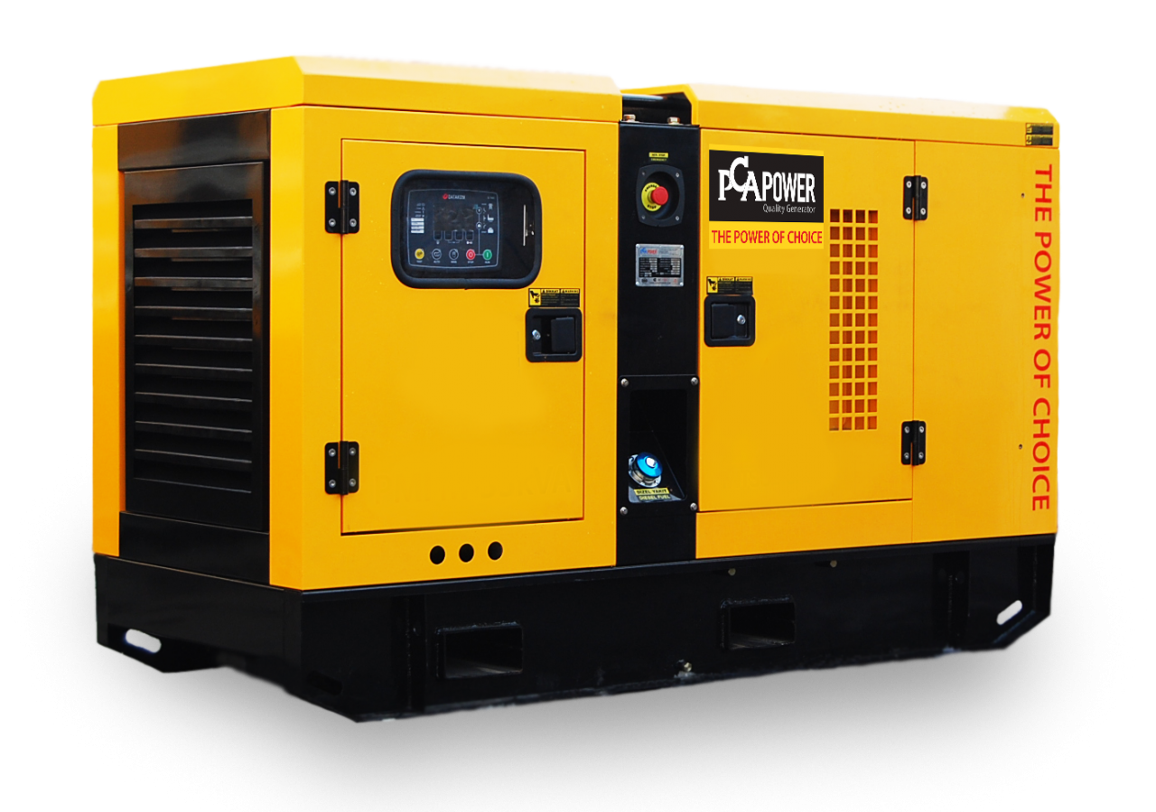

Eco-Efficiency Meets Reliability: Generators Transforming Condo Energy Use

Bill Henderson

National Business Development Manager @ T&T Power Group | Business Development
March 22, 2024
Condominium buildings often feature a suite of amenities, security systems, lighting, elevators, and other critical infrastructure that require a constant supply of power to function effectively. The loss of electricity can bring inconvenience, financial loss, and even safety risks to residents. To mitigate these risks, installation of standby generators, prime power generators, and combined heat and power (CHP) systems is a common practice.
Standby generators provide a reliable power supply in the event of a main grid failure, ensuring essential services remain operational. Prime power generators are used in situations where the grid is unavailable or unreliable, functioning as the primary source of power for prolonged periods. Lastly, CHP generators not only produce electricity but also utilize the heat produced in the generation process for heating spaces and water, leading to increased energy efficiency.

Importance of Generators in Condominium Buildings
Generators in condominium buildings serve vital roles, from providing an uninterrupted power supply to ensuring safety during emergencies. They are a critical infrastructure component in modern residential complexes.

Ensuring Continuous Power Supply
A standby generator is essential in condominiums for maintaining electricity during utility outages. It kicks in automatically, minimizing disruption by powering essential functions such as elevators, lighting, and water systems. For instance, units in a condominium may rely on a standby generator when the main power source fails, ensuring residents are not left in the dark.

Meeting Peak Power Demand
Prime power generators support condominiums during periods of peak power demand, which can occur during extreme weather conditions or when the grid is overtaxed. These generators can operate continuously without runtime restrictions, catering to variable loads as needed. They are especially useful in condominiums without access to ample grid power or in developing areas where the energy infrastructure is still evolving.

Safety and Emergency Preparedness
For safety and emergency preparedness, condominiums must have reliable backup systems. These include generators specifically designed for emergencies, which may power security systems, fire alarms, and communication networks. Toronto's condo backup power generators, for instance, are mandated to ensure resident safety during grid failures precipitated by events like ice storms.

Types of Generators for Condominiums
Condominium buildings require reliable power sources to ensure uninterrupted electricity for residents and to maintain essential building services. Different generators are used to meet varying needs, from emergency power to daily energy supply.

Standby Generators
Standby generators are critical for condominiums, providing emergency power during outages and preventing the inconvenience and safety hazards of a blackout. They automatically engage when the utility power fails to provide power to the services and equipment tied into the emergency panel, like elevators and lighting. These generators are typically quieter and are designed as a permanent installation, positioned to seamlessly supply electricity to the entire building or critical systems.

Prime Power Generators
Prime power generators serve as the main power source in the absence of a reliable local grid or where a constant power supply is a priority. These generators are robust and can run continuously to keep a condominium powered at all times. They may be used in remote locations or in buildings where power is critical, such as in complexes with numerous residents relying heavily on electrically powered medical equipment.

Combined Heat and Power Generators
Combined Heat and Power (CHP) generators, also known as cogeneration systems, simultaneously produce electricity and thermal energy from a single fuel source. They are extremely efficient and reduce overall energy costs. For condominiums looking to maximize energy usage, CHP systems can provide not only electricity but also heating and hot water, capitalizing on the fuel source to its full potential and resulting in lower environmental impact.

Considerations When Choosing Generators
When selecting generators for condominium buildings, administrators must evaluate specific factors to ensure a match between the power infrastructure and the building's demands. These considerations directly impact the generator's efficiency, compatibility, and environmental footprint.

Power Capacity Needs
Condominiums vary greatly in size and power consumption, necessitating a tailored approach to determining the ideal generator capacity. For standby generators, which provide emergency power, it is vital to calculate the load based on critical systems such as lighting, elevators, and security. Prime power generators, on the other hand, are intended for continuous operation and their power output must be assessed to handle the full load during extended outages or when utility power is consistently unreliable. Any surplus power supplied by one or more prime power generators can be sold into Distributed Energy Resources (DER's) that are becoming increasingly common.

Space and Location Constraints
The physical placement of generators is dictated by the building's architecture and available space. Standby generators often require less space and can be sited outdoors if necessary. Prime power units might be larger due to increased capacity demands and a corresponding need for proper ventilation and fuel storage. Thus, careful measurement and planning must ensure the generator fits the allocated area, with ample clearance for maintenance and adherence to life safety standards.

Environmental Considerations
Generators’ environmental impact is a significant factor, especially for condominiums in urban areas where regulations may be stringent. Standby and prime power generators must adhere to emissions standards, necessitating the selection of models with the latest technology to reduce pollutants. Noise pollution also plays a role; units should possess acoustic treatments to minimize disruption to residents. Furthermore, combined heat and power (CHP) generators offer an efficient solution by capturing and repurposing waste heat for the building’s heating needs, thus optimizing energy use and reducing greenhouse gas emissions.


Examples of Generator Usage in Condominiums
Understanding the specific application of different generators can exemplify their necessity in condominiums. Each type serves a distinct function, ensuring that residential needs and emergencies are competently managed.

Standby Generators in Action
In condominiums, standby generators are crucial for providing uninterrupted power during outages. For example, a condominium may utilize a standby generator to maintain essential services like elevators, security systems, and lighting in common areas. These generators typically operate automatically, activating within seconds of a power interruption and are known for being quieter than portable models, equating the noise level to that of a central air unit.

Prime Power Generators at Work
Prime power generators play a vital role when reliable utility power is not available. In a condominium building undergoing construction or renovation where the power supply is not yet stable, or in areas with frequent power cuts, a prime power generator can serve as the main power source, operational for a preset number of hours annually under a non-variable load selling surplus power to a Distributed Energy Resource (DER).

Benefits of Combined Heat and Power
Combined Heat and Power (CHP) systems in condominiums not only provide electricity but also utilize the waste heat from electricity generation for heating and hot water, increasing energy efficiency. Building swimming pool heating costs are usually nullified after installing a CHP. A condominium utilizing CHP can significantly reduce energy costs and carbon footprint by harnessing thermal energy that would otherwise be wasted, making it an eco-friendly power solution.

Generators play an indispensable role in condominium complexes, ensuring a continuous power supply, safety during emergencies, and enhanced energy efficiency. Standby generators offer a safety net during power outages, prime power generators fulfill the demand for reliable electricity where grid power is lacking, and combined heat and power (CHP) systems optimize energy use by producing both electricity and heat from a single fuel source.
This multifaceted approach to power generation ensures that condominium residents enjoy uninterrupted access to essential services and the comfort of their homes, underscoring the importance of integrating robust power solutions in modern residential designs. By prioritizing these systems, condominiums can significantly improve their resilience to power disruptions, contribute to environmental sustainability, and offer a higher standard of living to their inhabitants.

Published by



Bill HendersonBill Henderson
National Business Development Manager @ T&T Power Group | Business DevelopmentNational Business Development Manager @ T&T Power Group | Business Development

