

Winter Doesn't Break Buildings



Vlad Bakic

Senior Operations Manager | FMA, RPA, LEED AP+OM, CEM Operations Leader (10+ yrs) | Preventative Maintenance, Budgeting, Energy Management, Sustainability, Contracts, Compliance | Building & Property Ops Daily
October 21, 2025
With winter around the corner how are you preparing your portfolio.
Winter doesn’t break buildings. Missed maintenance does.
Winter doesn’t break buildings. Missed maintenance does. I’ve seen it, fixed it, and sworn I won’t repeat it.
Here’s my blunt take. Winter fails to destroy any structures. Missed maintenance does.
I manage mixed-use assets with office, retail, cinema, and a busy grocery. Different schedules. Different risks. Same cold. The three main requirements that tenants expect from their heating systems include proper heat delivery and clean air circulation and operation at a peaceful level. They don’t want stories. I have witnessed frozen mains and stuck shut dampers and a generator which succeeded quiet tests but failed when operating under load. That wasn’t bad luck. That was a checklist we hadn’t hardened. We solved that problem and we will continue to solve it.
Standards already tell us the floor. ASHRAE 180 sets fundamental inspection and maintenance standards which help maintain consistent comfort levels and operational efficiency and indoor air quality. The floor provides the foundation for your work to build up the ceiling through systematic and research-backed techniques

Begin with a question instead of using a wrench
What will break first—people, radios, or doors? I always ask that out loud with my team. We list risks by site: lobby doors that slam, dock curtains that leak, that north stair that never warms, the cinema AHU that hates weekends. Then we assign owners and time boxes.
No mystery work. No heroics. Just structured, human-first operations. Winter is a stress test you can schedule. If your BAS doesn't show warm-up, setback, freeze, and unoccupied modes behaving, you don't have control, you have hope.
Hope isn't a sequence.
ASHRAE Guideline 36 gives you those modes, plus fault detection. Use it, name it, and train to it. When your building automation system can't tell the story, the hallway will and tenants won't be quiet about it.

Heat Plant: Build Reliability Where Heat Is Made
If your pump sounds like gravel, your tenants will sound louder. Warmth starts in the plant, not at the thermostat. Everything downstream depends on what happens in this room, so get it right before the cold hits hard.
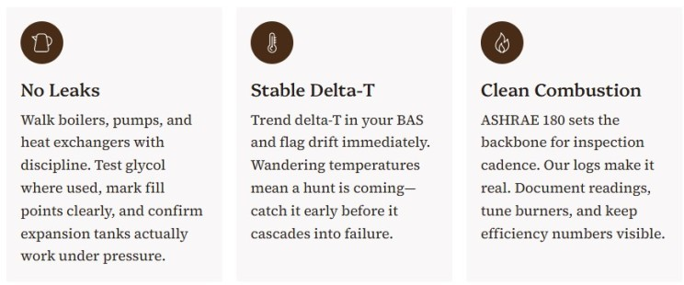

Airside: airflow beats good intentions, every day
Clogged filters, iced economizers, stuck dampers, and schedules that still think it's summer, these are the silent killers of winter comfort. The maintenance crew performs filter replacements before the start of winter season. We need to document the frame pressure drop measurement for future reference and perform another check in two weeks. The procedure includes coil cleaning and drain pan verification and damper travel and seal testing. The study shows that rising filter pressure drop and coil fouling development result in lower airflow while increasing energy consumption. Airflow should be treated like money because you need to eliminate all leaks.
The operational power source of HVAC systems depends on airflow.
- Filters First - Confirm dates, MERV, and fit. Clogged media drives up energy use and shortens compressor life.
- Coils & Drains - Clean, prime traps, and make sure no standing water is waiting to freeze.
- Economizers - In cool, dry weather they save a lot if they're working. Verify enable points and damper movement.
- Schedules - Load holidays, reduce after-hours, and set reasonable deadbands.

The Humidification Balance
Dry offices spark like a wool sweater. A modest RH bump reduces static and complaints, but push too high and perimeter glass sweats. That's not "comfort" that's repair work later.

ASHRAE notes humidification limits depend on the building envelope. Many programs cap indoor RH under 65% to limit microbial growth. Keep winter RH in a safe range to balance comfort and condensation risk.

Envelope: seal the bucket before you pour more heat
We walk every exterior door and vestibule. Adjust closers. Add sweeps. Seal all roof entry points and verify that flashing is properly installed. The Department of Energy identifies air sealing as a quick winter solution which delivers both improved comfort and lower utility bills and complete draft elimination. The method delivers excellent results at a low cost but lacks excitement in its process.
If you manage a tall-building, stack effect is the winter villain you can't see. Cold air drops your lower floors into negative pressure and pushes your upper floors positive. You'll feel it in lobby doors that won't behave and elevators that "breathe" when the wind shifts. Pressurizing the ground floor and minding vestibule behavior can tame it. It's not magic it's physics you can manage with the right setpoints and some strategic outdoor air.
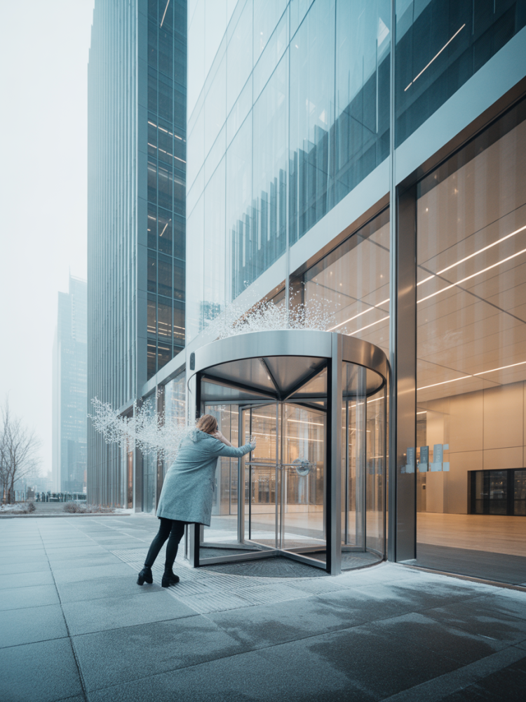
The amount of heat you maintain in your property determines how much energy you need to buy from the grid.

Pumps, Hydronics & Freeze Protection
Water wants to freeze. Don't let it. Dead heat trace, cold stairwells, uninsulated runs, and valves that don't actually close, these are the culprits behind most frozen pipe emergencies.
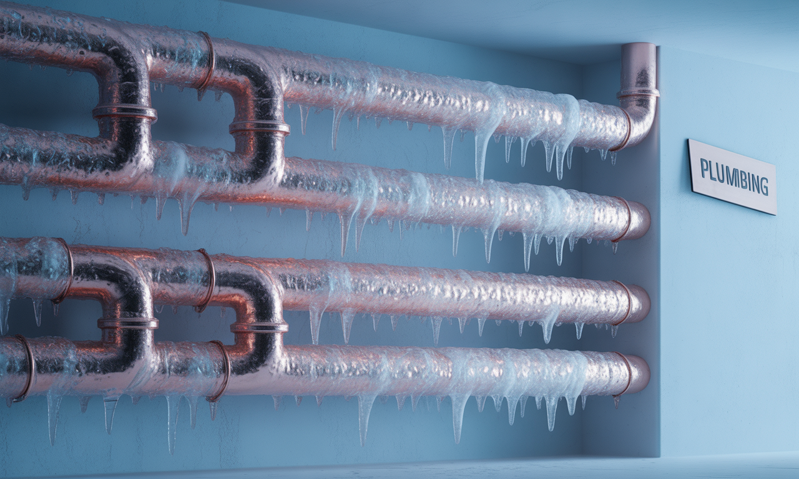
- Heat Tracing -Test power packs, verify controllers, and tag circuits. Add heaters in known cold zones on pipe and sprinkler runs exposed to freezing.
- Insulation -Look for missing jackets, wet insulation, or gaps on exterior walls and dock areas.
- Valves & Strainers -Exercise and clean. Note any seized isolation points before you need them in an emergency.
- Glycol Loops -Measure freeze point and log results. Don't trust last year's readings.
- Remote Spaces -Loading docks, mechanical penthouses, stair towers—use data loggers or BAS points to catch cold spots before the call comes in.

Cooling Towers & Chillers: Ice Is Not a Design Feature
Operating wet towers below freezing without controls, poor lay-up, or basin heaters not working—these failures turn equipment into expensive ice sculptures.
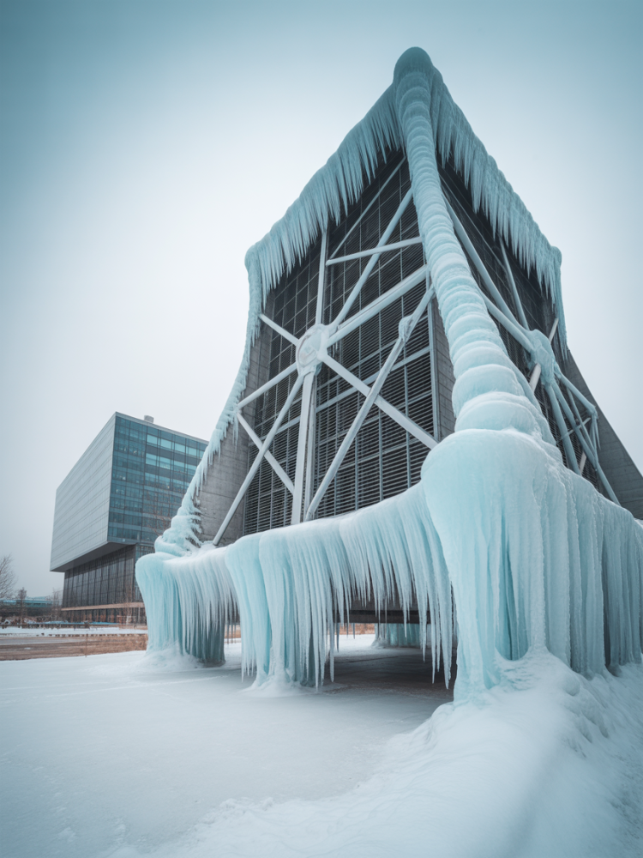

If Towers Run in Winter
- Maintain minimum flows
- Use basin heaters
- Consider fan cycling
- Watch for ice on air-inlet louvers
EVAPCO details ice formation risk and control strategies worth reviewing.

If Towers Are Seasonal
- Complete proper lay-up
- Apply biocide treatment
- Drain and dry, or wet lay-up with treatment control
- Ensure spring start isn't a microbial mess
Water treatment and CTI-style guidance stress correct lay-up procedures.

Life-Safety and Power: "Ready" Means Proven Under Load
Fire pumps need to perform required churn tests while maintaining room temperature within specified ranges and recording all test results. NFPA 25 serves as the fundamental standard for inspection and testing and maintenance work because it requires immediate action on all identified issues. NFPA
Generators need to run at less than full capacity for at least 30 minutes each month while staff members track the results. NFPA 110 stands as a mandatory standard which determines whether your facility will have functioning lights or face an extended period of darkness. A unit that fails to maintain load needs a load-bank test to determine the source of the problem for fixing.

BAS Sequences: Sequencing Beats Spending—Every Single Winter
We check the schedule for tightness and confirm the morning warm-up and monitor the freeze protection status. For larger sites, we map AHUs and terminals to Guideline 36 modes so every operator speaks the same language. We establish alerts for specific trends which demonstrate a high probability of customer complaints.
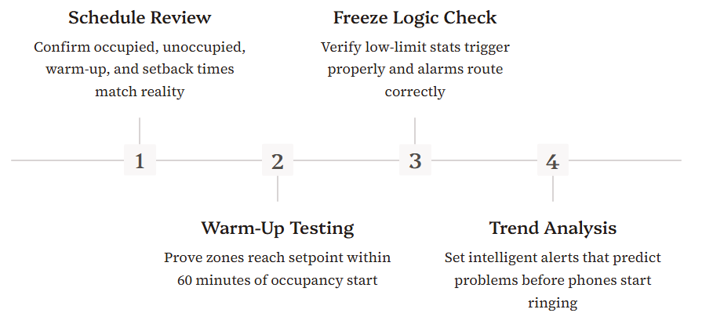
The hallway will tell the story if your BAS fails to do so.

Roofs, Drains & Entrances
Keep water moving, keep doors calm. Leaves in drains, snowmelt refreezing, and stack effect yanking doors open or shut, winter turns these minor issues into major headaches.
Roof Drains & Scuppers - Clear debris so meltwater flows. Roofing bodies warn ponding beyond 48 hours can damage assemblies and raise leak risk.
Snow Plans - Choose safe removal methods. Don't turn maintenance into a rescue.
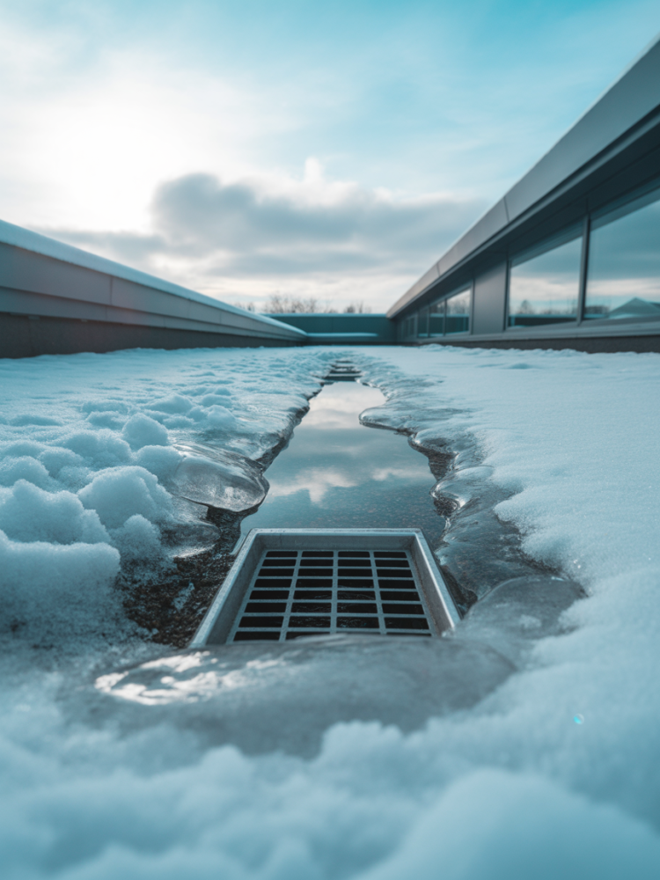

Five Non-Negotiables I Never Skip
- The team needs to perform joint inspections of boilers and pumps and heat exchangers to identify any signs of leakage and operational issues. Trend delta-T for proof.
- Seal all door and window openings and roof penetration points to prevent heat from escaping and cold air from entering.
- The team needs to test fire pumps and generators and backup systems at their correct operating frequencies and resolve all detected issues during the same day.
- The system requires filter replacement and coil cleaning to maintain airflow and capacity during periods of high demand.
- Review the BAS schedules and setpoints to ensure proper winter operation by checking the warm-up and freeze protection protocols.
The term non-negotiable holds absolute meaning during January.

Quick Wins You Can Do This Week

Change the dirtiest filters
Log pressure drop on the frame for tracking—write it with permanent marker so it's visible during the next check

Walk exterior doors
Fix the three worst gaps today, vestibules tomorrow—small moves now beat big invoices later

Run the generator under load
Write down every reading and compare to baseline—if load drops or temps rise, schedule deeper diagnostics

Screenshot your BAS warm-up trend
Set an alert for failure to meet setpoint—let the system tell you before tenants do

Test heat-trace and freeze alarms
Label breakers and route alarms to a responsible human who answers their phone at 2 AM
Small moves now beat big invoices later.

Make It Measurable or It Never Happened
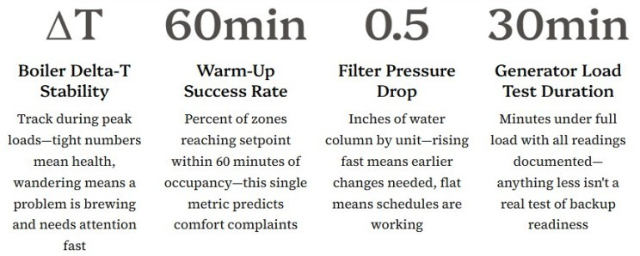
These aren't vanity metrics. They're predictive indicators that tell you where failure will strike before it happens. Graph them monthly. Share them with leadership. Use them to justify time and budget before the emergency call comes in.
If you can't graph it, you can't brag it.

The Quiet Energy Math That Pays for Your Time
Two moves consistently pay in winter: setbacks that work and air sealing that's thorough. Classic measured studies found heating savings around 14–25% from night setback when done right—but only when your BAS actually executes the sequence.

Air sealing frequently delivers fast payback while fixing drafts tenants actually feel. Your BAS proves one through trend data, your doors prove the other through tenant satisfaction scores that stop dropping.
Comfort wins hearts; savings wins budgets.
Present both numbers to leadership and watch how fast winter PM budgets get approved. Energy dollars fund reliability work.

I’ll say it again: Winter doesn’t break buildings—missed maintenance does. Your tenants pay the interest on delay.
What's the one winter PM task you never skip—people, systems, or doors? What's saved your portfolio when the cold hit hard?
Share your hard-won lessons so we can all get better at keeping buildings running when it matters most.

