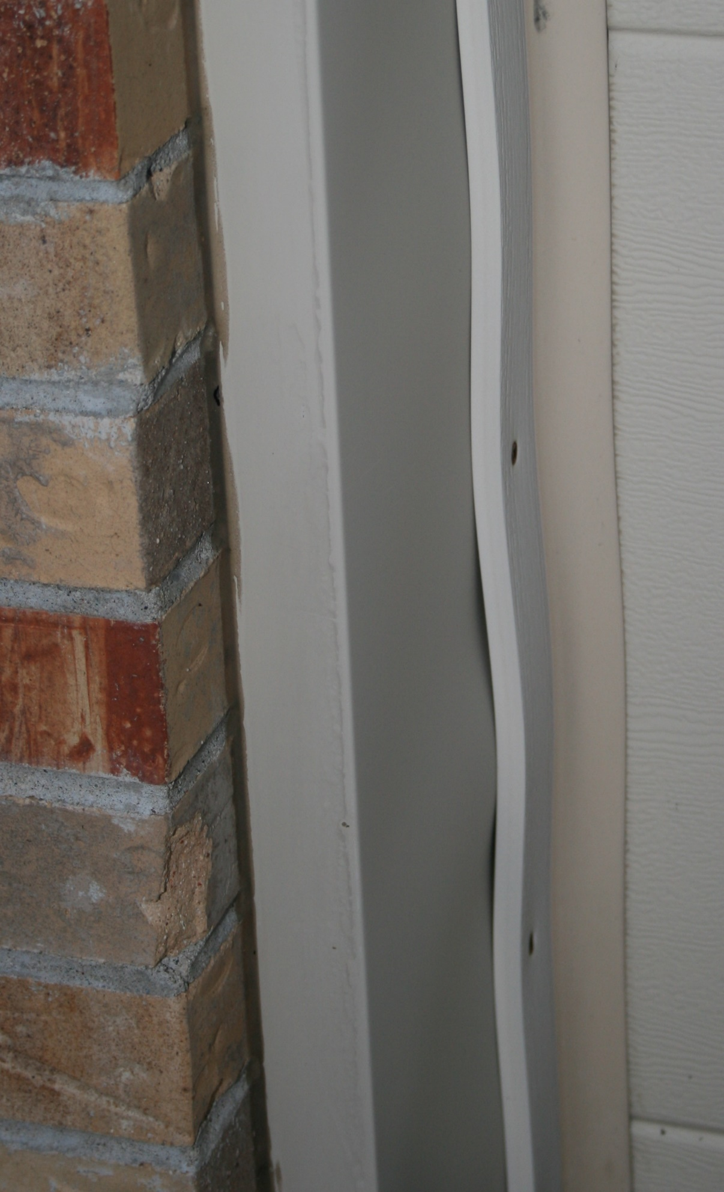

Signs of sealant trouble.
Guidelines for finding potential trouble spots in building facades before they affect facility operations.

Sealants are a primary defense against water penetration and air infiltration in building facades. Their performance is critical to the overall performance of the entire building envelope. Problems related to sealants usually result from a range of conditions affecting performance, including inappropriate sealant selection, inherent problems in the sealant, and aging and deterioration.
Signs of failure.
Four general conditions usually evaluated in assessing sealant failure:
- Adhesion, or the bond of the sealant to the substrate. A loss of adhesion results in a separation of the sealant from the substrate. This usually is visible in openings along either side of the joint but may not be immediately obvious ifthe joint is compressed.
- Cohesion, or the internal integrity of the sealant. A loss of cohesion is indicatedby cracking parallel to the joint interface.
- Elasticity. A loss of elasticity can contribute to adhesive or cohesive failure and is indicated by the inability of the sealant to recover after deformation and especially by an increased hardness of the material.
- Weathering, which is indicated by chalking, discoloration, random or alligator cracking, wrinkling, erosion, or excessive softening of the surface region of the sealant.

This Photo by Unknown Author is licensed under CC BY

Improper installation.
also can contribute to failure. For example, all sealants must be able to accommodate movement of the joint. Sealants typically are installed with polyethylene bond breaker tape, compressible foam backer rod, or other means to prevent adherence of the sealant to the back, as well as to the sides of the joint. If the sealant is adhered to the back, as well as the sides, it cannot expand or contract without tearing.
If sealant is installed when the substrate or ambient temperature is too cold below 45 degrees — the joint may be at its widest dimension through contraction of adjacent materials. The sealant might not be able to accommodate the subsequent cyclic expansion of the joint upon heating.
Conversely, if the sealant is installed when the temperature is too high — above 90 degrees — the joint may be at its narrowest dimension, and the sealant may be unable to accommodate cyclic expansion of the joint upon the cooling of the substrate.
Low temperatures directly retard the cure of most sealants, and if installed at very cold temperatures, frost contamination on the surface likely will interfere with proper bonding. If installed at a very high temperature, the sealant may flow.
This is especially likely to occur with dark-colored sealants in locations exposed to direct sunlight. The durability of some polyurethane sealants can be seriously reduced by high-temperature curing.

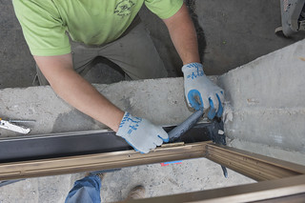

Finding a cause
Joint sealant investigations rarely turn up a single cause of joint failures. Here are some of the common suspects in the search for suspects.
- Mixing.
Although sealant manufacturers supply specific directions, many two-part sealants are mixed incorrectly. One example of this is a normal sealant bead that is interrupted by areas of uncured sealant. Sealant applicators should make sure to closely follow manufacturer directions for product use.
- Joint substrate.
It can be difficult for a building sealant to adhere properly to this type of a surface. In some types of concrete panel construction, the exposed aggregate can create a very irregular surface. The aggregate in the concrete panels is often loosely bonded to the panels. Thermal strains imposed by the sealant or freeze/thaw cycles cause the aggregate to detach from the panels. This can leave a void that lets water pass into the building.
- Primer problems.
Another common sealant adhesion problem involves primers. New metal finishes and glass coatings often make sealant adhesion difficult. In the most complicated installations, one type of primer is specified for one side of a joint, while another is specified for the other side. This specification almost guarantees the two primers will contaminate each other within the joint.
Checking out sealants

The goals of should be to determine the condition of the existing sealant, causes of deterioration or failure, whether problems with the substrate or adjacent materials are related to a sealant problem, and whether the sealant can be selectively replaced or requires complete replacement.
The investigator should understand different sealant types and the wall or paving system being investigated. It may be useful for the investigator to review original construction documents and those for repairs to determine what sealants and primers were specified, to what substrates the sealants bond, the location of weeps or sources of water, whether backer rod and bond breaker tape were specified, and the extent of repairs performed since the installation.
Mixing to Match
Certain types of sealants cannot bond to certain other sealants. It is generally desirable to avoid installing a sealant over an existing sealant, as this usually results in poor geometry for the new sealant joint and limited adhesion to the substrate.
For all sealants, improper priming or cleaning of the substrate can lead to adhesive failure. Solvent-based sealants placed over thermoplastic coatings, such as certain breathable masonry paints, can soften or partially dissolve the coating, causing partial failure within the paint or at the paint/substrate interface as the sealant shrinks.
Urethane sealants
Problems with multi-component urethanes usually are related to incomplete or improper mixing. If mixing is incomplete, portions of the sealant will be fluid or uncured. Incomplete curing also can be the result of using materials beyond their shelf life or, under certain circumstances, from improper formulation.
To evaluate problems that may be related to incomplete curing, it is best to sample sealant that has cured properly for comparison with sample that has cured improperly. Also, it is possible to purposely incorrectly proportion components in the laboratory for comparison with samples taken from the building. Curing at high temperatures — around 120 degrees — can make some urethanes vulnerable to premature degradation in ultraviolet light, leading to severe reversion.
Silicone sealants
The most often observed problem with silicone sealants is staining. Staining can be indicated by dirt accumulation on the sealant itself or by migration of the sealant plasticizer in the adjacent substrate.
Stone substrates are particularly vulnerable to migration and staining from silicone sealants with a high percentage of fluids. Silicone sealants installed on glazing are susceptible to poor adhesion if there are contaminants on the glass surface, and the sealant itself may leave deposits on the glazing if improperly cured.

The information for this article was provided by Wiss Janney Elstner Associates Inc., an architectural, engineering and materials science firm based in Northbrook, Ill. specializing in investigation, repair and preservation services for historic and contemporary buildings and structures.

