Temperate Zones
This Photo by Unknown Author is licensed under CC BY-SA

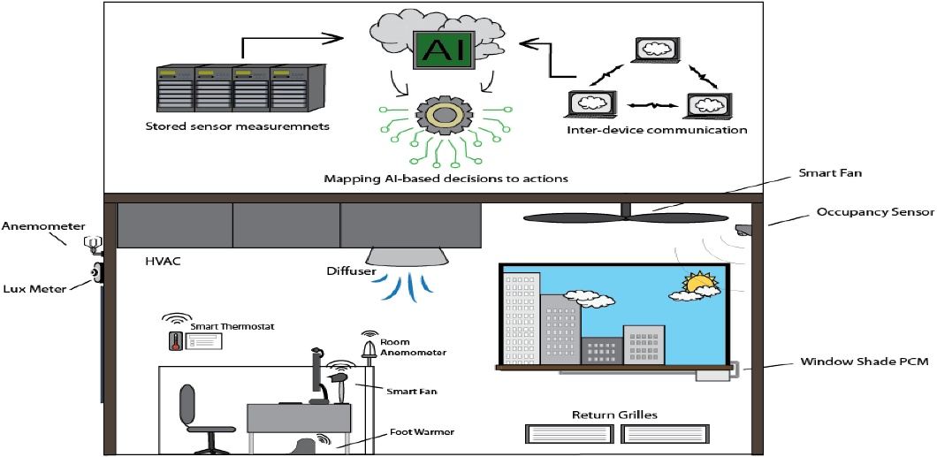

New HVAC technology offers total climate control
CONSIDERING THE CONFLICTING goals that HVAC professionals have to meet when installing a heating, ventilation and air conditioning system, it is amazing that they manage to install anything at all.
The first thing HVAC contractors must determine is the size and capacity of equipment needed to deliver adequate air, heating, and air conditioning for the size, shape and complexity of the building. When specifying the appropriate chillers, boilers, ducts, piping and other equipment, the contractor has to consider not only the size and shape of the building, but also what it's used for, how many people will be in it, what other kinds of equipment will be in the plant, how much heat that equipment creates, and what the different areas, or zones, of the building will be used for.
At every stage, the contractor has to balance conflicting desires: offices need different air flows than manufacturing or storage areas, and partitioning once-open rooms into smaller offices changes the air flow and puts a different load on the system. Meanwhile, it seems that no one is ever happy with the air conditioning - the building is too hot, or too cold, and someone always wants to increase or to decrease the air flow in his or her area.
Of course, the HVAC contractor can try to install the perfect air conditioning system with multiple zones that can be individually adjusted. But then reality strikes usually from the accounting area. New trends in building and in maintenance are also putting even more constraints on HVAC contractors. Buildings are getting more complex, as are environmental and safety regulations and building codes; owners and occupants are demanding shorter schedules for completing HVAC installation. There is also continued pressure on contractors to keep prices from rising. All too often, a more sophisticated HVAC control system is sacrificed in order to save money on the installation costs, without considering the ongoing cost of HVAC.


Control systems save money, improve performance
Fortunately, new developments in control technology and in electronic communications are being applied to building maintenance today. HVACs can be controlled by systems that offer more flexibility for occupants while reducing power consumption at the same time. What's more, these systems can be linked to, or even become part of an integrated building automation system.
A central control and monitoring system, or CCMS, is perhaps the most effective HVAC energy-saving program - even if all it can do is turn the HVAC system on in the morning and off again in the evening. And by using the system judiciously, the CCMS can reduce wear and tear. This system can also be used for regular maintenance shut-downs, further extending the life of the components.
One of the most common complaints about HVAC systems comes from the occupants of the buildings however, occupants traditionally have no direct way of controlling the temperature of their own work areas. This goes against the grain of standard HVAC design.
Conventional HVAC theory dictates that adding more individually-controlled zones means driving up the cost, not only of the installation, but also of maintenance and operation. The prevailing wisdom says that if people are continually adjusting the temperature settings, the company is spending more on power and maintenance of the system. In theory, as long as you design an HVAC system that delivers the right amount of air and maintains the right average temperature, then everyone inside should be comfortable and won't have to adjust the temperature. Changing the temperature or the airflow, according to this theory, will just complicate the problem and pull more electrical power.
Now consider a new approach to 14VAC: all parts and control points linked to the same network that runs the building automation system - and that links all the building's computers. With a few mouse clicks, the building occupant can open up the environmental control program for his or her area and adjust those parameters that the maintenance manager has given him or her. The occupant can increase the temperature a little, or increase the air now, and these adjustments don't affect the system's performance anywhere else because the system can compensate automatically.
This kind of HVAC controlling system can also be integrated with the controls for the other building systems, such as lighting, fire alarms and security. At the top end are integrated Building Automation Systems (BAS), that link all the physical controls to the owner's management system, enabling building owners or facility managers to monitor, track and control costs, and link BAS data with accounting, purchasing and other management software. More management information means potentially even greater savings.
These systems can also mean greater comfort and security for the building's occupants. Using occupancy sensors such as motion sensors, temperature sensors or other devices, a BAS can determine that someone is in a office after hours. It can turn on the hallway lights for that person, adjust the temperature in the office and even send an empty elevator to that floor to be waiting when the night owl finally leaves. This concept is not so farfetched: these systems, including sensors, controllers and software, are already in place in many buildings. For more information on this idea, see the Lighting Answers Web site maintained by the Lighting Research Centre of the School of Architecture at Rensselaer Polytechnic Institute in Troy, New York at www.Irc.rpi.edu.
A U.S. study of office and industrial building owners found that more than half have already invested in some kind of integrated building control system. Their main reasons were:
- reduced operating costs; a lower maintenance and repair costs;
- better tracking and management of systems;
- improved employee/occupant comfort; the ability to avoid major systems failure.
The trend in HVAC today is to integrate its controls into a total building management system or building automation system (BAS). The results of doing so are greater efficiency in the HVAC system, lower power consumption, longer life of the components of the system, and greater productivity from more comfortable workers inside the buildings.
Types of building and HVAC controls What is needed to automate a building's HVAC controls' The components and the communications networks to tie them together are readily available and getting less expensive and easier to use.
The simplest centralized building control system allows the operator or manager to check the status of the various building systems: HVAC, fire and security, power consumption and so on. At the other end is the direct digital control network, or DDC, in which a computer not only monitors the systems, but adjusts settings so they're operating at optimal levels.
Every building management system has the same basic capabilities: a start/stop program to turn HVAC equipment on and off according to a schedule. Adding complexity to the equation, a reset program can reduce RVAC operation during off-peak hours, or turn it on in time to restore comfortable conditions when employees arrive.
More complex systems can provide reports on total daily or monthly cooling and heating loads, energy consumption and other statistics, as well as calculate preventive maintenance.
For some years now, many HVAC control system vendors have been adding lighting, fire alarm and security alarm controls to the HVAC control system.
As the systems or buildings operated by HVAC systems get larger, they have more "addressable points:' which are elements or components to control, and that communicate in some way with the central processing unit. After about 2000 points which can include sensors, thermostats, valves, chillers, boilers and so on - the data gets too large for a single computer to handle efficiently. At this point, the addressable points are grouped, with each group communicating with one data gathering panel, which in turn feeds information to the central controller. But as the number of data gathering panels increases, the ability of the central processor to deal with each one decreases.
At some point, direct digital control (DDC) becomes a viable option. DDCs are typically used in complexes of several buildings, such as colleges and universities. Two things set DDCs apart from other types of control systems: two-way communications and distributed control. Two-way communication with the systems under control means that a DDC records data including outside and indoor air temperature, supply air volume, and temperature of various zones. Then, it calculates the required settings of the HVAC components to achieve optimal conditions.
Distributed control means that there is more than one computer involved. While the central processing unit acts as a hub, satellite processing units can stand alone and control zones of the system. If the central computer fails, the whole system doesn't have to go down, too.
DDCs are easily expandable to control more buildings or more systems. For instance, you could implement a DDC just for the HVAC system, then later add controls for lighting or security.
Tying it all together
What allows direct digital control systems to work, or any other kind of building automation system, is a network to tie together the components including chillers and boiler and valves, as well as the computers, switches and sensors. While there are many different networks available, from Ethernet to TCP/IP, the special needs of the HVAC industry have led to the creation of specialized building automation networks.
Three different building automation networks dominate the market, although each has its own specific niche: Building Automation and Control network, or BACnet; LonWorks; and Consumer Electronics Bus, or CE Bus.
Where is HVAC control heading?
Whether LonWorks or BACnet - or another, newer standard will eventually dominate HVAC controls is still a toss-up. Both are viable choices that can deliver better control over HVAC and other building systems, reduce costs and make a more comfortable and productive environment for the occupants.
It's time to look carefully at automating HVAC controls.

