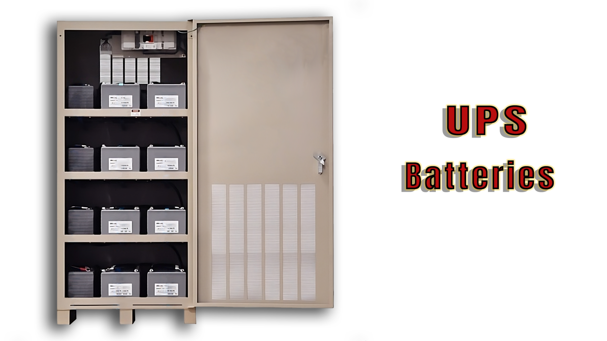

Choosing the correct UPS battery:



Mohsen Abedi P.Eng, PSM.Eng

Technical Consultant | Senior UPS Systems Specialist | Electrical engineering design | Power electronic systems design | Power quality systems & Harmonic filters | BESS Renewables

Selecting the right battery for a UPS (Uninterruptible Power Supply) involves considering various technical parameters to ensure compatibility, reliability, and optimal performance. Here are the key technical parameters to keep in mind:
1. Battery Type:
- UPS batteries are commonly Valve Regulated Lead Acid (VRLA) or Lithium-ion. Choose a battery type based on factors such as cost, maintenance requirements, and expected lifespan. VRLA batteries are often more cost-effective, while lithium-ion batteries may offer longer life and higher energy density.
2. Nominal Voltage and float voltage:
- Verify that the battery voltage aligns with the UPS requirements. Common voltage ratings for UPS batteries range from 12V to 480VDC, contingent on the size of the unit. Additionally, it is crucial that the UPS system supports the specified float voltage configuration of the chosen batteries; otherwise, proper charging may be compromised.
3. Capacity (Ah):
- Battery capacity is measured in ampere-hours (Ah). Select batteries with sufficient capacity to meet the runtime requirements of your UPS. Calculate the required capacity based on the power consumption of your connected devices and the desired backup time during a power outage.
4. Number of Batteries:
- Consider the configuration of the batteries in the UPS. This includes the number of batteries and whether they are connected in series or parallel. Ensure that the UPS can support the specified battery configuration.
5. Physical Size and Form Factor:
- Check the physical dimensions of the batteries to ensure they fit into the UPS enclosure or external battery cabinet. Consider the form factor, such as rack-mounted or tower batteries, depending on your UPS installation.
6. Internal or External Batteries:
- Some UPS systems allow for the connection of external battery packs to extend runtime. Determine whether you may need to add external batteries in the future and if the UPS supports this option.
7. Self-Discharge Rate:
- The self-discharge rate indicates how quickly a battery loses its charge when not in use or floating voltage. Lower self-discharge rates are desirable for UPS batteries to ensure they remain charged during periods of inactivity.
8. Cycle Life:
- Cycle life refers to the number of charge and discharge cycles a battery can undergo before its capacity significantly degrades. Choose batteries with a cycle life that meets your expected usage patterns.
9. Temperature Range:
- Check the operating temperature range of the batteries. Ensure that the UPS and battery system can operate within the specified temperature limits of your environment.
10. Charging Current:
- Consider the charging current supported by the batteries. Faster charging can be advantageous, especially in situations where the batteries need to recharge quickly after a power outage.
11. Compatibility with UPS Charging System:
- Verify that the batteries are compatible with the charging system of the UPS. Some UPS models may have specific charging requirements for optimal battery performance.
12. Monitoring and Management:
- Batteries with monitoring features provide information about their health, status, and remaining capacity. This data can be crucial for proactive maintenance and ensuring the reliability of the UPS system.
By considering these technical parameters, you can select batteries that are compatible with your UPS system and provide reliable backup power when needed.

