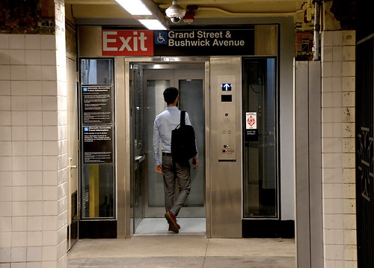
This Photo by Unknown Author is licensed under CC BY
Elevator Safety, Codes and Regulations.
by Stephen Murray

There number of safety related issues of importance to the building operator and manager. We will be looking at the following issues:
1. Recent Code changes
2. Safety issues with hydraulic cylinders
3. Entrapments
Highlights of the changes are:
- Maintenance is required on all elevator at a minimum of once per quarter. ( Previously no min. requirements)
- All escalators are required to have inspection switches installed in each machinery space where access space is provided.
- A log book either manual or electronic must be provided on site or with the maintenance contractor. The log shall at minimum record the last 5 years activities.
- Current up-to-date wiring diagrams detailing circuits and primary directional circuits are to provided in the machine room at all times.
This code change also requires that all modernization work on elevators must be performed within the guidelines of the B44-94 code requirements.
SAFETY ISSUES WITH HYDRAULIC CYLINDERS
Uncontrolled descent of Hydraulic elevators due to a catastrophic collapse of the cylinder has occurred resulting in environmental contamination and even injuries and death. This has resulted in litigation which has spurred Elevator manufacturers to outline the safety precautions that can be taken. Owners and managers of facilities should be aware of the potential ramifications.
Background
Up until 1977 cylinders on hydraulic elevators were single bottom in design. They are prone to collapse due to corrosion attaching the welded seam at the bottom of the cylinder. These units are most susceptible to collapse.
Code requirements after 1977 call for the double bottom or Safety Bulkhead bottom. This was to prevent to collapse of the cylinder, but corrosion could still occur resulting in potential oil loss.
Mandatory on all new installations to have the Safety Bulkhead and also a protective PVC lining around the cylinder with a enclosed monitoring system to detect oil loss from the cylinder and to isolate the oil loss.
Solutions
On installations an oil loss monitoring program should be put into place. Any detection of oil loss for any reason other than obvious seal or associated loss sites indicates a potential problem. A full load safety test should be conducted. Again any noticeable movement of the elevator would necessitate the unit be turned off and remedial measures be put into place.
Remedial measures
Replace the cylinder - This should be budgeted for in pre-1977 installations. Where a major loss of oil is involved the cylinder should be replaced with a cylinder that meets the latest code requirements.
Install a Safety Device - There are devices in the market place that will act to stop the elevator from falling should a sudden breech of the cylinder occur.
Insurance - Some Elevator companies will insure the cylinder covering only replacement costs.
ENTRAPMENTS
Getting stuck in an elevator is not a pleasant experience. Elevators are designed with the utmost safety standards and are one of the safest means of transportation on the planet. However entrapments happen and how they are dealt with is more of the issue.
As a building operator or manager you should consider the following:
Educate your riding public through seminars or articles in building publications.
Train your security and on site staff as to how to deal with an entrapments.
Have a procedures policy in place.
In all events of entrapment it is recommended that you call your maintenance service company and have them come and deal with the entrapment. You would do this as your mechanic is aware of the safety procedures involved with releasing passengers and at the same time he will be able to trouble shoot the problem to ensure it does not happen again.
In the case of an entrapment you can do the following :
Don’t Panic - Remain calm, call your Elevator Maintenance Company.
Assure the passenger by means of the in-car communication system or by way of the door itself that there is someone on the way. There is plenty of oxygen in the cab and the elevator will not fall. Get the passengers to sit down, in most cases they may have something with them they can read to pass the time.
Lighting shouldn’t be a problem as most elevators are fitted with emergency lighting.
DO NOT try to pry the door open or release the passengers.
In some buildings, particularly residences or hotels people may try to get out themselves. There are products on the market to prevent the doors opening outside the door landing zone such as electromechanical door locking devices and door latches. Extended toe guards are also a good safety precaution. You should consider the installation of these.
Summary
In summary, safety is of the utmost importance when dealing with elevators. In terms of the issues raised in this article the facts are people are injured and die as the result of unsafe procedures or situations.
Review your facility and determine if you need to implement any of the actions mentioned above. Be aware of the Codes. Check your elevators for telephones and emergency lighting. If a building does not have 24 hour manned attendants you require a communications device in the elevator. Implement an oil monitoring program on your hydraulic elevators. Establish a policy on passenger entrapments. Above all think safety when it comes to elevators §

The above article was presented by Mr. Stephen Murray of Thyssen Elevator Company

