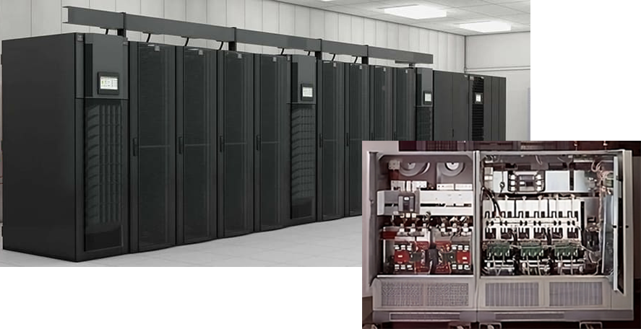

Definitions of Major Preventive Maintenance for UPS System:



Mohsen Abedi P.Eng, PSM.Eng

Technical Consultant | Senior UPS Systems Specialist | Electrical engineering design | Power electronic systems design | Power quality systems & Harmonic filters | BESS Renewables

Major maintenance on UPS (Uninterruptible Power Supply) systems involves more comprehensive and extensive tasks compared to regular maintenance. Major maintenance is typically conducted at longer intervals and is aimed at ensuring the UPS's continued performance and reliability over an extended period. Here are the tasks that need to be performed during major maintenance on UPS systems:
1- Visual Inspection: Conduct a thorough visual inspection of the UPS system, including its components, wiring, and connections. Look for signs of physical damage, loose connections, or overheating.
2- Battery Testing: Test the UPS batteries to assess their health and capacity. This includes checking the voltage, internal resistance, or performing load tests to determine how long the batteries can sustain power during an outage.
3- Cleaning: Dust and debris can accumulate inside the UPS, affecting its cooling efficiency and overall performance. Clean the internal components, cooling fans, and air vents to ensure proper ventilation.
4- Inspection or Replacement of Components: Inspect and Replace any time-out or faulty components, such as capacitors, fans, or damaged circuit boards. Using genuine replacement parts is crucial to maintain the UPS's reliability.
5-Firmware and Software Updates: Check for any firmware or software updates provided by the UPS manufacturer. Keeping the UPS's firmware up-to-date helps address known issues and improve performance.
6- Calibration and Adjustment: Calibrate and adjust the UPS as per the manufacturer's guidelines to ensure accurate function.
7- Environmental Checks: Ensure that the UPS is installed in an appropriate environment with proper temperature and humidity levels. Check for any issues that may arise from the operating environment, such as excessive heat or dust.
8- Load Bank Testing: For larger UPS systems, perform load bank testing to simulate real-world operating conditions and verify that the UPS can handle its rated load.
9- Alarm and Log Checks: Review the UPS system's alarm logs to identify any historical issues or warning messages. Clear any false alarms and address any recurring issues.
10- Remote Monitoring Configuration: If the UPS supports remote monitoring capabilities, configure and test the monitoring system to ensure proper communication and alerts.
11- Review of Operating Parameters: Check and review the UPS system's operating parameters, such as input and output voltage, frequency, and waveform. Verify that the UPS is within acceptable operating limits.
12- Documentation and Reporting: Maintain detailed records of the maintenance activities performed, test results, and any identified issues. These records are useful for future reference and warranty compliance.
13- UPS Bypass Test: Test the UPS's bypass functionality to ensure a seamless transfer of power in case of UPS failure or maintenance.
14- Emergency Shutdown and Restart Tests: Test the emergency shutdown (EPO) and restart procedures to ensure the UPS can respond appropriately during critical situations.
It is crucial to follow the manufacturer's guidelines and recommendations for major maintenance. This level of maintenance often requires specialized skills and tools, so it's best to have the work performed by trained and qualified UPS service professionals. Major maintenance ensures that the UPS continues to provide reliable backup power and safeguards critical equipment during power outages or disturbances.

