

Caught in the Current: What Every Building Operator Must Do When Facing an Electrical Hazard.



Juan Carlos LaGuardia Merchán

Senior Maintenance & Facility Manager | 30+ yrs in pharma, biotech & healthcare | Expert in GMP, HVAC, clean utilities, CMMS, CAPEX/OPEX | Driving uptime, compliance & operational excellence onsite.

In the world of facilities management, few emergencies demand more immediate attention or come with greater risk than electrical hazards. One wrong move can mean injury, fire, or even fatality. Yet, too many building operators are caught off guard when a real threat emerges. Do you know what to do when the lights flicker, the circuit hums, or the acrid smell of burning insulation hits your nostrils? This isn’t theory, it’s your responsibility.
This article explores how seasoned professionals handle electrical emergencies and how you can be just as prepared, calm, and effective when it matters most.

A Real-World Wake-Up Call
Two years ago, in a research facility in central Manchester, a minor water leak from a rooftop chiller found its way into an electrical panel via a ceiling conduit. It happened overnight.
By morning, a facilities technician inspecting a temperature anomaly heard a faint crackling noise behind the panel and saw a slight wisp of smoke. He didn’t panic. Instead, he followed protocol: isolated the panel, triggered the emergency shutdown, alerted the electrical response team, and evacuated the floor.
The potential disaster was neutralised in under 15 minutes. No fire. No injuries. Minimal downtime.
His quick action came not from luck, but training.
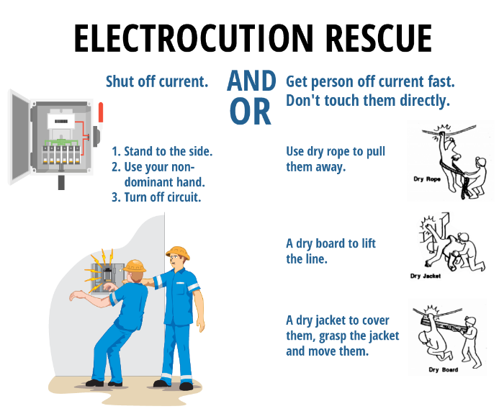

How to Handle an Electrical Hazard – Step by Step
1. Remain Calm and Assess the Risk. Do not rush in. Stay calm. Ask yourself: Is this an active arc? Is there smoke, heat, or sound? Do not touch anything that may be energised. Visual and auditory cues are often the first sign that something is wrong.
2. Isolate the Area Immediately. Keep people away. Secure the zone. Use signage or barriers. Preventing exposure to others is a top priority.
3. Shut Off the Power – If It Is Safe to Do So. If you know the source and can shut off the electricity from a safe, dry, and insulated location (like a main breaker outside the hazard area), do it. Never attempt this if water is involved or if there’s visible arcing.
4. Contact the Right Emergency Services. Activate your internal emergency procedures. Alert your facility’s electrical contractor or in-house qualified electrician. If fire or major damage is involved, call emergency services.
5. Evacuate If Required. Don’t hesitate to evacuate if there’s any indication of fire or potential for explosion. Follow your facility’s fire and life safety protocol.
6. Keep a Log of Events: Time of detection. Observations. Actions taken. This record will be crucial for post-incident reviews and insurance purposes.
7. Initiate Lockout/Tagout Procedures. Once safe, ensure the affected system is locked out and tagged until a certified technician verifies its safety.
8. Conduct a Root Cause Analysis. Every electrical hazard is an opportunity to learn. Was it equipment failure? Moisture ingress? Human error? Identify the cause and prevent recurrence.
9. Review and Update Protocols Ensure that lessons learned translate into updated SOPs, enhanced training, and improved infrastructure.
10. Communicate With Your Team. Transparency builds trust. After the event, debrief your team. Share the incident, the lessons, and the plan going forward.

Why This Matters More Than You Think
Most electrical incidents in buildings are preventable, yet thousands occur annually in the UK alone. Building operators are the first line of defence. It’s not just about preventing property damage; it’s about protecting lives and sustaining critical operations. An untrained or unprepared response can turn a manageable issue into a catastrophe.


The Hidden Dangers You Might Overlook
- Improperly labelled panels
- Wet environments near power sources
- Ageing or uninspected electrical infrastructure
- Overloaded circuits
- Poorly managed third-party contractors
Each of these is a silent threat waiting to become your next emergency.


Investing in Training Saves Lives
Do not wait for your first electrical emergency to become your training session. Invest in:
- Annual electrical hazard awareness training
- Regular emergency response drills
- Documented isolation procedures
- Frequent inspection schedules
Your team’s confidence in handling electrical hazards must match their confidence in routine maintenance.
If you’re a building operator reading this, ask yourself: When was the last time I walked through our emergency electrical response protocol? If your answer is anything other than “within the last three months,” you’re overdue. Schedule a review. Conduct a drill. Talk to your team. Bring your electrical contractor in for a refresher. Don’t wait for the smell of burning plastic to be your wake-up call.

Because in an electrical emergency, being reactive is already too late.

