Facility Managers Guide to Life Safety Emergency Power Standards – Part IV The Quin



Bill Henderson

National Business Development Manager @ T&T Power Group | Business Development

January 12, 2024

Every day, in our business we encounter new generator services and a recurring pattern emerges in the records of these new accounts: the critical quinquennial (5-year) generator service is often overlooked. Frequent staff turnover, poor record keeping and a disruption to the continuity of service are the chief reasons. Numerous maintenance and property managers fail to consider their emergency standby generators until there's a power outage and ...nothing happens.
A proactive manager who regularly services their standby generator can rest assured, knowing a brief wait is all it takes for power restoration. Conversely, managers new to their roles, those frequently switching portfolios, or those dependent on staff or service providers for maintenance reminders must educate themselves on the importance of regular generator servicing.
The quinquennial generator inspection is crucial for identifying and fixing issues that are not apparent during routine annual checks, thereby guaranteeing extended generator operation. The Canadian Standards Association 282-19 stipulates five essential steps for the Quinquennial service:
1) Complete all items specified in weekly, monthly, semi-annual and annual testing requirements. This is a very thorough and meticulous examination and testing of the backup generator where a methodical scope of work needs to be employed, that is, the CSA282 Emergency electrical power supply for buildings. The generator service company will have a report that covers all of the tests and inspections from Table 2 (weekly) to Table 6 (Quin) of the Scope of Work per CSA282-19. (an abbreviated copy is included at the end of this newletter for your convenience.)
Most service companies will conduct the annual service and load test together with the quinquennial service . An experienced generator technician can complete the Annual Service and Load Test for a gen-set up to a 250kW rating in about 4 hours and the Quinquennial Service in another 4 hours for 8 hours in total. As the gen-sets get larger, likely two or more technicians will be required to get the job done in one shift.
2) Removing the alternator's vented plate to inspect the windings visually and with a meggar meter, ensuring the insulation is intact to prevent catastrophic failures due to arcing. Gen-sets work in just about every environment imaginable. Health care facilities, schools, universities, condominiums and government buildings are among the cleanest. While agricultural dryers, machine shops and marine engine rooms are among the dirtiest.
With lots of fly and dust from feed or oil and exhaust contamination hanging in the air. If the gen-set resides in a particularly dirty environment, the alternator should be inspected more frequently than every five years. In a room with high humidity and abundant particulate matter, the amount of soot that sticks to the alternator windings may eventually arc to ground, causing a catastrophic failure resulting in repair costs in the tens of thousands of dollars.
The dirty alternator below needs to be thoroughly cleaned by a technician who knows what they are doing, properly dried for an adequate amount of time and then megger tested to ensure the winding insulaton remains intact. When done properly, this alternator will provide power for years to come.

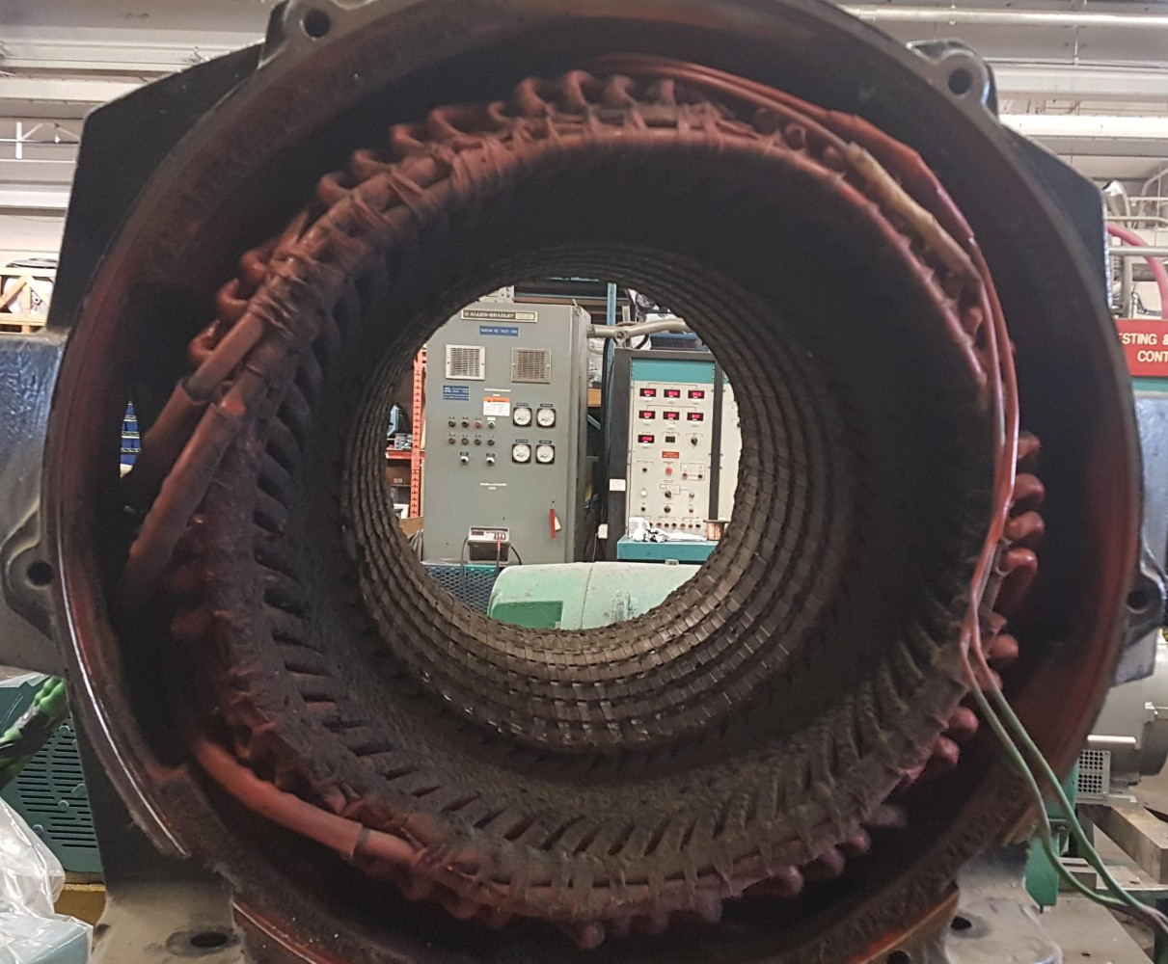

3) Draining the cooling jacket, installing new thermostats, refilling with fresh coolant, cleaning the radiator fins for enhanced cooling efficiency, and adjusting the engine valve clearance to the manufacturer's specifications.
Engine valve clearance on a standby generator with low hours should not take much movement but valve cover gaskets will need to be ordered prior to the quinquennial service. Make sure you order the gaskets even if you think you might be able to get by without them. If some tear, rip or leak after service or soon thereafter, it will be expensive to return to replace as most generator service companies offer one year warranty on parts and labour for service jobs.
Prior to attending the quinquennial service make sure you order the proper thermostats, gaskets and manufacturer recommended coolant. It is not uncommon for larger CAT, Cummins or Mitsubishi engines to require four or more thermostats. Gotta love that Cummins "Blue".
I don't know how the radiator in the photo below kept the gen-set cool for so long before overheating with the sludge in the cooling jacket. We picked up this account several years ago, when the generator alarmed out. Obviously, no monthly checks were done on this standby unit. Simple maintenance can save you thousands in repairs.

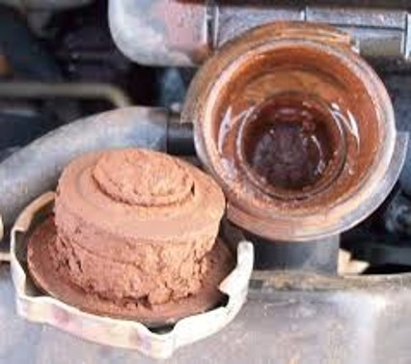

4) Addressing all minor issues and potential non-start deficiencies during the inspection, and providing quotations for any future work.
5) Documenting all inspections, tests, and corrective actions in a logbook kept near the generator, enabling quick review of the generator's maintenance history by any technician.

Be Prepared, Stay Powered: As we wrap up this guide, remember that the key to uninterrupted power and peace of mind lies in the planning and meticulous care of your generators. Regular quinquennial inspections are not just a recommendation; they are your safeguard against the unexpected.

Scope of Work per CSA282-19
