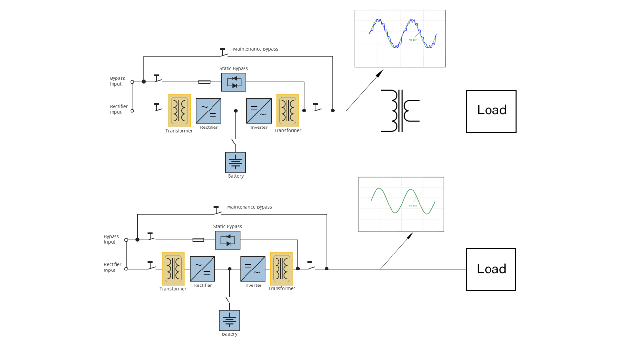

The impacts of an external stepdown transformer on the power quality of UPS systems.



Mohsen Abedi P.Eng, PSM.Eng

Technical Consultant | Senior UPS Systems Specialist | Electrical engineering design | Power electronic systems design | Power quality systems & Harmonic filters | BESS Renewables
August 1, 2024
It is preferred to select a UPS system that matches the load voltage to avoid the need for a step-down transformer, as the transformer can cause output voltage distortion for several reasons:
- Non-Linear Load Effects: Transformers can introduce non-linear characteristics to the load. When the UPS output feeds into a step-down transformer, the transformer's magnetizing current can create harmonics, leading to voltage distortion.
- Inrush Current: When a transformer is energized, it draws a significant inrush current. If the UPS is not designed to handle this inrush current, it can lead to voltage dips or distortion.
- Impedance Mismatch: The impedance of the step-down transformer can differ from what the UPS is designed to modulating PWM signal by internal output LC filter. This mismatch can cause reflections and distortions in the voltage waveform.
- Resonance: Transformers and the UPS might interact in a way that causes resonance at certain frequencies. This resonance can amplify certain harmonics, leading to voltage distortion.
- Load Changes: Sudden changes in the load on the transformer can affect the voltage regulation capabilities of the UPS. If the transformer steps down the voltage for a variable load, this can cause fluctuations in the UPS output voltage.
- Quality of the Transformer: Poor-quality transformers can introduce more losses and distortions. The core material, winding design, and overall construction quality play a significant role in how much distortion is added.
To mitigate these issues, it is important to:
- Ensure the UPS can handle the inrush current of the transformer.
- Use high-quality transformers with recommended K factor and low harmonic distortion.
- Select a UPS system that matches the load voltage to avoid the need for a step-down transformer
- Properly match the transformer impedance with the UPS.
- Implement filtering solutions to reduce harmonics and resonance effects.

