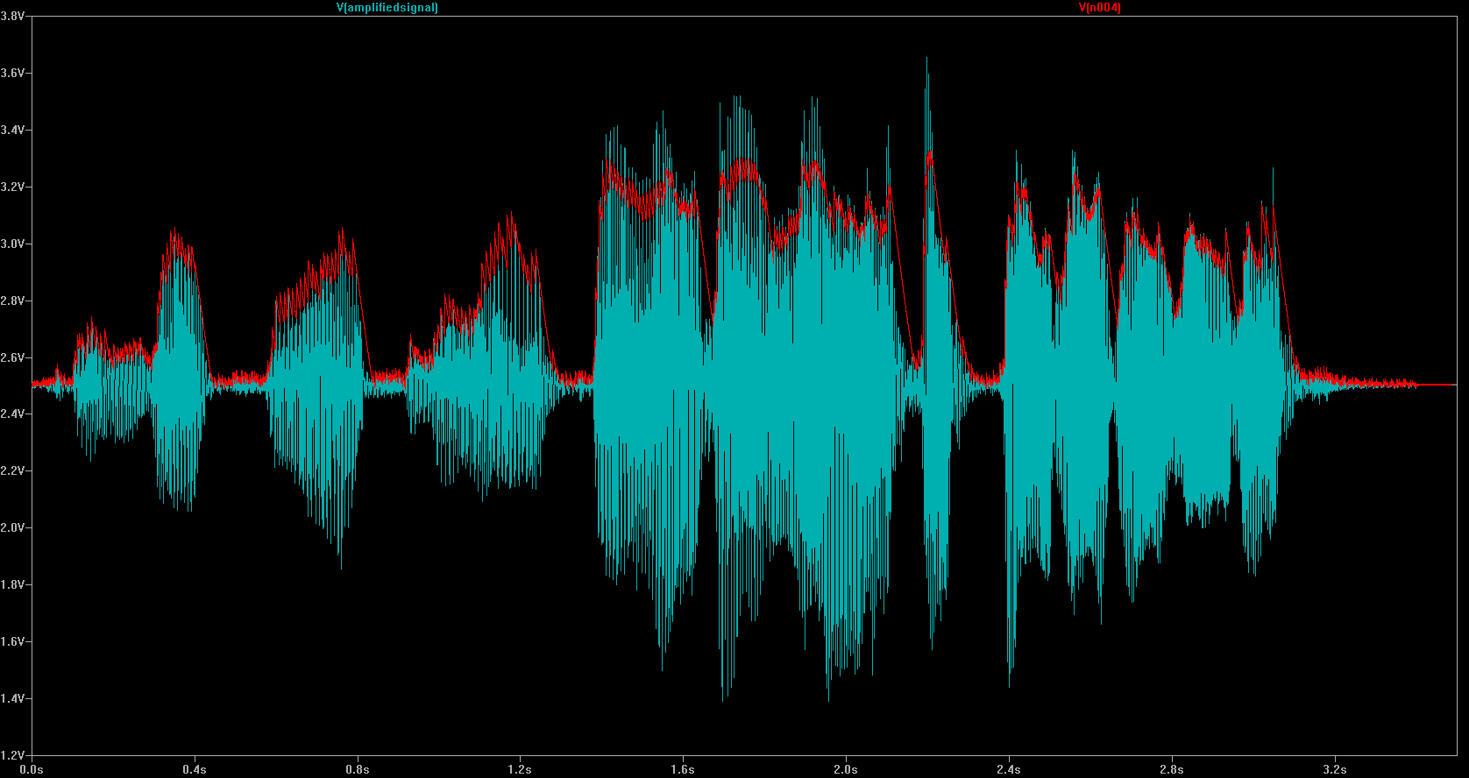

Sounds Good to Me

Tell them this: Hearing PPE is required in an area because there is no other feasible solution to protect them from an already identified, known hazard.
More than 30 million workers are exposed to hazardous noise levels in the workplace. It is estimated that costs just for work-related hearing disability exceed $282 million annually! The National Institute for Occupational Safety and Health reports hearing loss is one of its priority areas for research for this century. Noise-induced hearing loss is the most common way for a person to lose hearing; one out of every 10 suffers a loss of hearing severe enough for it to affect daily conversation and how normal speech is understood.
It is no wonder the Occupational Safety and Health Administration has implemented a hearing conservation standard for employers to follow. Noise exposure at work, though, is not our only exposure. More young people are starting their working careers with significant hearing loss already from noise exposures at home or in the environment. It's sad to think we are causing our children to go deaf through poor choices and high noise exposures even before they get to a legal working age.
What continues to amaze me, however, is that although noise-induced hearing loss is 100 percent preventable, it continues to be such a recurring problem. Why are employees continuing to suffer hearing loss that directly affects their safety, their work, and their quality of life?
Employees don't need to watch the same "plug-n-play" compliance video or listen to you read the hearing conservation standard to them every year. What a snooze!
In general, noise induced-hearing loss is not painful or obvious. Exposures to hazardous noise levels can cause temporary and gradual hearing loss that, with repeated exposure, becomes permanent. It is a silent killer (no pun intended--well, maybe) of nerve cells in the cochlea inside the ear that creates no pain, no visible signs of bleeding, and generally no immediately obvious signs of loss. Hearing does not come back once it is permanently damaged and gone.
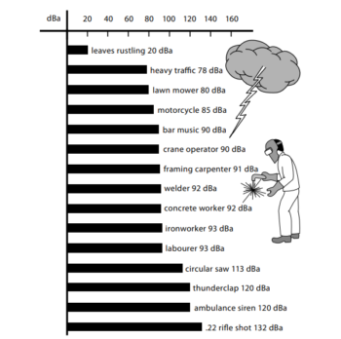

What Can We Do?
In the workplace, start by conducting a hazard assessment related to noise. If you don't have access to dosimeters, purchase a hand-held digital sound meter and carry it around with you. Measure some real-time decibel levels in the work environment and write down what and where the levels are.
Once locations within the work environment are identified with noise levels above 85 dBA (the OSHA and MSHA action level requiring a hearing conservation program), you can begin to explore corrective action to reduce the harmful levels. Regulatory agencies want to see engineering controls used to reduce the noise level at the source whenever feasible. The next step involves administrative controls, such as rotating people mid-shift to cut exposure times. When engineering and administrative controls are not enough to eliminate the hazard, personal protective equipment is used as a last resort.
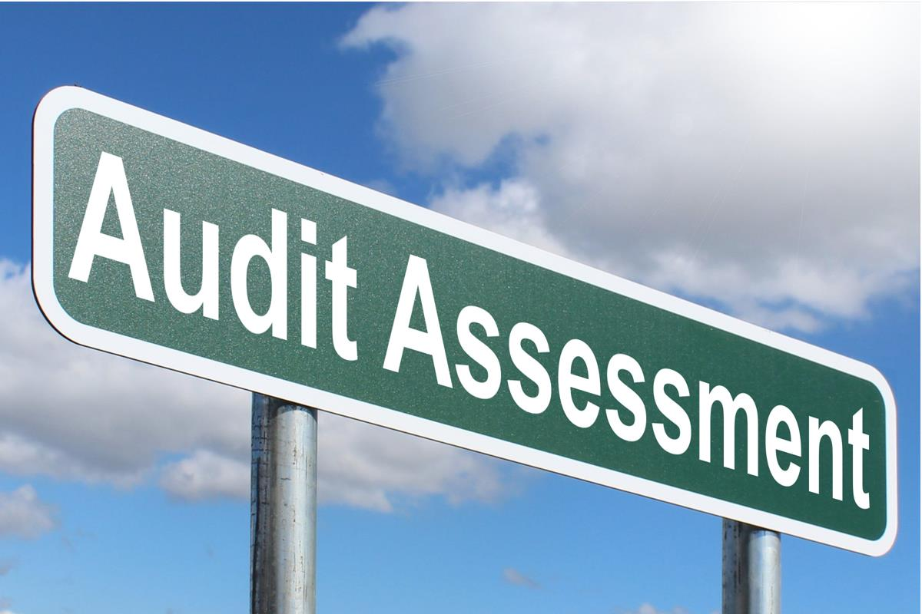

Training and Education
When training on the subject of hearing protection, I tell managers and employees the reason hearing protection is required in an area is because there is no other feasible solution to protect them from an already identified, known hazard. Hearing protection is required because there is no other means of protection. Failure to wear the protection guarantees hearing loss because all other feasible attempts to reduce the hazardous levels have been done.
This helps drive the point that there is exposure to a hazard that cannot be addressed by any other means. When they choose to not wear the protection, they are consciously exposing themselves to a known hazard and are taking risks that can reduce the quality of their lives permanently over time.
From there, I can begin sharing what some of the real-world decibel level readings were in and around the work environment. I use examples of decibel levels from outside of work, as well, to provide comparisons, such as gas lawn mowers, chain saws, weed eaters, leaf blowers, and other equipment that would be familiar to my employees.
Employees don't need to watch the same "plug-n-play" compliance video or listen to you read the hearing conservation standard to them every year. What a snooze! They do need to understand some basic hearing protection concepts and how hearing loss can occur. I had an employee tell me he didn't need to wear ear plugs any more because he was getting used to the noise. Unlike your body's ability to adapt to changes in heat and cold, you cannot "toughen up" your ears. Your ears do not adapt to noise. You simply begin to go deaf.
Training and education in home-related exposures is as important as those at work. Employees need to know they should protect their hearing regardless of where they are.
My experience in working with managers and safety professionals shows that we often have missed some wonderful opportunities by taking the wrong approach in our training and accountability with our employees. For example, telling an employee to wear hearing protection while you are not wearing hearing protection is just being stupid. Some managers seem to think they have only to tell others what to do without the need to follow their own instructions. You have to play by the same rules you give your people. If that means wearing ear plugs when you walk through the shop, wear them. What your employees see you do is what they will do.
Next, once you are setting the example, hold your people to the same standard. Take a few minutes during each shift to observe people's performance. Make a conscious effort to see they are wearing the appropriate PPE for the tasks they perform. Have a handful of ear plugs in your pocket and, when necessary, personally hand an employee ear plugs and wait for him to insert them properly. This communicates to the employee your expectation, backed by the importance of the message.
Hearing protection comes in various designs, sizes, and formats. There is no "one size fits all" for every work environment. Talk with your managers and employees and make every effort to get the right protector for the right task matched to the right person. For example, I wore ear plugs for years but developed a problem with wax build-up from "cramming" plugs into my ears and wearing them for 12-hour shifts. Once the doctor cleaned them out, I began using ear muffs and have not had a repeat problem. Some employees develop rashes or react to certain plug types. Others may develop discomfort and rashes from wearing muffs in a hot and humid environment. Size does matter for ear plugs to match ear canals, for both protection and comfort.
Administrative Requirements
Audiograms (hearing tests) are required when employees are exposed to decibel levels above 85 dBA. A baseline hearing test that is conducted by a licensed or certified audiologist is required and should be provided soon after an employee is hired or once he/she is assigned to a work area where exposure to noise is a problem. This lets the employee and you know whether there is already hearing loss prior to work exposures at your facility. It also gives you an opportunity to help the employee conserve and protect what hearing he or she has.
After the baseline test, annual tests are required. When the annual test comes due, explain to your employees the benefit of taking the test, as it measures current hearing levels compared to original hearing levels. Share with them that change in hearing does not necessarily mean it is work-related. If you have a good conservation program at work with employee participation, you shouldn't see an adverse change that would reflect a working condition. This is why training and education in home-related exposures is as important as those at work: Employees need to know that protecting their hearing regardless of where they are is important to keeping their hearing and their quality of life as they get older.
Of course, no program is complete without recordkeeping requirements. Training records, audiogram results, hazard assessment results--all of these must be retained and properly documented, not just to comply, but also to help you improve and measure your hearing protection program.
Additional Resources
If you need help with your hearing conservation program or training, there are plenty of solid resources you can tap. Check with your worker's compensation insurance carrier or your liability carrier for information. Invite your local audiologist to provide material or conduct a training session for you. Contact your PPE supplier or a manufacturer's representative for videos, newsletter materials, or guest appearance at one of your training programs.
Your occupational physicians can be utilized for material and asked to help you conduct a health fair that includes hearing protection. Other sources may include trade associations, Web searches for pertinent articles and illustrations, and your local library. For additional compliance and training assistance, search the OSHA and MSHA Web sites, as well as that of NIOSH.
You don't have to reinvent the wheel when it comes to hearing protection materials and programs. You do have to keep your managers and employees engaged in the process. Your goal is not simply compliance, but hearing protection that will ensure on- and off-the-job protection.

