

The Hidden Cost of Silence: Why Neglecting Energy Preventive Maintenance is Draining Your Building and Your Budget



Juan Carlos LaGuardia Merchán

Senior Maintenance & Facility Manager | 30+ yrs in pharma, biotech & healthcare | Expert in GMP, HVAC, clean utilities, CMMS, CAPEX/OPEX | Driving uptime, compliance & operational excellence onsite.

Walk into any corporate office, hospital, or data centre, and you’ll see lights on, air handling systems humming, and screens flickering with metrics. Everything appears functional. But is it optimal? More often than not, the answer is a reluctant no.
Buildings are energy-hungry organisms. However, what we often forget is that energy is not just about kilowatts; it's about decisions. It's about how systems are maintained, how data is interpreted, and how proactively we act.
Having worked across critical environments, from biotech labs to financial hubs, I've come to a sobering realisation: our maintenance culture is reactive when it should be strategic. And nowhere is that more evident than in the way we manage energy.

The Hidden Truth About Energy Maintenance
Energy inefficiencies rarely shout. They whisper, persistently, and expensively.
Consider a simple air-handling unit in a university laboratory. It’s working, yes. But no one has recalibrated its sensors in three years. The filters are changed only when visibly dirty. The control logic hasn’t been reviewed since commissioning. What does that mean?
- The unit might be cooling and heating at the same time.
- It may be operating at full capacity when only 40% is needed.
- It could be consuming 20–30% more energy than it should, every single day.
This is not an exception; it’s the norm in many sites.

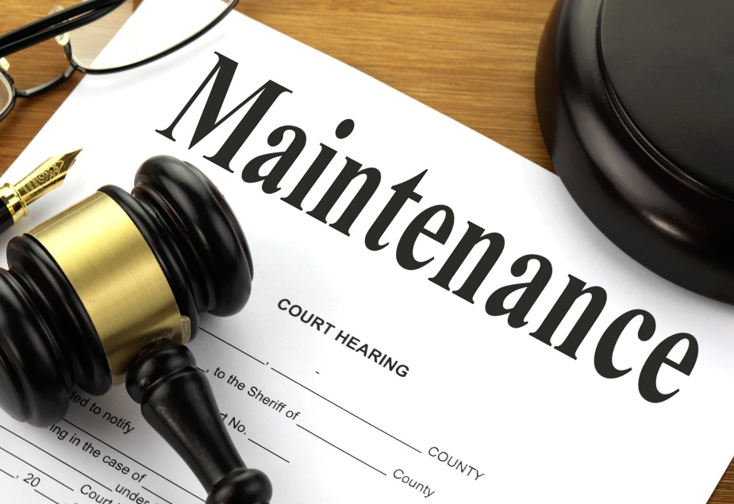

Why Preventive Energy Maintenance Falls Through the Cracks
Facility managers and building operators are not indifferent. We're overtasked. Firefighting, compliance, tenant demands, budget constraints, it’s endless. Energy optimisation becomes a “nice-to-have,” especially when systems appear to be running.
But there are deeper issues:
- Lack of visibility: Without real-time energy monitoring, inefficiencies remain invisible.
- Fragmented contracts: Vendors maintain their systems in silos, with no one looking at the holistic energy performance.
- Misaligned KPIs: Many teams are judged on uptime and tenant satisfaction, not energy efficiency.
- Deferred maintenance culture: If it’s not broken, don’t fix it. Except... energy waste doesn’t look broken. It looks normal.
And so, money bleeds out silently.

A Consultant’s Lens: Stories from the Field
Let me share a real case.
A regional hospital in southern England was spending nearly £500,000 annually on electricity. I was brought in to advise on HVAC performance. Through thermal imaging, BMS log reviews, and physical inspections, we discovered:
- Several VAV boxes were stuck open, flooding spaces with cold air unnecessarily.
- Chillers were short-cycling due to a poorly tuned control loop.
- Nighttime setpoints had not been reduced in years.
Total investment in recalibrations, control updates, and staff training? £16,000.
Annual savings post-optimisation? £84,000.
Another example: A data centre that thought they were running lean. My team installed a temporary energy monitoring kit. It revealed that several server room CRAC units were fighting each other, one cooling, the other reheating. That site is now saving £113,000 per year after we reprogrammed the coordination logic.
This isn’t about big spend. It’s about big awareness.

From Passive to Proactive: How to Change the Game
Here’s what I recommend to facility professionals who want to turn the tide:

1. Conduct a Tactical Energy Audit, Not a Cosmetic One
Go beyond utility bills. Focus on system behaviours:
- Check operating schedules.
- Investigate simultaneous heating and cooling.
- Review control sequences with a critical eye.
- Include operators in walkthroughs, they often know where the ghosts are.
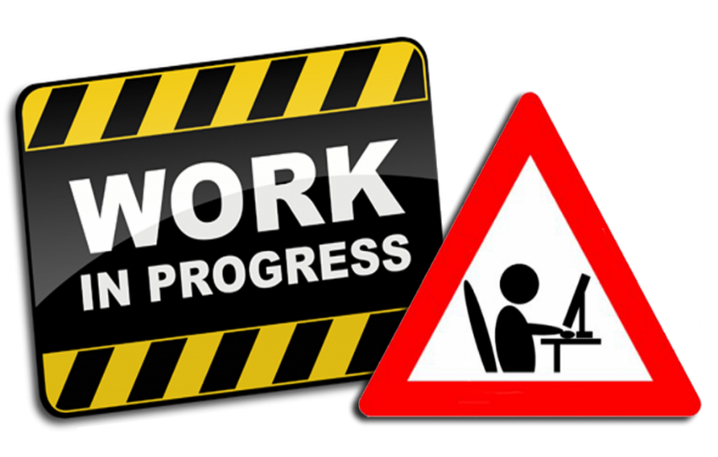

2. Map a Preventive Energy Maintenance Plan
Don’t just list assets. Build routines based on energy impact:
- Motors and drives: Vibration, belt tension, and airflow alignment.
- Boilers: Flue gas analysis, burner tuning.
- AHUs: Damper calibration, control logic testing.
- Lighting systems: Occupancy sensor testing, daylight harvesting recalibration.
This is not just “maintenance,” it’s energy defence.

3. Train Technicians to Think in Kilowatts
Many good techs don’t know the cost of a misbehaving pump or misaligned VFD. Include energy awareness in toolbox talks. Show them real numbers. Make energy savings part of your internal success metrics.

4. Use Temporary Metering Tools
Can’t afford a permanent monitoring system? Use portable loggers for two weeks. Compare input/output trends. You’d be shocked at what you'll find.

5. Create Accountability with Energy KPIs
Include energy use per square metre or occupant in monthly reports. Start with trend lines. No need for perfection, consistency reveals the story.

The Emotional Cost: More Than Just Money
We talk about costs in pounds and pence. But the emotional cost of poor maintenance is just as damaging:
- Tenants who complain about inconsistent temperatures grow disengaged.
- Engineers are frustrated by constantly reacting instead of solving.
- Directors are losing faith because they only see rising bills and vague explanations.
An energy-efficient building is not just “green”; it’s a place of confidence. It radiates competence, calm, and control, and that feeling is infectious.

The Long Game: Operational Resilience
In times of economic tightening, preventive maintenance is often the first cut. However, that’s precisely when it’s most needed. Energy inflation, environmental scrutiny, and supply chain delays all render reactive strategies more dangerous.
Your building is your patient. Would you skip regular check-ups simply because there’s no pain today?
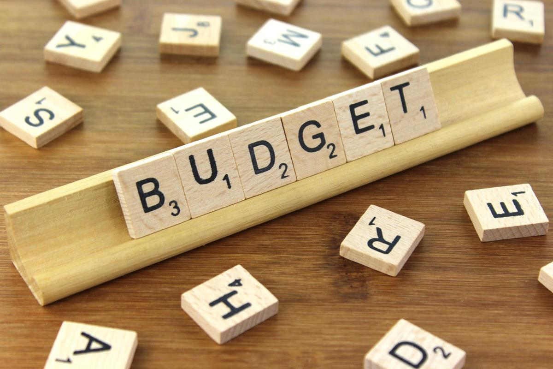

When Budget Is the Barrier: How to Make a Difference Still
Here’s what I’ve advised in resource-constrained settings:
- Prioritise the top 10 energy-consuming assets and schedule preventive checks quarterly.
- Bundle energy checks with regular maintenance, no extra labour cost.
- Negotiate performance-based contracts with vendors (e.g., bonuses for reducing energy by 10%).
- Leverage utility provider schemes, many offer free or subsidised audits.
- Engage the finance team differently: Present projects as ROI, not cost.
Example: We replaced a faulty damper actuator (£380) and recovered the cost in 18 days through reduced overcooling. Finance loves that kind of language.

It’s Not About Being Perfect, It’s About Being Accountable
Preventive energy maintenance doesn’t need a glamorous budget or a six-month strategy. It needs attention, intention, and ownership. It’s the difference between being a building operator and being a building leader.
If you’re a facility manager reading this, I encourage you not to wait for permission. Start small. Prove value. Document wins. Build trust. The rest will follow.
We’re not just maintaining assets, we’re stewards of operational integrity, financial discipline, and environmental responsibility.
If you’re facing rising energy costs and feel your preventive strategy isn’t delivering value, I’m here to help. As a consultant, I offer real-world solutions tailored to your building, your team, and your budget. Let’s stop energy waste before it becomes your next crisis.

