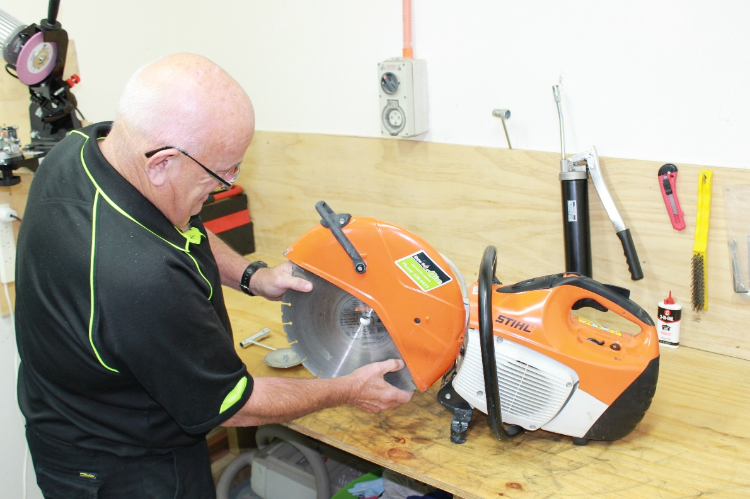
Power Tools: Taking Safety in Hand

Many of the same strategies designed to enhance safety also can help departments operate more productively
Maintenance workers spend a large percentage of their productive work time using power tools. Saws, drills, hammer drills and screwdrivers have become bulwarks of institutional and commercial maintenance. In many cases, workers continue to use tools — both power tools and hand tools — unsafely and unproductively. Often, many of the same tactics that address tool safety also can produce increased efficiency. Managers who keep both of these issues in mind are likely to have a much better chance to bring cost-effectiveness to their departments and facilities.
Productivity
Power tools generally require more setup than hand tools. They are all of the electric, electronic or hydraulic variety and, therefore, need an electric power source, batteries, air supply or hydraulic system interconnection. Their setup time is offset by greater capability or higher speed of use, compared to hand tools.
Since these tools are often rated in terms of horsepower, they can do a lot of work very quickly, but herein lies the problem that causes low productivity associated with potentially high-productivity power tools. They get dirtier and dull more quickly than their manual counterparts.
Productive maintenance shops plan for these situations. Workers have a tool room where they can check tools after each use and clean and lubricate them, if needed. They also can sharpen tooling such as bits for drills, jackhammers and impact hammers.
If a department can’t justify hiring a full-time or part-time tool maker, managers might want to give each worker, after proper training, tool repair and cleaning work in between other maintenance work.
Such assignments can be a very effective cost trade-off. A few minutes of tool maintenance can eliminate many hours of wasted time and tiring extra effort needed to work with dull or ineffective power tools. Any laborer who has tried to break concrete with a jackhammer that leaks air and has a dull point, or any carpenter who has tried using a power saw that sticks in the board because the teeth need to be reset, will attest to the wasted energy and time that result.
Managers also can enhance worker productivity by incorporating and combining appropriate products that help workers move tools and materials between job sites. These products should include: tools belts; walking tool carts; three-wheel bikes with front or rear containers; pickup trucks fitted with tool boxes and material racks; radio-dispatched van workshops; electric-gas carts and fork and lift trucks.
Specification and selection
Selecting the right power tools is essential for ensuring safe and productive power tools use. Managers might consider the following insights when selecting and specifying power tools.
Use ratchet wrenches when possible in place of adjustable wrenches. Besides being faster to setup, ratchet wrenches are easier and faster to tighten or loosen fasteners with.
Use a power wrench rather than a manual wrench where a high volume of fasteners or long threads are used, such as the lug nuts on a vehicle wheel, split-casing pumps or pressure-vessel heads.
Use cordless screwdrivers and wrenches rather than the corded version to reduce setup time. Workers won’t have to take extension cords to the job site, find a power source, or keep the cord out of the way while working.
Use carbide rather than high-speed steel drills and cutting tools. Carbide removes metal two to three times faster than other materials. Use carbide masonry drills on brick, block and concrete.
Use drill sharpeners that can be preset to the proper tip angle, rather than grinding drill bits on a wheel by hand. Tool geometry has too great an impact on metal-removal rate to leave it to either guesswork or chance.
Use quick-acting clamps or vises rather than the knob-and- screw type. They are at least four to five times faster to use.
Mark all feeds and speeds clearly in shops with several different drills, mills, lathes and shapers. Designate primary- and secondary-use machines, depending on their relative productivity. The most productive machine tools should always be fully loaded with work before using less productive ones. Check feeds and speeds to ensure they are right for the job.
Use abrasive cutoff machines rather than bandsaws or hacksaws to cut materials such as pipe, tubing, bar stock, angle and flat steel, and other structural materials. Abrasive cutoff machines can do in seconds what it takes other saws several minutes to accomplish.
Ask vendors for a good selection chart for matching proper belt or wheel grits and bonders with the application. All maintenance shops do a lot of grinding to repair tools. Dress wheels often enough to refresh the surface and prevent metal particles from filling in the cavities in the wheel.
Establish a company policy regarding tools, both those that the worker supplies and those the company supplies. Keep cutting tools and pneumatic hammer bits sharp. Use a gang saw with a carbide-tipped blade, rather than a single high-speed steel blade, when ripping large volumes of wood.
Use a pneumatic nailer rather than a manual one for heavy, rough carpentry work, such as skid or box making that requires a great deal of nailing. Use a heavy table at work height rather than the floor as a work surface.
Tool safety checklist
Safety starts with regular checks of tool condition and use. Training materials should cover the following points:
- Are employees made aware of the hazards caused by faulty or improperly used tools?
- Are appropriate personal protective equipment, such as safety glasses and face shields, used with power tools or equipment that might produce flying materials or be subject to breakage?
- Are tool cutting edges kept sharp so the tool will move smoothly without binding or skipping?
- Are tools stored in a dry, secure location where they won’t be tampered with?
- Are grinders, saws and similar pieces of equipment fitted with appropriate safety guards?
- Are power tools used with the correct shield, guard or attachment as recommended by the manufacturer?
- Are portable circular saws equipped with guards above and below the base shoe?
- Are circular saw guards checked to assure that they are not wedged up, leaving the lower portion of the blade unguarded?
- Are rotating or moving parts of equipment guarded to prevent physical contacts?
- Are all cord-connected electrically operated tools and equipment effectively grounded or of the approved double-insulated type?
- Are effective guards in place over belts, pulleys, chains and sprockets on equipment such as air compressors?
- Are portable fans provided with full guards and screens over openings of 1/2 inch or less?
- Is hoisting equipment available and used for lifting heavy objects?
- Are hoist ratings and characteristics appropriate for the task?
- Are ground-fault circuit interruptors provided on all temporary electrical 15- and 20-amp circuits that are used in construction?
- Are pneumatic and hydraulic hoses on power-operated tools checked regularly for deterioration or damage?
- Are employees who operate powder-actuated tools trained in their use? Do they carry a valid operators card?
- Is each powder-actuated tool stored in its own locked container when not in use?

