Evolution of the Building Systems MSI



Brian Turner

CEO @ Buildings IOT | LEED AP, Automation

April 12, 2023

Buckle in. This is going to cover a lot. It will seem like I am going off topic, and in some ways, I am, intentionally. This is not a chatbot driven article with a ton of referenced research support these opinions. Rather, I am sharing my insights based on 25 years in this industry that has given me so much. The disruption to the short term economic uncertainty of a lot of the built environment is very real, but there are plenty of opportunities as well. The tumultuous market we have experienced since 2020 has exposed so many things that were easy to ignore or dismiss when times were great. It seems as though Black Swan events do that once in a while, so let's dive in.
The acronym MSI carries so many definitions in the building systems market today that it is difficult to have any expectation of what to expect from an MSI. The fact is that the role of an MSI in the building systems has evolved so much over the last 20 years, that it has become largely unrecognizable, even to the organizations who consider themselves to be MSIs. Strange, but true.

Definitions are key to understanding
At the most basic level, the MSI (Master Systems Integrator) is the company who will design and integrate building systems into a common network, database, IDL (Independent Data Layer), workflow, and/or user experience. Sounds simple enough until you stat to unpack each of these and follow the rabbit hole that each will take you down. Understanding the why, what, and how for each system is extremely important when deciding what data is required, how it is integrated, managed, and utilized. The MSI will continue to engage with the client over the life of the building to continue the evolution of the what it means to operate a smart building. Too much, too soon? Let's take a step back in the evolution...

Controls Contractors and Controls System Integrators
The Building Systems MSI has evolved from HVAC controls contractors, who are also commonly referred to as system integrators. This term was updated when it become practice to integrate communication protocols like Lonworks, BACnet, Modbus, OPC, and others into a common platform. Tridium launched in 1998 and quickly simplified what had been a highly complex exercise. It also allowed for controls contractors of various size and skill levels to characterize themselves as System Integrators. The most common systems to be integrated into a common platform, like the Niagara Framework™ by Tridium, since 1998 are HVAC controls, energy metering, and lighting controls. They are not necessarily concerned with the Why for any specific project as it is typically specified in the project documents. They are there to install the systems contracted and move on, ideally with an annual service contract to maintain the installed systems.
There are other contractors in the building vying for the MSI role as well. The list of possible MSIs includes the lighting controls contractors, access control and security contractors, IT contractors, electrical contractors, irrigation contractors, plumbing contractors, etc. I like to refer to these different contractors generically as Building System Contractors (BSC). Each of them is installing a system that may of may not have data that is interesting to the use case the owner or operator is interested in. Most modern systems in each of these categories include intelligent devices that can deliver data, will sit on a network, and must be managed.
The motivations for the Master System Integrator and Building System Contractor are wildly different.

Obvious truths are sometime difficult to acknowledge and challenging to accept.
What happens next is where a lot of the confusion starts to take shape. The creation of the Internet of Things (IoT). This new paradigm created IoT solutions for every industry that turned sensors into systems and pushed internet connectivity to edge. The thirst for data became the leading reason "why" which ultimately drove a need for another level of provider. But let's not get ahead of ourselves. The desire for data has exposed so many other questions and concerns that need to be addressed. Some of the questions to be answered:
- How do we secure our data?
- What is the network architecture?
- Who will manage the network(s)
- Are the building systems operating properly?
- Do we have accurate energy meter data?
- Who are the service providers? What is their skillset?
- Independent Data (Access) Layer ... What is that?
- Many...many more
The quick answer was to develop a new acronym for the system integrators with the skill level and interest in connecting these new sensor clouds, that used to be part of a higher level system, into the building management system. The protocols required started to look more like APIs rather than field bus protocols that are so common in building systems. Although this network change caused some angst, the delivered outcomes are still very much the same as they have been for more than 20 years. In an effort to further distance this new role from the system integrator, many added expertise in IT and networking. New products were introduced to the market to make it easier for non-IT contractors to install and manage these new OT networks. And now, we have the first definition of the MSI for building systems. This has caused another budding conflict with cyber-security, network security, network ownership, network design that is best left for another day.
There is real value in Building System Contractors and Master System Integrators. It is extremely RARE that the two competencies exist in the same organization, especially amongst many disciplines.
Let's start by taking a look in the advancing technology in the building systems. Each domain specific building system is increasingly more intelligent. Analytics are running at the edge. Communication amongst devices is increasingly peer to peer and decisions are being made without the need of supervisory controllers. The systems also are being designed to be good citizens in the emerging architectures for connected grid solutions and enterprise applications. The expertise required to be employed by the BSC to implement these new solutions is far greater than it was just a few years ago. The expertise to maintain each of these systems generally requires manufacturer specific knowledge as well as specific domain knowledge. We are witnessing increased complexity and required depth of knowledge as we pursue improved overall building performance.
The MSI is also being challenged to step into a new world of complexity as well, though the path is much less clear. Many requests are first time requests, or have been executed sparingly in the market such that there is no obvious or well-traveled path to a repeatable solution. Many of the solutions are provided case by case, which is not scalable for any business, much less an entire industry.
Now, let's take a look at the evolution of the use cases being requested from building owners and operators.
- Allow tenants to specify temperature and lighting preferences for conference room booking.
- Combine the utility data with near-real-time occupancy and comfort data to ensure we are not over-conditioning, or under-conditioning, a space.
- Integrate near-real-time data in each building system with the corporate asset management system, ensuring the corporate asset management system is the source of truth for all meta data and asset information.

MSI teams are different than BSC teams
I could go on and on, but I think this starts to illustrate a bit of the expertise required for the MSI, but not necessarily for the BSC. The MSI is expected to combine some aspects of consulting, cyber-security, software development, data management, user experience, system integration, platform deployment, building performance, grid connectivity, business system integration as well as interacting with IT and business operations on security, privacy and work flows. In many projects, the role of the MSI is being executed by a team of experts, many times from different companies to deliver the desired results. The expertise require is multi-disciplinary and requires in depth knowledge in several of these disciplines.

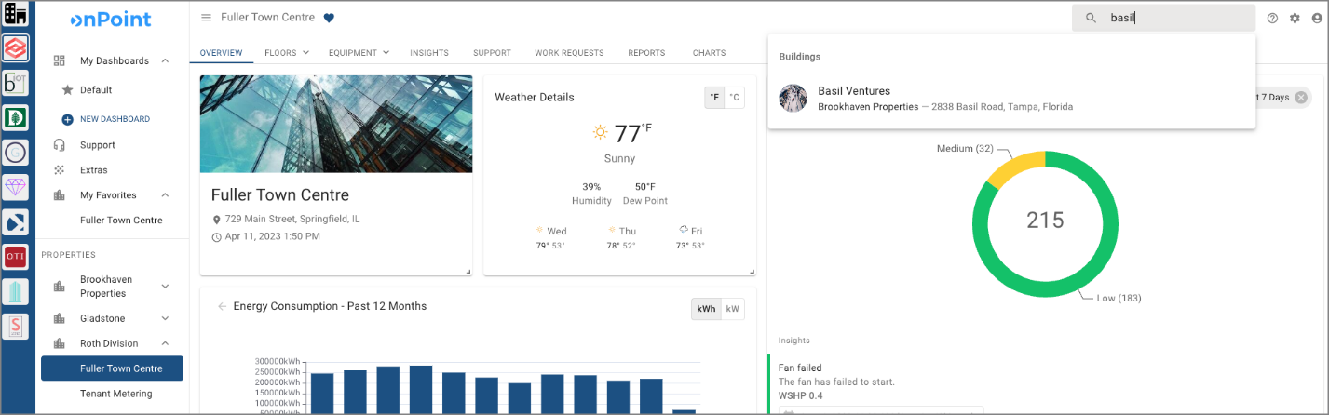
Integrated tools that become part of the daily workflow for users is critical to success.
The MSI is also expected to deliver and deploy one or more platforms to solve the variety of use cases for the client. In many cases today, the MSI is the creator of at least one of the platforms being delivered, but this is not a requirement of an MSI. This is the case much of the time today given the adoption stage of the industry as a whole, but it is expected the number of platforms will reduce over the next several years and the number of MSIs will increase. The platforms are evolving as well, and the use cases that create the most value for users of the platforms are driving the innovation and roadmaps of the platform companies.
Gaining a clear understanding of the user profile is important to the overall success of the MSI. There are many potential users of the platforms being deployed, and many of them do not cross over in skillset. For example, the energy manager has different goals than the mechanical service provider and the Regional VP is focused on well informed reporting, but is not necessarily interested in the minutia of the systems creating the data. Many times, the eventual stakeholders that will determine the overall success of the platform deployment are not part of the decisions making or selection process. You read that right...stated differently: many of the users of the platform are not in the room when the decision is made. This can work out well, but can also lead to internal conflict and underutilization of the platform post deployment.
Not all platforms are created equal and every platform is not necessarily a fit for your building or portfolio. In some cases, it may make sense to have multiple platforms in the portfolio working together to achieve the corporate goals. It is easy to see the obvious alignment between platforms like Measurable, Planon, and onPoint, but it may be less obvious to see Clockworks and onPoint in the same building or portfolio. The truth is that each building, campus, or portfolio will have its own journey and will make use of multiple tools. Technology is not slowing down for us to pause and reflect for very long. We will start seeing language user interfaces (LUI) enter the smart building space very soon and we will need to be ready to deploy LUI based solutions consistent with the cyber-security, privacy, safety, efficiency, comfort, and ESG performance policies that form the foundations of success today.
The right team of Smart Building Consultant, Master System Integrator, and Building System Contractors will create the best overall chance for success.


Redefining the Return on Investment
Changing the conversation again...we start to explore the desired outcomes which are moving from energy savings to ESG performance. Sometimes these two are aligned, but in many cases, these two things are in direct conflict. The return on investment is morphing into a different kind of return, which is not always easy to track directly to the bottom line. We have often spoken internally about adding a dial to give the operator the ability to control buildings systems based on priority ranging from human comfort, safety and security, energy efficiency, and ESG performance. There can also be a balanced approach, but each of these will have an impact on the financial ROI. This topic is again, for another day, but it is key to getting the conversation moved to action.

Published by

Brian TurnerBrian Turner
CEO @ Buildings IOT | LEED AP, AutomationCEO @ Buildings IOT | LEED AP, Automation
Published • 11mo

