5 Fire Safety Tips for High-Rise Condominium Owners & Managers... for a Happy and Fire-Safe Holiday Season!
- Published on December 19, 2019
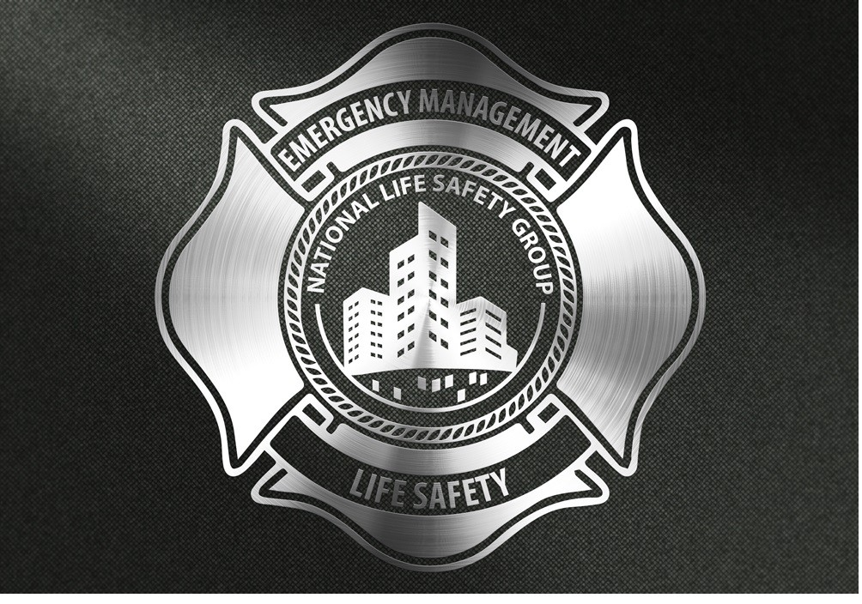

Status is online

Jason Reid

Senior Advisor; Fire & Emergency Management; High-Rise, Commercial, Mission Critical, Residential & Mass Assembly.
Excited to share the following high-rise "Condo" Fire Safety Tips for a happy and fire-safe holiday season.
Condo Fire Safety TIP #1:
Resident fire safety depends on the right decision in the event the fire alarm sounds in your building. Residents need to understand the systems installed in their building, uniquely designed to protect them, how they work, whats their limitations, and objectives, and further, that their decision to go or stay in their suite during a fire alarm is theirs. It’s the building Owner’s (property manager) job to ensure these building systems are maintained as required, and the occupants are given the knowledge to make an informed decision to stay or go. Residents need to understand the building’s approved emergency procedures, and what gives them their best chances of surviving a fire emergency in their unique building
This resident understanding is vital ! Resident safety also depends on the actions of building management - and other residents. As the calendar year ends and 2020 approaches, ensure you have communicated a reminder to the residents of their roles and responsibilities during a fire emergency. This is typically done through information sessions delivered by a specialist, or by simply providing occupants with copies of the building’s "approved" fire safety plan procedures. The best practice in Ontario - Do both at the same time every year !

Condo Fire Safety TIP #2:
Both building Management and residents are to never hang holiday decorations from sprinkler heads / pipes, or in a manner that would impede their intended use. Choose decorations that are flame-retardant, non-combustible and non-conductive. Use the proper lights for the environment. Indoor light strings/sets should not be used outdoors because they lack weatherproof connections. Some outdoor light strings/sets burn too hot for indoors. Inspect light strings/set before use. Check for cracked bulbs and for frayed, broken or exposed wires, and discard if faulty.

Condo Fire Safety TIP #3:
Does your onsite security / concierge program enhance your building’s emergency preparedness? Make routine security checks a part of your building’s emergency management program. Ensure your security officer conducting patrols within your building is tasked with identifying unusually cold rooms during routine patrols. Identifying these rooms in the fall, more than often allows property managers an opportunity to address frozen pipes, false alarms, temperature complaints, and HVAC concerns in advance of these issues becoming an emergency. An example of these rooms includes sprinkler rooms, electrical rooms, generator rooms, fuel storage rooms, and mechanical / electrical rooms and parking garages. Did you know that during winter months building staff must be documenting Sprinkler Room Checks on a daily basis?

Condo Fire Safety TIP #4:
In addition to number three above, exterior building security patrols are an excellent opportunity to provide enhanced benefits to building security / safety. I would expect my security patrol program to actively identify concerns in advance, such as pooling water that may turn into ice at the side of a building, trip hazards in the walkway, and even “leaf” building up over top of storm drains in the parking lot. Identifying these areas of potential concern, coupled with swift action leads to the elimination of common emergencies in your building. Your guard has a direct impact on your condo's bottom line.

Condo Fire Safety TIP #5:
Digitize your building’s fire safety plan – reduce costs and digitally track code compliance!
Over 190 resilient building managers here in Ontario have implemented “digital fire safety plans,” allowing their building staff to rapidly access building floor plans and isolation valve locations in under 3 seconds - saving time, and money. Your building can be digitized in under 2 hours, and all of the building staff can digitally track their code compliance – allowing building owners to know their true fire code status 24 hours per day. Digital fire safety plans can also be provided to the fire department on the way to the building! 6 Minutes faster than any other building in Canada.

Published by

Status is online

Jason Reid
Senior Advisor; Fire & Emergency Management; High-Rise, Commercial, Mission Critical, Residential & Mass Assembly.

