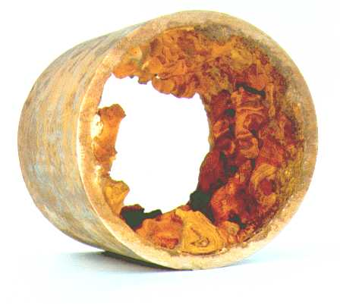

Corrosion Types and Prevention:
-Corrosion Types and Prevention:- Corrosion is the process of eating up away of metal surface by the action of the surrounding. Rusting of iron, tarnishing of sliver jewellery, formation of green film on the surface of copper etc. are some of the common examples of corrosion which we come across in daily life.

Type of Corrosion:
- Chemical or dry corrosion
- Electrochemical or wet corrosion

1. Chemical or Dry Corrosion:
This type of corrosion due to direct attack by the atmospheric gases like oxygen, carbon dioxide, chlorine, sulphur dioxide, hydrogen sulphide etc. on the surface of metal when metal or Suface is kept exposed in the atmosphere for a long time.

A) Oxidation Corrosion (Corrosion by O₂):
Oxidation corrosion occurs due to attack oxygen on the metal surface, usually in the absence of moisture. All the metals except noble metal (Ag, Au & Pt) are attacked by oxygen to some extent with the formation of oxide on the surface of metal.
Metal + O₂ → Metal oxide
2M + x.O2 → M₂Ox

B) Corrosion due to other Gases:
other gases like SO₂, CL₂, and H2S etc also cause corrosion to some extent depending upon the nature of corrosion product.
2AG + Cl₂ → 2AGCl

2. Electrochemical corrosion or Wet Corrosion:
This type of corrosion occurs when the metal is in contact with moist air or Kept dipped in some aqueous medium. Tiny voltaic cells or galvanic cells are set up between two dissimilar metals or between dissimilar parts of the same metal. The metal (more active metal) surrounded by an aqueous medium or moisture has a tendency to pass into solution as metal ions.
M → M^{n+}+ ne–
An equal number of electrons are produced at the surface of metal. The positively charged metal ion combines with negative electrons at the same rate at which they are formed. Equilibrium is thus reached and further reaction stops. The moisture or aqueous medium acts as an electrolyte. Thus, the impure metal in contact with an aqueous medium behaves like an electrolytic cell or galvanic cell or galvanic cell and is oxidized. Pure metals do not set up galvanic cell, and hence, do not suffer corrosion. The rate of electrochemical corrosion depends upon the nature of corrosion product. If the corrosion product is an insoluble compound, it acts as a protective coating on the metal surface and further action is stopped. But if the corrosion product is a gas or gets dissolved in the solution, the phenomenon of corrosion goes on unaltered.

PREVENTION OF CORROSION:
- Purification of metal:
- Alloying of metals:
- Cathodic Protection:

1. Purification of metal:
The impurities present in metal are responsible for their corrosion due to formation of tiny galvanic cells. The greater is the amount of impurities, the more will be the corrosion. So the impure metals are purified to control their corrosion.

2. Alloying of metals:
The corrosion of a metal can be decreased by making its alloy with suitable element. For example alloying effects of chromium with iron decreases its corrosion resistance due to passivation of metal surface.

3. Cathodic Protection:
In this method, a metal which is to be protected from corrosion is made to behave like a cathode either by connecting it to some more active metal or by the use of an impressed voltage on the metal. Thus Cathodic protection of metal can be divided into two types:
- Sacrificial Protection
- Impressed Voltage Protection

