Safe Work Practices and Safe Job Procedures: What's the Difference?

By [Karoly Ban Matei](https://www.safeopedia.com/contributors/karoly-ban-matei)  
Published: October 24, 2022

KEY TAKEAWAYS

While they have very similar names, Safe Work Practices and Safe Work Procedures are distinct safety tools with unique functions.

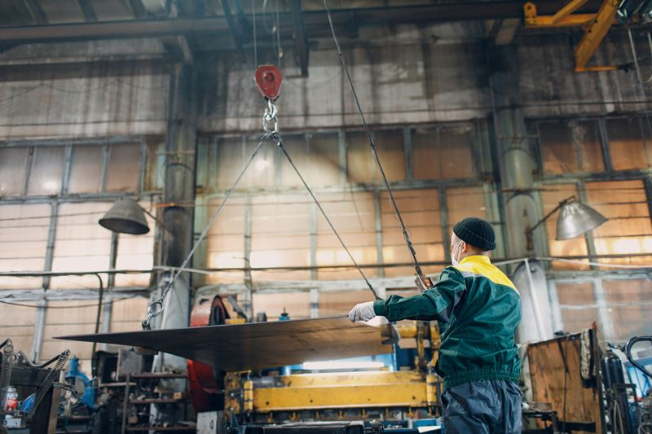

*Caption: Worker guiding sheet metal in a factory Source: [primipil / iStock](https://www.istockphoto.com/photo/worker-lift-metal-sheet-with-crane-chain-hoist-with-remote-controller-and-hook-at-gm1370800465-440275942)*

Safe Work Practices (SWP) and Safe Work Procedures, or Safe Job Procedures (SJP), are familiar concepts among health and safety professionals. They are part of a comprehensive health and safety program and, when properly applied, both will help you identify and minimize risks.

But these two concepts sound so similar that non-safety professionals, including management and employees, are often confused about the distinction. Sometimes, it even puzzles the less seasoned safety professionals.

In this article, we'll define these two concepts and discuss the role they play in making workplaces safer.

To make them more easily distinguishable, we'll refer to Safe Work Procedures exclusively as Safe Job Procedures. There is no technical justification for the difference in name (Work vs. Job), so we'll opt for the one that will cause the least confusion.

Do You Need Both?

More often than not, companies will draft Safe Work Practices and Safe Job Procedures mostly for compliance reasons. Both are mandatory for [Certificate of Recognition](https://www.safeopedia.com/definition/1791/certificate-of-recognition-cor-safety) (COR) programs developed or promoted by certifying partners. These programs are generally industry-specific, such as construction or manufacturing, and in most Canadian provinces SWPs and SJPs are part of the program's audit tool. Like other elements of a safety program, the focus of these audits is on compliance and the questions are generally quantitative, asking if you have them or enough of them, but with no direction on what a quality SWP or SJP should look like and what they should contain.

Given this focus on compliance, you might wonder if SWPs and SJPs should be an integral part of your [health and safety management system](https://www.safeopedia.com/definition/1050/safety-management-system-sms). The short answer is yes. Both are tools created to make your employees aware of hazards and provide with direction on how to act in order to minimize risk. These tools should originate from and complement the [hazard assessment](https://www.safeopedia.com/definition/4547/hazard-assessment) process, providing additional information and serving as a checklist for employees to determine what they need to do to stay safe.

Safe Work Practices

Definition

Safe Work Practices are a set of written guidelines (“Do’s and Don’ts”) that describe, in simple terms, how to perform a specific task with minimum risk to people, equipment, materials, processes, and the environment.

SWPs are not very regimented. They are supposed to convey basic, non-technical, common sense information. The order of the steps in the form is irrelevant.

Scope

SWPs are fairly generic and should be developed for the most common tasks performed in an organization. For example, a roofing company will likely want to have SWPs for the following:

* Using ladders
* Working at heights
* Using [pneumatic tools](https://www.safeopedia.com/definition/1610/pneumatic-tools)

High-risk activities that are covered by an SWP will also require an SJP. Working at heights, for instance.

(Learn more in [Roofing Safety: A Three-Step Approach](https://www.safeopedia.com/roofing-safety-a-three-step-approach/2/8471))

Development and Content

SWPs originate from generic knowledge about your organization and industry. A good starting point for developing them are your formal [job hazard assessments](https://www.safeopedia.com/definition/400/job-hazard-analysis-jha) or information collected during the [field hazards assessment process](https://www.safeopedia.com/definition/684/field-level-risk-assessment).

Advertisement

While it is intended to be prescriptive, an SWP should be designed for a fairly generic task and does not always need to be completed in the same way. It does not and should not offer a complete set of instructions for the task.

As mentioned above, SWPs cover the Do's and Don'ts associated with a task. However, since the goal is to provide your team with clarity about what they should do, it is better to focus more on the Do's and less on the Don'ts.

Consider, for example, the following instructions about lifting:

* Always ask for help when lifting objects over 50 lbs

And

* Don’t lift objects heavier than 50 lbs

The first option gives precise instruction about what a worker should do. The second statement only tells them not to lift anything too heavy but leaves them to figure out what they should do instead. Leave the object alone? Push it across the floor? It's unclear.

Emphasizing the Do's is also the more practical option. There is a minimal set of instructions you'll want your employees to follow, while there is a virtually unlimited number of things your employees should not do. Listing all the Don'ts would be impossible.

This is not to say that the Don'ts don't have their place. When properly worded, a negative statement can provide clear direction on how employees should behave. “Don’t work from the top two rungs of a ladder” is a clear message that applies to all ladders, regardless of how many rungs they might have or the task you might perform.

Safe Job Procedures

Definition

A Safe Job Procedure is a sequential series of precise steps that guide employees through a task, from start to finish and in chronological order.

Whereas SWPs are generic, SJPs are regimented and apply to specific tasks. They are more technical and the correct succession of steps is crucial for carrying out the work safely.

Scope

SJPs should be developed for all high-risk activities within an organization. In other words, any activity where deviating from the procedure, missing a step, or reversing the order could lead to serious negative health and safety outcomes (death, injury, illness, or serious material or environmental damage).

Development and Content

Most auditing tools will ask if a list of critical tasks has been developed for the activities conducted by the organization. The purpose of this question is to ensure that every critical task listed has a corresponding SJP that provides employees with clear direction on how to safely execute it.

SJPs can also originate from proactive (hazard assessments, inspections, etc) or reactive (accident reports) approaches outside of the critical task list.

Unlike an SWP, the procedure outlined by the SJP is intended to be comprehensive. Not only must every step be followed, but they must be followed in the correct order.

SJPs are generally developed by management or safety departments with input from employees. It is crucial that the step sequence and the information in the SJP are correct and that there is no gap between the way management thinks the task ought to be done and the way the team executing the task does it.

Once developed, the SJP should be reviewed with the employees executing the task. It is a good practice for a safety professional, manager, or supervisor to observe the execution of the task against the SJP and adjust the SJP or the worker’s action to ensure that the work as imagined matches the work as it is done.

What SWPs and SJPs Have in Common

While very different in scope (covering generic tasks vs. specific tasks), Safe Work Practices and Safe Job Procedures share a lot in common. Both should be:

* Based on information provided by a risk assessment
* Developed collaboratively with different stakeholder groups (e.g., management, the health and safety, workers)
* Approved by management and reviewed at agreed intervals or when operational or equipment changes occur
* Communicated to employees through formal or informal training before they are expected to complete a task covered by these documents
* Concise and clear to ensure that workers of different comprehension or linguistic abilities can understand and follow them
* Available (either electronically or on paper) for employees to reference at the site where the task is being performed

Summary

Safe Work Practices and Safe Job Procedures have been integral parts of health and safety systems for a long time. Yet, there's a good chance your employees don't know the difference between the two.

To combat that, it's important not to treat them as compliance-only elements. When properly designed and communicated, SWPs and SJPs not only act as a new layer in the hazard assessment process but can be invaluable training tools, raising awareness about common practices and guiding your team through the safe execution of their tasks.