

If you want to find the secrets of the universe, think in terms of energy, frequency and vibration.

Overview of Modern Energy Conversion Technologies



Bill Henderson

National Business Development Manager @ T&T Power Group | Business Development
April 23, 2024

Energy is the linchpin of modern technology, vital for powering devices, machines, and systems that shape daily life. From turning on a light switch to driving cars, energy conversion is a fundamental process that transforms energy from one form to another, making it usable for a variety of applications. The methods of energy conversion are diverse, each with unique mechanisms and applications. One common example is the use of steam turbines, where thermal energy from steam is converted into mechanical energy to generate electricity, a principle that lies at the heart of many power plants.
Current technologies harness various forms of energy such as chemical, nuclear, and radiant energies, and convert these into electrical, mechanical, or thermal energy. For instance, chemical energy stored in batteries is transformed into electrical energy to power mobile devices. Similarly, the energy within atomic nuclei is released during nuclear fission or fusion to produce heat, subsequently used for electricity generation. Moreover, innovations in materials science have led to the development of topological materials that can efficiently convert waste heat into electricity, improving energy efficiency across different industries.
In the world of renewable energy, solar panels utilize photovoltaic cells to convert sunlight directly into electricity, while wind turbines convert kinetic energy from the wind into mechanical power, illustrating the versatility and advancement of energy conversion technologies. As the global demand for energy grows, these methods of energy conversion are continually refined and optimized, paving the way for more sustainable and efficient energy usage.

Mechanical Energy Conversion
Mechanical energy conversion encompasses methods that transform kinetic or potential energy into electrical energy. Technologies in this field capitalize on natural forces such as falling water, wind, and ocean waves. Consider that this type of energy can be stored via pumped water storage reservoirs, stretched elastics and compressed springs.
Hydropower
Hydropower utilizes the energy of flowing water to drive turbines connected to generators, producing electricity. It remains one of the most efficient and oldest methods of energy conversion. Examples include the Hoover Dam in the United States and the Three Gorges Dam in China, where massive quantities of water are managed to generate substantial amounts of electricity.
Wind Power
Wind power harnesses air movement to rotate turbine blades which, in turn, drive generators to produce electricity. This method of energy conversion is heavily dependent on weather conditions and geography. Examples comprise onshore wind farms like the Alta Wind Energy Center in California and offshore farms such as the London Array in the United Kingdom.
Wave Power
Wave power converts the energy from ocean surface waves into electricity. This technology exploits the up and down movement of waves to activate generators. While not as widespread as hydropower and wind power, more and more examples of wave power conversion can be found around the world every year.

Thermal Energy Conversion
Thermal energy conversion is the process of transforming heat into other useful forms of energy, such as mechanical work or electricity. This conversion account for a significant amount of modern energy technology, with applications spanning from power generation to transportation.
Steam Turbines
Steam turbines function by harnessing the thermal energy from heated water vapor. The high-pressure steam passes through a series of blades, imparting force and causing the turbine to rotate. This mechanical work is then converted into electrical energy through a generator. Notable examples include nuclear power plants, where nuclear reactions provide the necessary heat, and concentrated solar power facilities, where the sun heats the working fluid.
Internal Combustion Engines
Internal combustion engines convert thermal energy from fuel combustion directly into mechanical energy. They ignite a mixture of air and fuel, creating a high-pressure gas that drives the pistons. This process is integral to the operation of the majority of vehicles on the road today, from small cars to large trucks and buses.
Stirling Engines
Stirling engines are a class of external combustion engines that operate on the expansion and contraction of a gas at different temperatures. Unlike internal combustion engines, they have a fixed amount of gas that cycles between a hot and cold heat exchanger, resulting in a net conversion of heat into work. Stirling engines are known for their high efficiency and have applications in solar power generation and submarines.

Chemical Energy Conversion
Chemical energy conversion involves transforming the energy stored in chemical bonds into other forms of energy that can be utilized by technology. This energy is typically harnessed to generate electricity or power machinery.
Batteries
Batteries operate on electrochemical reactions. They convert chemical energy directly into electrical energy through the movement of electrons between two different materials, usually an anode and a cathode. For example, lithium-ion batteries power everything from smartphones to electric vehicles by shuttling lithium ions between electrodes.
Fuel Cells
Fuel cells generate electricity through a chemical reaction between a fuel, like hydrogen, and an oxidizer. They are similar to batteries but can continuously provide electric power as long as fuel is supplied. Examples include hydrogen fuel cells used in some vehicles and backup power systems.
Combustion
Combustion is a high-temperature exothermic chemical reaction between a fuel and an oxidant, resulting in the production of heat energy. This heat can then be used to produce steam for steam turbines in power plants. An everyday example is the internal combustion engine in automobiles, which converts the chemical energy in fuel into mechanical energy.
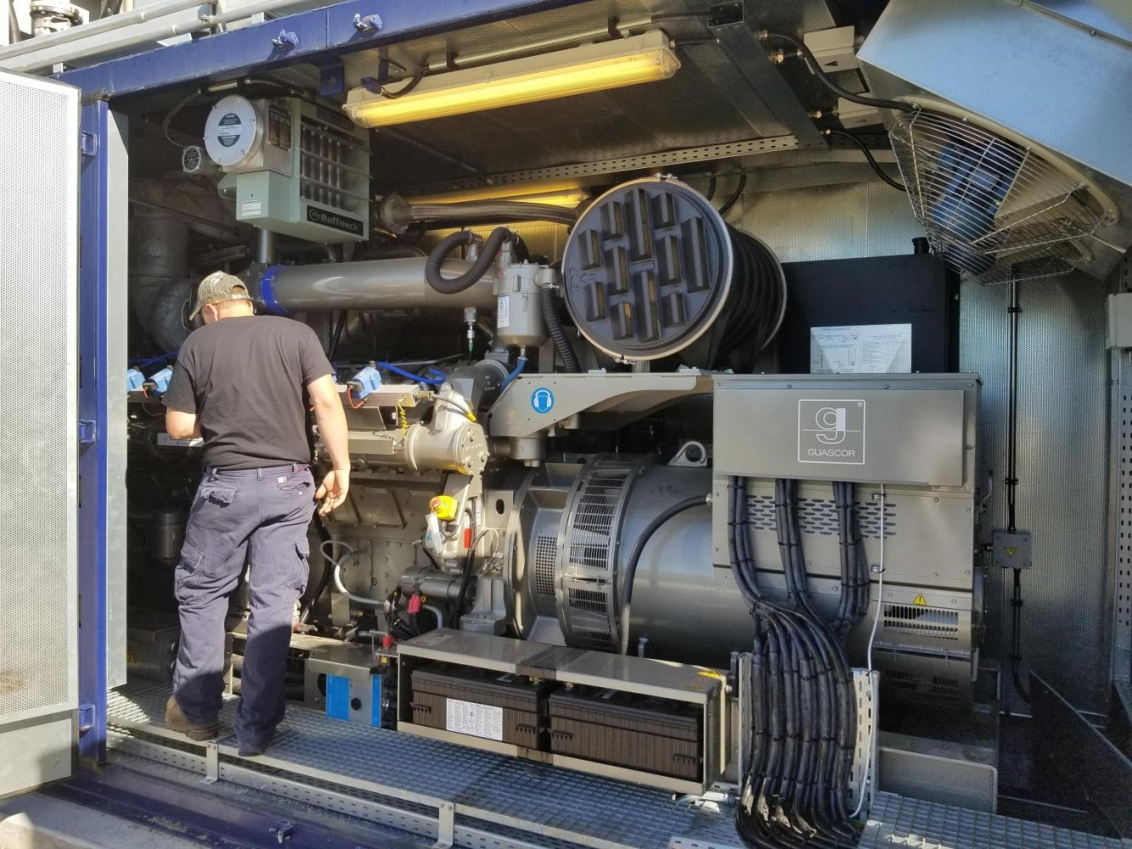

Electromagnetic Energy Conversion
Electromagnetic energy conversion encompasses technologies that transform energy into electricity, leveraging physical principles such as electromagnetism. This transformation is pivotal for numerous applications, including renewable energy generation and wireless power solutions.
Photovoltaic Solar Cells
Photovoltaic solar cells operate on the principle of converting sunlight directly into electricity. When photons from sunlight hit the cells, they free electrons in the material, typically silicon, creating an electrical current. For instance, a standard solar panel installed on a home can convert sunlight into electrical energy, which is then used for residential power needs.
Electromagnetic Generators
Electromagnetic generators produce electricity through the movement of a conductor in a magnetic field. The rotating action within these generators causes electrons to move, therebys generating electric current. A common example is a hydroelectric power plant, where flowing water turns turbines that spin conductors within magnetic fields to create substantial amounts of electrical power.
Inductive Charging
Inductive charging relies on electromagnetic fields to wirelessly transfer energy. This process involves an induction coil in the charging station creating an alternating electromagnetic field, which then induces current in a second coil in the device being charged. One can find this technology in various applications, such as electric toothbrush charging bases or wireless smartphone chargers.

Nuclear Energy Conversion
Nuclear energy conversion encompasses the processes that harness the energy from atomic nuclei. This transformative technology generates significant amounts of electricity, requiring critical safety mechanisms and conversion methodologies.
Fission Reactors
Fission reactors operate on the principle of nuclear fission, where the nucleus of an atom, typically uranium-235, is split into two smaller nuclei, releasing a considerable amount of energy. This energy is primarily released in the form of heat, which is used to produce steam. The steam then drives turbines, which in turn produce electricity. Examples include the pressurized water reactor (PWR) and the boiling water reactor (BWR). Over time, reactor designs have enhanced features aimed at safety, cost-efficiency, and extended operational lifespan, as detailed at Energy Basics.
Fusion Reactors
Unlike fission, fusion reactors aim to replicate the process that powers the sun, combining light atomic nuclei like hydrogen to form a heavier nucleus, typically helium. This reaction releases a vast amount of energy. Although still in the experimental phase, fusion reactors promise a less radioactive and potentially limitless energy source. The heat produced by the kinetic energy of the fusion products can be converted to electricity with near-perfect efficiency. While no fusion reactors are currently commercially operational, research such as that at the International Thermonuclear Experimental Reactor (ITER) is ongoing, as is further reading at How do we turn nuclear fusion energy into electricity?

Electrochemical Energy Conversion
Electrochemical energy conversion is a process where chemical energy is directly transformed into electrical energy. Electrochemical devices like fuel cells are prominent examples, efficiently generating electricity with heat and water as by-products.
Electrolysis
Through electrolysis, electrical energy is applied to drive a chemical reaction that would not occur spontaneously. This method is crucial in decomposing compounds such as splitting water into hydrogen and oxygen.
- Industrial Application: Large-scale production of hydrogen for fuel cells or chemical manufacturing.
- Environmental Impact: Generates pure gases without direct carbon emissions if the electricity used is from renewable sources.
Electrolysis serves as the backbone of a variety of green energy solutions, including the generation of hydrogen for fuel cells and advanced energy storage technologies With growing emphasis on sustainability, electrolysis is key in the transition to low-carbon energy systems.

Biological Energy Conversion
Biological energy conversion encompasses processes where organisms convert organic materials into energy. These methods are utilized to produce sustainable forms of energy that can be harnessed for various applications, including heat and electricity generation.
Biofuels
Biofuels are derived from organic matter, commonly plant material that contains stored energy from sunlight. These fuels come in different forms, such as ethanol, produced through the fermentation of crops like corn and sugarcane, and biodiesel, obtained by processing vegetable oils or animal fats. For instance, soybean oil can be converted into a usable fuel for diesel engines.
Biogas
Biogas is mainly composed of methane and carbon dioxide, resulting from the anaerobic digestion, a process where microorganisms break down organic matter in the absence of oxygen. One example is the decay of food waste in landfills, which produces biogas that can be captured and used for generating electricity or as a heat source. Additionally, agricultural waste can be transformed into biogas in a more controlled environment such as a digester.

Energy conversion technologies play a crucial role in modern life, transforming various forms of energy into electricity, mechanical power, and heat to drive the many devices, vehicles, and systems integral to daily activities and industrial processes. From the steam turbines that harness thermal energy in power plants to the innovative materials science developments enabling efficient conversion of waste heat into electricity, the spectrum of energy conversion is broad and impactful.
In the realm of renewable energy, advancements such as photovoltaic cells and wind turbines exemplify the ongoing innovation and adaptation aimed at meeting the growing global energy demand sustainably. As technology progresses, these energy conversion methods continue to evolve, reducing dependency on non-renewable resources and enhancing energy efficiency, which is crucial for environmental sustainability and energy security.
Join me as we explore the many advances of energy conversion toward a more sustainable economy and planet friendly outlook. Each edition going forward will introduce the most promising technologies being imagined and built to move us forward from a parasitic to a symbiotic relationship with nature.

Published by

Bill Henderson
National Business Development Manager @ T&T Power Group | Business Development

