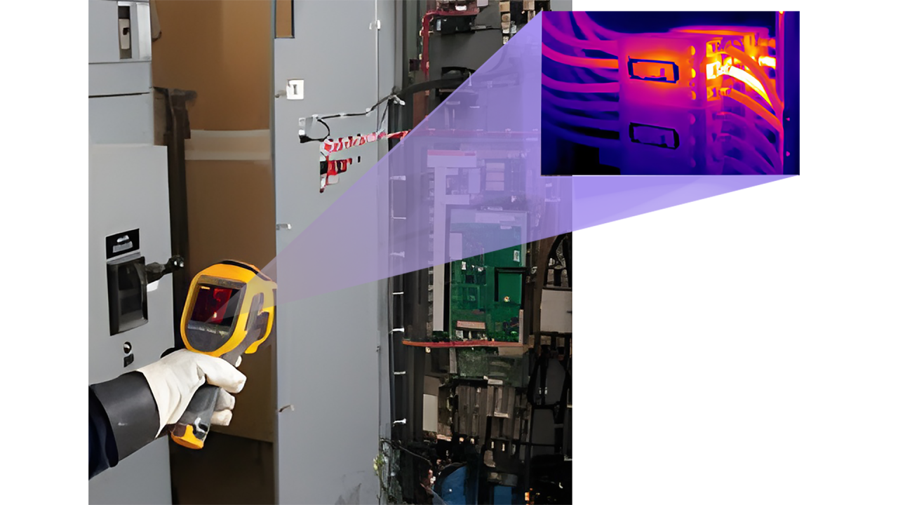

What factors contribute to the recommended practice of conducting load bank testing for UPS systems and their accompanying batteries?

Performing load bank tests on UPS (Uninterruptible Power Supply) systems and their associated batteries periodically offers several benefits:
1- Ensuring System Reliability: Load bank testing allows you to assess the reliability and performance of your UPS system and batteries under realistic operating conditions. By subjecting the equipment to a simulated load, you can verify that it can handle the expected power demands during an actual power outage. This helps identify any potential weaknesses or malfunctions in the system, allowing you to address them proactively before they cause critical failures.
2- Capacity Verification: Load bank tests help you determine if your UPS system and batteries can deliver their rated power capacity. Over time, batteries may degrade or develop internal resistance, leading to reduced performance. Load bank testing helps identify any capacity issues, such as reduced runtime or insufficient power delivery, allowing you to take corrective measures like battery replacement or maintenance.
3- Battery Health Assessment: Batteries are a vital component of UPS systems, and load bank testing provides valuable insights into their health and condition. By conducting load tests, you can identify weak or failing batteries that may not be able to sustain the required power load during an outage. This information allows you to replace or repair problematic batteries promptly, minimizing the risk of unexpected downtime.
4- System Optimization: Load bank tests provide an opportunity to optimize your UPS system's configuration, settings and calibration verification. By analyzing the performance data gathered during the test, you can fine-tune various parameters like voltage and frequency regulation, response time, and system behavior under different load conditions. This optimization ensures that your UPS system operates at its best efficiency and reliability, enhancing its overall performance.
5- Compliance and Certification: Certain industries and regulatory standards may require load bank testing for UPS systems and batteries as part of their compliance protocols. By conducting these tests periodically, you can ensure that your organization meets the necessary regulatory requirements and maintains the appropriate certifications or accreditations. as example IEEE 1188 for valve-regulated lead-acid batteries (VRLA) and IEEE 450-2002 for wet lead acid cells.
6- Thermal Scanning: Thermal scanning on UPS and batteries during load bank testing, also known as infrared thermography, involves using thermal imaging cameras to detect and visualize heat patterns in electrical equipment, including UPS systems and batteries. By examining the temperature distribution across the equipment, thermal scanning can identify areas of excessive heat, which may indicate potential issues such as loose connections, overloaded components, or faulty components. Elevated temperatures can also be an early sign of battery or UPS system problems.
7- Preventive Maintenance: The combination of load bank testing and thermal scanning allows you to proactively address potential problems before they lead to critical failures or downtime. By identifying and rectifying issues during scheduled maintenance, you can enhance the overall reliability and longevity of the UPS system.
Overall, load bank testing on UPS systems and batteries helps verify their reliability, capacity, and overall health. It enables proactive maintenance, reduces the risk of unexpected failures, and ensures continuous operation of critical infrastructure.
Published by



Mohsen Abedi P.Eng, PSM.EngMohsen Abedi P.Eng, PSM.Eng
Technical Consultant | Senior UPS Systems Specialist | Electrical engineering design | Power electronic systems design | Power quality systems & Harmonic filters | BESS RenewablesTechnical Consultant | Senior UPS Systems Specialist | Electrical engineering design | Power electronic systems design | Power quality systems & Harmonic filters | BESS Renewables

