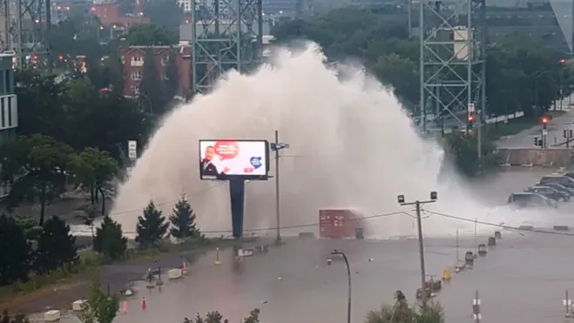

Emergency Power Plans: Why Every Facility Needs One—And What Yours Should Include

 | Bill Henderson

I was driving home with my youngest daughter from the market last Saturday morning when our conversation was interrupted by the piercing screech of another EMERGENCY ALERT on our cell phones.
Tornado Warning! I may be giving away my age but when I was a kid, tornados were something that only happened in Kansas. It was a rare affair for a tornado or huricane like Hazel in 1955 to arrive this far north.
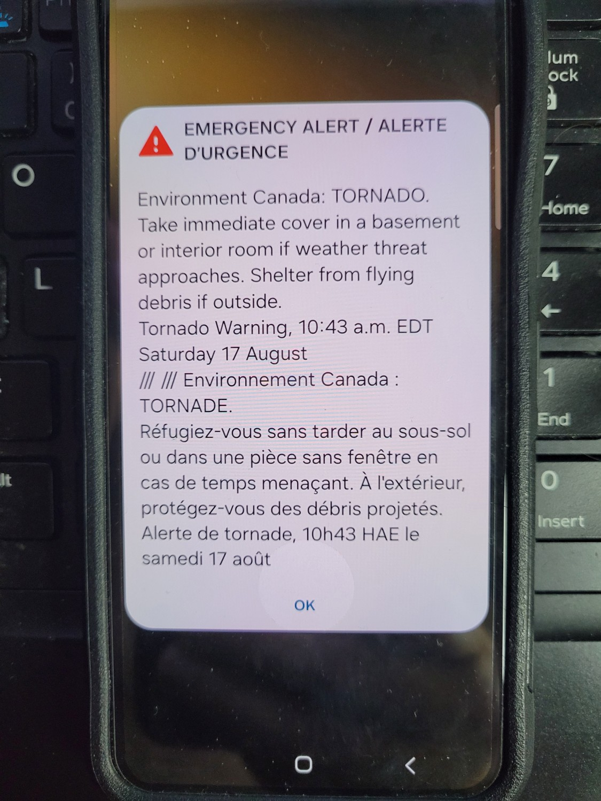Environment Canada Tornado Warning August 2024
Unfortunately, as you think back over the past few years you realize, this is the new normal. Forest fires, atmospheric rivers, storm surges from hurricanes., heavy snow, hail, canyon rock slides damming up rivers flooding out communities downstream or two meter water mains bursting and flooding out a large section of downtown Montreal. The list of possible climate calamities seem endless.
If you have been thinking that planning for a climate emergency was something you could keep putting off into the future….THE FUTURE IS NOW!
To ensure readiness across all locations in the event of a local or regional emergency it is crucial to develop a comprehensive emergency power supply plan. The following are key points to consider:

Assess Power Requirements
Determine Critical Loads: Identify essential equipment and systems that require power during an emergency (e.g., lighting, refrigeration, communication systems). Ensure that critical operations can continue smoothly during an emergency.
Power Consumption Analysis: Calculate the power requirements for each location to ensure that generators and backup systems can support these loads.

Backup or Standby Power Systems
Standby Generators: Often facility managers with a generator believe they have their power generation needs covered in an emergency. However, depending on the age and type of facility, the generator could simply be a Life Safety generator that only powers the basics like hallway lighting to get people out of the building safely.
A standby or backup generator powers all loads considered critical to the normal operation of a building should utility power fail for an extended period. In many scenarios with region wide emergencies this can mean days or even weeks. If you are to be prepared for an emergency without utility power, you need to know and understand the difference between a Life Safety and Standby generator and the electrical equipment that each generator panel powers.
For those facilities without sufficient standby power generation, short term portable generators need to be sourced that can be deployed quickly while capital procurement works on the viability of a longer-term solution.
Fuel Supply Management: Most generators are fueled by diesel, natural gas and in some remote areas, propane. Contingency plans must be considered and incorporated in you emergency plan if you are to keep your generator fueled. If it is a region wide emergency, the fuel supplier may not be able to reach you, or fuel may not be available for many days. How many days fuel supply should you keep in storage on site to run your operation? If your standby generator runs on natural gas, what is the plan if the gas supply is cut off?
The 2011 Goderich tornado, an F3 tornado, caused significant damage, including the disruption of the natural gas supply to the town due to safety concerns. In severe weather events like this, it is sometimes necessary to shut off natural gas supplies to prevent potential explosions or fires caused by damaged gas lines. Many buildings and businesses were without natural gas for weeks while lines were being repaired and inspected. A comprehensive emergency power program needs to consider an alternate supply of portable power.
Automatic Transfer Switches (ATS): In cases where you don’t have sufficient standby power or you need to pivot due to your regular fuel supply being interrupted, each location should have an ATS with quick connects to enable rapid and seamless emergency hookups of portable generators.
Electrical Hookups: Each region, province and state have their own regulations for temporary electrical hookups, who is allowed to make them and who has authority to inspect them prior to applying load. The emergency plan should have a list of local electricians that can be relied upon to make this happen properly and safely in compliance with local regulations.
Portable generators can usually be in place in a couple of hours with the proper emergency planning.

Renewable Energy Solutions
While renewable energy projects such as wind and solar energy harvested by a battery storage solution will have its day in the future, in my opinion we are not quite there yet. Battery storage solutions are relatively short term and expensive when compared to legacy standby generators, when compared to kW’s delivered per dollar spent.

Infrastructure and Facility Upgrades
Flood-Proofing: Elevate critical electrical equipment above potential flood levels and seal building envelopes against water ingress. Build earthen berms around the building or tunnels for water to flow with grates over them or permeable asphalt parking lots. There are many solutions, if you plan for them.
Fireproofing: Use fire-resistant materials for critical infrastructure and create defensible spaces around locations to protect against wildfires.

Communication Systems
Emergency Communication Plans: Develop and maintain communication plans to coordinate with local authorities and employees during emergencies. Do you have a plan in place to make sure that everyone who was in the building got out? Plan ahead.
Redundant Communication Systems: Use satellite phones and other redundant systems to ensure continuous communication.

Training and Drills
Staff Training: Train staff on emergency procedures, generator operation, and safety protocols. Staff training provides a level of comfort to enhance confidence and reduce panic in a stressful situation.
Regular Drills: Conduct regular emergency drills to ensure readiness and address any weaknesses in the plan. Frequent drills help staff anticipate the unexpected. Police, fire and paramedics, the military, all practice and drill endlessly so that when the time comes, the basic skills are so automatic and second nature that you are prepared for the unexpected.

Collaboration and Coordination
Local Authorities: Collaborate with local emergency services and government agencies for coordinated response efforts. Know where to find out when roads are closed by local police due to heavy snow or roads washed out in a storm.
Mutual Aid Agreements: Establish mutual aid agreements with other businesses for resource sharing during emergencies. Excess fuel, water pumps, generators,, even labour. As they say, what goes around, comes around. It may be your turn tomorrow.

Monitoring and Maintenance
Regular Inspections: Conduct regular inspections and maintenance of backup power systems and emergency equipment. Planned maintenance and regular operation ensure the gen-set will operate as expected, when expected.
Monitoring Systems: Implement remote monitoring systems to track the status of power systems and quickly address issues. Oil, fuel and coolant level sensors are cheaper than ever, often costing less than $100. Certainly much cheaper than having to scramble to get a technician on site in an emergency.
Now more than ever, standby power generation adds value to real property.
Document Plans: Maintain detailed documentation of the emergency power supply plan and update it regularly with current vendor contacts; fuel delivery, electricians, fire & security alarm systems, and so on.
Post-Emergency Reviews: After each emergency, review the response and update plans based on lessons learned. What worked and what did not. Failures or weaknesses in the plan this time around can be resolved by discussing alternatives for next time.
In an era where the unexpected has become the norm, the importance of proactive preparation cannot be overstated. Climate emergencies—whether they come in the form of tornadoes, floods, or wildfires—demand a robust response plan that safeguards not just the physical infrastructure but also the lives and operations within. The time to act is now. By assessing critical power needs, securing reliable backup systems, and ensuring seamless communication and coordination, we can face these challenges head-on. Remember, it’s not just about surviving the storm but thriving in its aftermath. Plan today, protect tomorrow.

