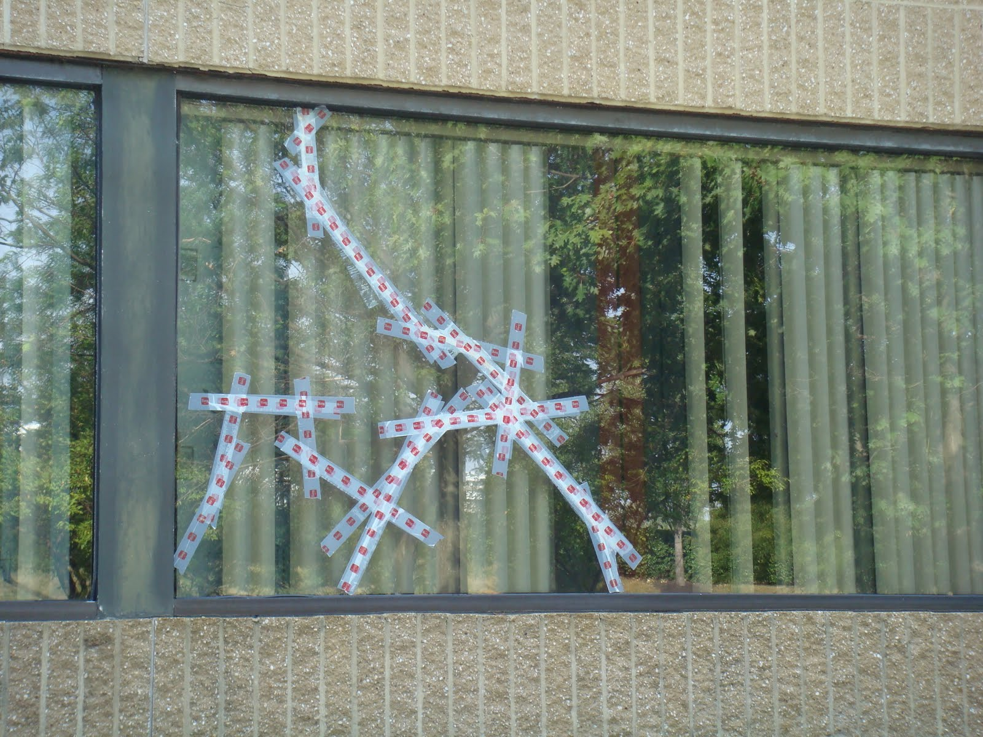

Window Replacement: 7 Mistakes to Avoid

The right choice can minimize costs and improve comfort. But making the wrong choice is all too easy
Replacing building windows requires a major commitment by building owners and facility executives. Not only are replacement windows a significant investment, but their typical life expectancy of 35 to 50 years means that building owners, facility executives and occupants will have to live with whatever window — good or bad — was selected. A good selection reduces energy and maintenance costs while keeping the building’s occupants comfortable and secure. A bad selection, while it might reduce energy use somewhat, will not be as energy efficient as other options. Maintenance costs may stay the same, or they may even increase. And building occupants may find that the new windows interfere with their operations, resulting in increased complaints.
Selecting the most suitable replacement window for a particular application requires that facility executives first understand the needs of their facility and evaluate all window options before selecting the one that best matches the needs of the facility. But all too often, that doesn’t happen. Instead, the facility executive makes one of the following mistakes:
1. Consider first costs only
Although the cost to install replacement windows is a factor, it is far more important to consider life-cycle costs. In addition to first costs, life-cycle costs include energy, maintenance, painting, cleaning and all other costs associated with owning and operating the windows. Over the life of the windows, these costs will greatly exceed their initial cost To determine the most cost-effective replacement windows, all costs must be evaluated for various window options suitable for the application. It is seldom that the window with the best life-cycle cost is also the one with the lowest first cost.
2. Replacing in kind
One of the most serious mistakes that can be made when replacing windows is to simply replace the existing windows with ones of the same type and style. Replacing in kind makes the replacement process easy. No consideration has to be given to various window options. Aesthetics is not an issue as there will be no change in the appearance of the windows or the facility.
Replacing in kind, however, fails to take advantage of any of the features available in new window designs. The opportunity to reduce energy and maintenance costs and improve occupant comfort will be missed. Even worse, the problems that led to the need to replace the windows may still exist.
3. Ignoring maintenance
Maintenance costs, such as painting, cleaning and routine repairs, represent a major portion of the total cost of owning windows. Over the life of the window, these costs exceed the original installed cost of the window, typically by a factor of two or more. Failing to take them into consideration can result in an installation that is unnecessarily expensive to maintain. Maintenance costs will vary with the type of materials used to construct the windows. Wood windows will require painting on a regular interval, typically every five to seven years. Steel windows also will require painting on a regular interval, typically every five to 10 years. All painting costs can be eliminated through the use of aluminum, vinyl or clad wood windows.
Cleaning costs are often overlooked. Conventional window designs require the use of ladders or scaffolding to access the exterior surfaces for cleaning. However, some window designs allow cleaners to gain access to the outside surfaces from the interior of the building, reducing the time and expense of window cleaning.
In addition to painting and cleaning, windows will require both preventive and corrective maintenance to keep them in good operating condition and watertight. Typical maintenance activities include replacing the caulking between the window frame and the building wall, adjusting or replacing window operators, replacing broken glass and repairing or replacing damaged gaskets. How difficult each of those maintenance tasks is and how often they will have to be performed will depend on the construction of the window.
4. Ignoring intangibles
Although energy conservation and reduced maintenance costs can be quantified when considering window replacements, intangible factors also must be considered. While these factors are more difficult to identify and quantify in terms of dollars saved, they are equally important in selecting a replacement window.
One intangible factor is the impact that the new windows will have on the comfort of the building occupants. Improperly matching windows to the needs of the occupants and the tasks being performed in spaces next to windows can cause hot spots, drafts, glare and poor visibility. By considering the tasks that are being performed, facility executives can select glazing to meet the requirements of those tasks and the building occupants.
Another intangible factor that must be considered is the effect windows will have on the appearance of the building. Different window designs in general, and different window glazings in particular, will have a great impact on appearance. A poor match between the window selected and the style of the building will produce unwanted changes in the appearance of the building.
5. Failing to consider glazing options
There have been great advances in window technology, primarily in the materials used in the glazings. Facility executives can select from glazings that are clear, tinted, reflective, heat absorbing, low-emissivity or designed to allow visible light to pass while blocking infrared and ultraviolet light. The type selected will, to a great extent, determine the energy efficiency of the replacement project, the appearance of the building and the comfort level for building occupants in the exterior spaces of the building. Failing to consider different glazing options will result in a less-than-optimum installation.
6. Failing to consider security
Windows play key roles in building security. They provide a physical barrier between the building interior and the outside, limiting access to the building. They allow building occupants to see what is going on outside the building. They allow security personnel outside the building to see what is going on inside the building.
How effectively the replacement window performs these roles depends on the characteristics of the particular window selected. Operable vs. fixed sashes, hardware installed, the tint and reflectivity of the glazing — all are characteristics that will influence how windows will affect building security. The characteristics of the glazing material used in the windows also will affect building security in another way. Some glazings resist shattering, making it more difficult for someone to break into the building through the windows. Other glazings are designed to resist explosions or impacts, preventing the window glass from becoming flying shrapnel.
7. Poor scheduling
The installation of replacement windows is a disruptive process. Building occupants must clear furniture and equipment away from windows. Removing the old window can create dust and dirt within the building that will interfere with operations and the use of the space during construction. If lead-based paint has been used on the windows, additional precautions will have to be taken. And removing the old windows will open that portion of the facility to the outside elements.
To minimize the impact of the window replacement project, building occupants must be consulted to determine the best time for the work to take place. Simply notifying them of the replacement project is not sufficient: They must be able to participate in the scheduling of the work
The window replacement project also must be scheduled around weather conditions. The contract should limit installation to times when weather conditions are within the guidelines set by the window manufacturer. For example, if caulking is installed when the temperature is too cold, it will not properly adhere to surfaces.
Facility executives need to recognize that there is no universal best replacement window. What works well in one building may not work at all in another. But by starting with an understanding of facility needs, facility executives can avoid most of the mistakes commonly made in window replacement projects. The result is an installation that reduces building energy use, reduces maintenance costs and provides a more comfortable and secure working environment for the building occupants.

