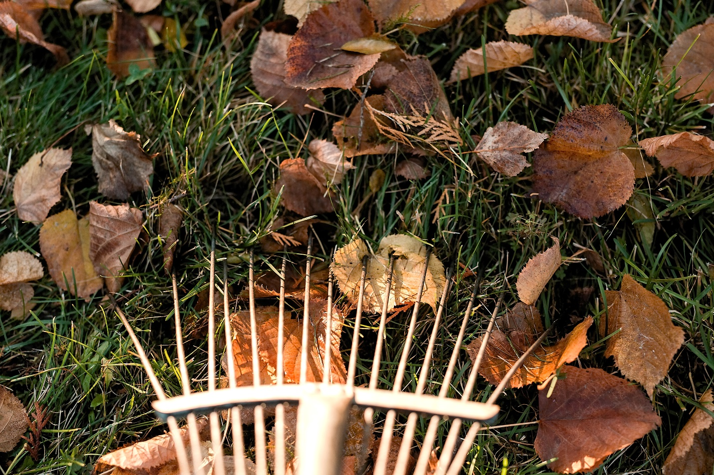

Improve your lawn

These tips should ensure the best of health for your lawn, whether you're starting a new one or maintaining an existing one.
New lawn
Spring is a good time to start a new lawn as it will quickly establish in the warm, moist soil. Sowing is the cheapest way to do this, but the grass will take several weeks to establish. Laying turf is much quicker but also much more expensive.
Whichever method is used, the site will need to be prepared well beforehand. Any existing plants should be removed, either by hand-weeding thoroughly or applying a systemic weedkiller containing glyphosate.
Once these plants are dead, dig over the ground, removing any large stones or debris. Sprinkle on a general fertiliser and rake the area until level. Finally, tread over the site to consolidate the soil.
Feeding and edging
Feeding and weeding - feeding the grass with a lawn fertiliser will make it greener and thicker, which in turn helps it to resist weeds and moss. It's possible to tackle weeds and moss while feeding by using a combined feed and weed product or a moss treatment. Late spring is the best time for feeding. If your lawn receives heavy wear it's advisable to feed every six weeks until mid-summer.
Edge trimming - tidying lawn edges keeps the grass looking neat and stops it spreading into borders. Re-cut the edges each spring using a half-moon edging tool. For a straight edge, cut against a plank of wood; for a curve, trim along a rope laid on the ground. Pull away the excess soil to leave a vertical edge measuring 5cm to 7.5cm (2in to 3in) deep. After mowing, trim any grass that overhangs the edges with long-handled edging shears or a rotary trimmer.
Edge repair - the following technique will completely restore deteriorating edges:
Use a garden spade to slice through the turf, cutting out a small rectangular section from around the damaged area
Carefully undercut the turf with the spade and turn it around so that the damaged area now faces into the lawn
Fill in the damaged patch with a handful of compost so the surface is level with the surrounding turf
Sow grass seed over the damaged area and water well. In a few months it will be as good as new
Tips
Mowing - little and often is the secret. Regular cutting keeps it tidy, thickens the turf and deters weeds. In the summer, mow at least once a week. The lawnmower blades should be set to cut the grass about 2.5cm (1in) high to help protect the lawn against damage. For a traditional striped finish, use a mower fitted with a roller.
Moss prevention - moss occurs if the lawn is shady, badly compacted, damp or too short. Spiking compacted or damp areas with a garden fork will help prevent these problems in future. Then treat the moss with a chemical moss killer. Once the moss has died, it can be raked out with a spring-tined rake. For larger lawns, an electric scarifier saves time.
Surviving dry spells - during long dry spells, mow less frequently and leave grass to grow longer. It may turn brown, but it will grow green again when the rain comes. In the meantime, don't feed the grass as this can scorch it. Don't water either, as this encourages the grass to root closer to the surface, making it vulnerable to drought.
Banishing weeds - small patches can be pulled up by hand or spot-treated with weedkiller. Larger areas can be treated with a selective lawn weedkiller.
Paths - if part of the lawn is used regularly as a path, it's worth laying a proper pathway for protection. Stepping stones are an attractive choice. Lay them with their surface just below the level of the lawn so the mower's blades can pass over them safely.

