What are the consequences of power harmonics:
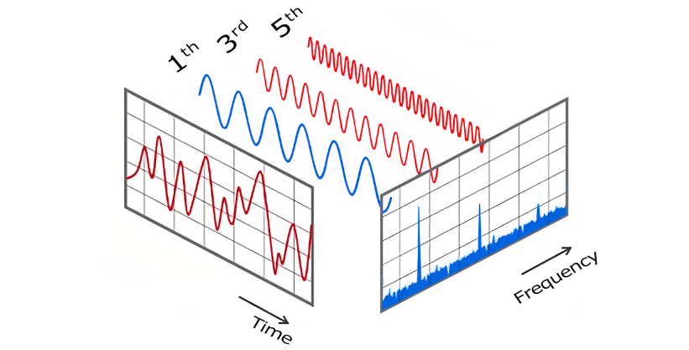


Mohsen Abedi P.Eng, PSM.Eng

Technical Consultant | Senior UPS Systems Specialist | Electrical engineering design | Power electronic systems design | Power quality systems & Harmonic filters | BESS Renewables
January 19, 2024

Power harmonics can lead to several negative consequences, both for the electrical system and the connected equipment. Some of the key issues associated with ignoring power harmonics include:
- Voltage distortion: Harmonics can cause distortion in the voltage waveform, leading to a higher Total Harmonic Distortion (THD) in the voltage. Excessive voltage distortion can affect sensitive electronic equipment and cause malfunctions or premature failures.
- Overheating of equipment: Nonlinear loads and harmonics can cause equipment, such as transformers, motors, and cables, to overheat due to increased losses. This overheating can lead to premature failure and increased maintenance costs.
- Reduced power factor: Power harmonics can lower the overall power factor of a system. A low power factor can result in increased electricity bills and reduced efficiency in power transmission and distribution.
- Equipment Damage: Non-linear loads and harmonics can cause excessive stress on electrical equipment, leading to premature failure and increased maintenance costs. Motors, transformers, and capacitors are particularly vulnerable to harmonic-related damage.
- Interference with Communication Systems: Harmonics can create electromagnetic interference, causing disruptions in communication systems, such as telecommunication and radio equipment.
- Violation of Regulatory Standards: Many countries have standards and regulations to limit the level of harmonic distortion in electrical systems. Ignoring harmonics can lead to non-compliance and potential legal consequences.
- Higher Energy Costs: Due to the additional losses caused by harmonics, energy bills may increase. Ignoring harmonic issues means wasting energy and paying for electricity that isn't effectively used.
- Reduced Lifespan of Equipment: The presence of harmonics can decrease the lifespan of electrical equipment and result in frequent breakdowns, leading to higher maintenance and replacement costs.
- Safety Concerns: Harmonics can cause increased current levels in neutral conductors, potentially leading to overheating and fire hazards.
In summary, power harmonics can have a cascading effect on an electrical system, leading to poor power quality, increased energy costs, and potential equipment damage. It is essential for industrial and commercial consumers to address harmonic issues through measures like harmonic filtering, proper equipment selection, and compliance with regulatory standards to ensure a reliable and efficient electrical system. To mitigate the consequences of power harmonics, it's essential to employ harmonic filters. Regular power quality monitoring and analysis can also help identify and address harmonic-related issues before they cause significant problems.

