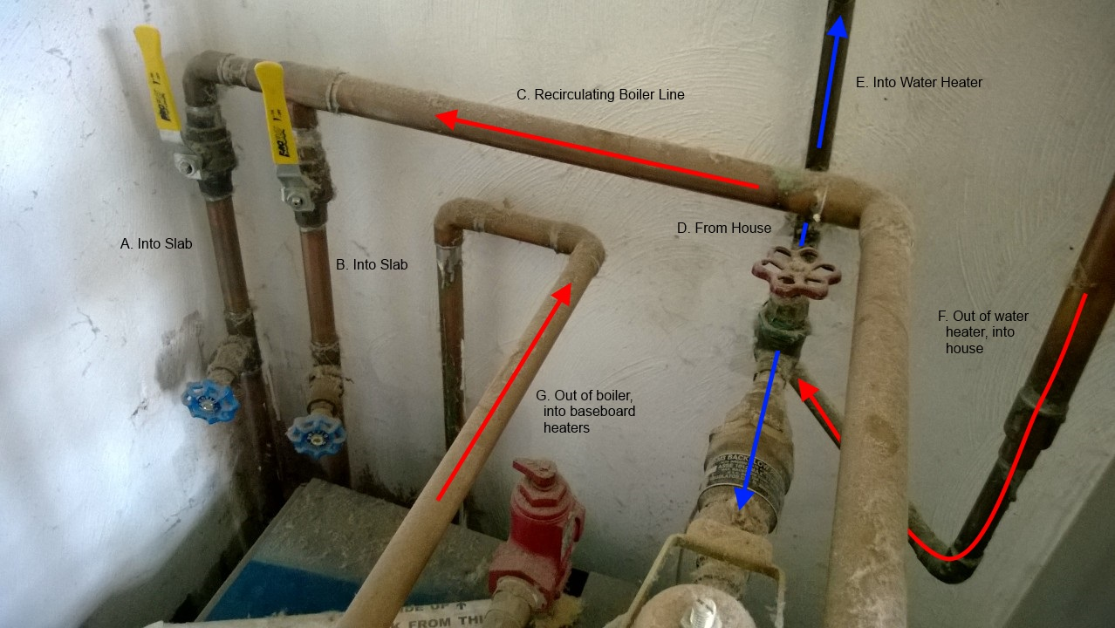
This Photo by Unknown Author is licensed under CC BY-SA
Strategies that aim to keep plumbing systems flowing.

Maintenance and repair of a facility’s numerous plumbing system components is especially important because according to health and safety codes, buildings must not be occupied without Functional plumbing.
Plumbing systems are constantly in operation, maintaining pressure, temperature and water seals between the occupied spaces and the septic or sewage disposal system.
Starting a plumbing maintenance program
The first step in beginning a maintenance program is a complete audit of the various systems and a count of all fixtures and plumbing apparatus, such as pumps, water heaters, pressure regulators and filters.
A set of the building’s plumbing plans and specifications is helpful to have, as are operating and maintenance manuals, valve tag charts, parts lists and manufacturers’ cuts. All of these materials are usually readily available from the architect or the plumbing contractor for a recently constructed building.
Part of initiating the maintenance program is to make decisions pertaining to service, such as how much will be performed in-house and how much will be contracted out to a plumbing contractor or professional service organization. It is imperative that these decisions be made before an emergency arises.
Emergencies such as broken water pipes, backed up drains, gas leaks, and lack of hot water have to be addressed immediately. As with HVAC equipment, when plumbing emergencies occur during non-work hours, telephone numbers should be available so custodians or security personnel can contact building maintenance people.
Maintenance managers then will have decide how best to respond. The goal of any response will be to have all systems functioning as soon as possible without disrupting facility operations.
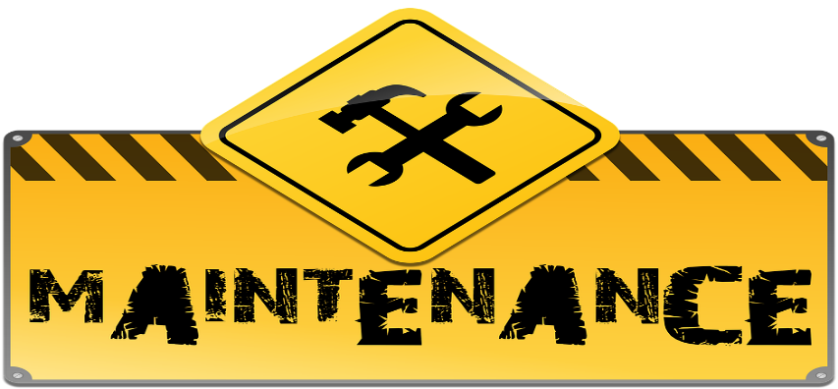
This Photo by Unknown Author is licensed under CC BY-NC
Preparing a maintenance log
A log should be kept of all plumbing fixtures, appliances and ancillary equipment.
The log should indicate the age and condition of each item, as well as its history of operation and repair. It also should list any spare parts, along with their location.
In larger facilities, rather than log each individual plumbing fixture, a log page can suffice for each toilet room, as it can in the case of a motel/hotel or nursing home, individual or patient rooms.
If the plumbing systems contain pumps or shell and heat tube exchangers, keep records showing inlet and outlet pressure and temperature readings. Changes in these readings might indicate air accumulation in the lines or the need to punch tubes in the exchanger coil. Also record the electrical current drawn by the pump motor.
The log can be used as a checklist, as well as a repair record for the various items, noting those requiring excessive repair. From this, a proper maintenance schedule can be determined.
Equipment inspections
The simplest form of inspection of plumbing systems is observing the daily use of the equipment and its reliability. Questions to be answered during inspection include the following:
- Are adequate water pressure and temperature being maintained?
- Is the design or set water temperature being maintained?
- Do all faucets or flush valves close completely, or do they continue to drip or dribble after closure?
- Do any fixtures show discoloration? This may rust or other water borne minerals, as well as the need for a water treatment or filtration program.
- Are any of the fixtures’ drains noisy or slower to empty that what is desirable? This might indicate that fixture traps need to be emptied or cleared out, or perhaps a more aggressive action is necessary. A chemical drain cleaner can break up clumps of hair or other forms of build-up inside traps or on the interior walls of the drainage piping system. Using any chemical cleaner can be hazardous, so follow manufacturer’s directions strictly.
- Are odors present? Check for dry trap seals in floor drains or fixtures.
- Does exposed pipe coverings or insulation appear moist, indicating a possible leak or condensation?
In addition to the daily “inspection by use” of these systems and fixtures, janitorial crews should be alerted to notify maintenance personnel of any perceived malfunctions.
During a heavy rainstorm, observe area drains for slow operation, indicated by a backup of standing water or water cascading from the roof down the exterior walls, roof hatches or into ducts serving exhaust fans or other rooftop HVAC equipment.
Check screens or strainers on roof and areas drains periodically for blockage.
Continual occurrences of any of the above should alert the maintenance department to the possibility of a defect in the system design or a malfunction of a mechanical device within the system.
Common repair items
The most frequently needed plumbing repairs typically involve flushometers on water closets and urinals and seals on faucets or other water outlets.
The need for repairs is identified by routine inspections or in the course of daily use of plumbing fixtures by the building’s occupants. If the cleaning crew is part of the facility’s in-house maintenance department, they are a good source of information on any problems and needed repairs.
Some modifications required by the Americans with Disabilities Act also may be included in the repair upgrade category. Major remodeling of rest rooms, hallways, for example, may be categorized as capital improvements, but smaller adaptations of such as pipe covering insulation may be considered maintenance and repair items.
Unlike HVAC and fire protection, plumbing maintenance generally does not involve regularly scheduled maintenance procedures. Instead, it relies chiefly on regular inspections to reveal problems or potential problems. The observations of building users and the cleaning crew are also a primary source of information as to fixture condition.
An effective reporting and response system prevents minor maintenance issues from developing into long-term nuisances or costly major repairs, thereby protecting the maintenance department and its reputation.
Specialized Systems
Certain specialized plumbing systems in some facilities may require additional attention in terms of maintenance and inspection. These include:
- Hospitals, which have medical gas systems carrying oxygen, vacuum, nitrogen, nitrous oxygen and compressed air. Hospitals and laboratories also have acid waste systems, bed pan washers, autopsy tables and therapeutic baths.
- Schools, gymnasiums, athletic facilities, and hotels/motels, which have specialized swimming pool and filtration systems.
- Restaurants and other food preparation facilities, which use various plumbing systems to serve dish, utensil and tray washers; pot washers; coffee urns; ice makers; and refrigerators.
- Dental offices, which require cup sinks and vacuum and compressed air.

