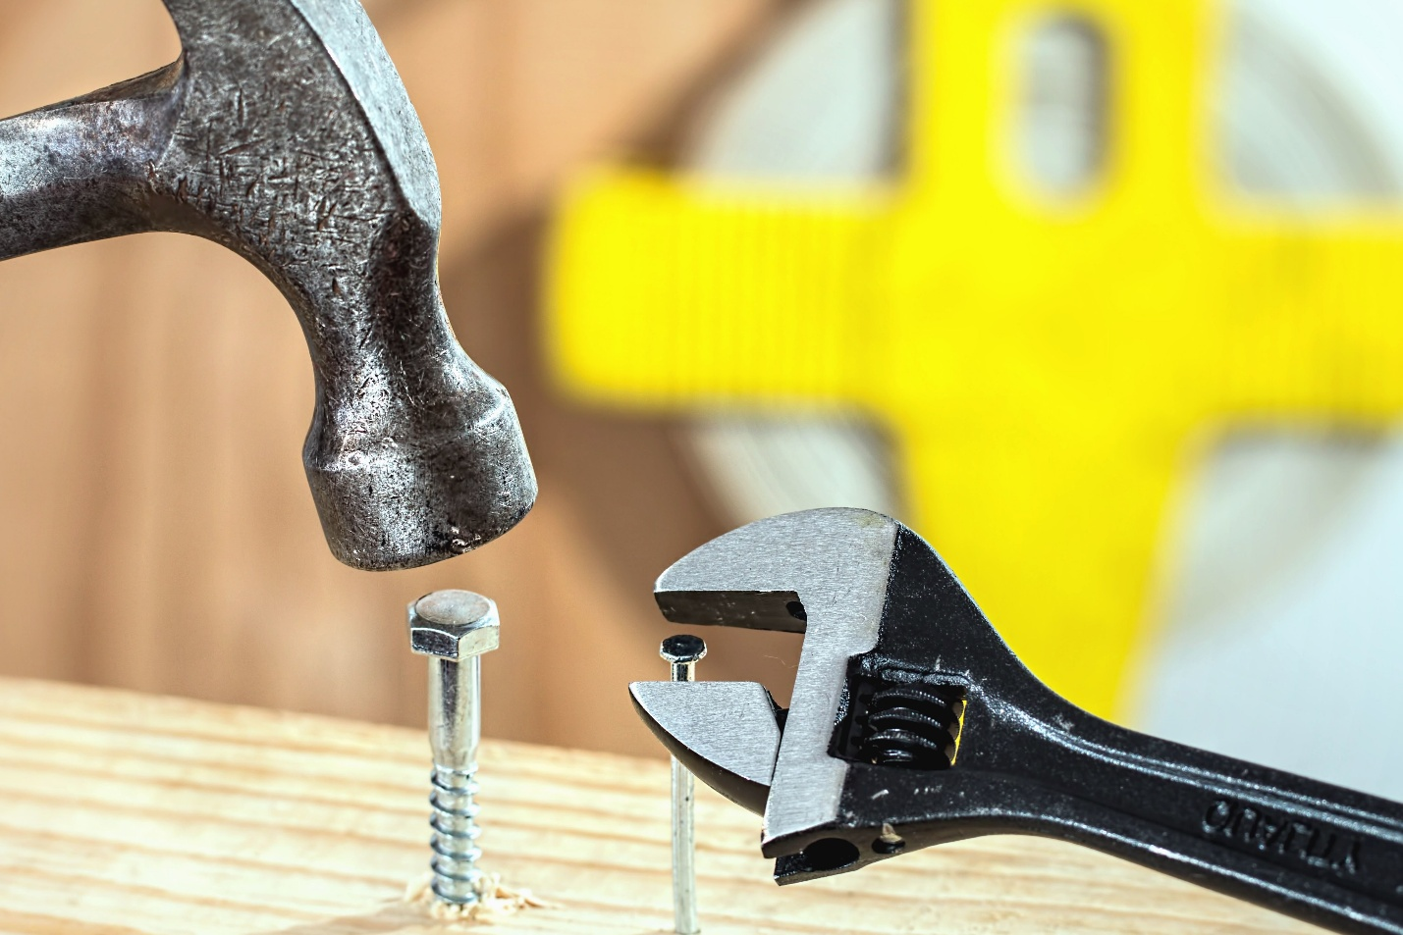

Preventing worker injuries by stressing the benefits of proper tool use.

Probably the most effective - and most overlooked - accident prevention measure in maintenance is tool safety. Managers can greatly reduce worker injuries by focusing their efforts on manual hand tools, such as screwdrivers and chisels, and on heavy-duty power tools, such as air-powered hammers, saws and drills.
For these efforts to succeed, managers must understand and use tool safety techniques designed to prevent injuries. Managers can reinforce these safety techniques through training sessions and other efforts designed to create a culture of safety.
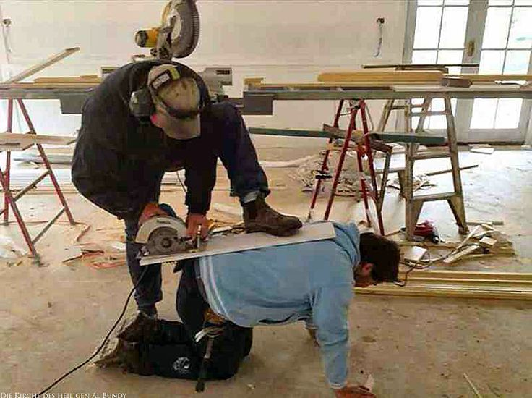

Signs of danger.
Tradespeople face a variety of dangers that arise from unsafe tool use, so the first and most important step toward safety is getting them to recognize the conditions that can cause injuries.
Take saws, for example. Wood that is wet, pitchy and full of knots can cause a saw to kickback suddenly, injuring the worker. Kickbacks in this context are defined as the sudden backward movement of the saw that causes loss of control, often resulting in severe injuries to arms, hands and legs.
Tradespeople using saws should use good-quality wood, not wood that is warped, wet or full of pitch or knots. They should use sharp blades, making sure to examine the blade for excess sawdust in the grooves and brushing or blowing out any that has collected.
Dull blades or those with rust spots can cause kickbacks. Dull blades result in workers having to apply more force. The added force causes excess friction on the blade, allowing it to heat up and potentially warp.
Safety training should emphasize that workers should not force any tool to its limit. Proper technique calls for a worker to push the saw with light force and allow it to complete its job.
Workers also must wear eye and hand protection to prevent wood chips from harming eyes and slivers from entering the hand. Managers also should be sure that tool guards are installed and in use during tool operation.


Shocking problems.
Another common hazard with saws is electrocution. Train workers to carefully inspect the tool’s cord, as well as the entrance point where the cord meets the appliance. Replace any cords that are frayed or in poor condition. Cords also should be replaced, not simply taped, if there are spots where the cord’s insulation Workers also should not operate saws in damp or moist areas. High humidity levels can cause short-circuits, especially if a tool is in poor condition. Excess vapor in the air can come in contact with motor parts that have a sparking action. Sparks are caused by the motor’s brushes coming in contact with the commutator.
If a crew must work in a damp area, they should have proper ventilation, such as a fan running, or they should use a saw with an enclosed motor.
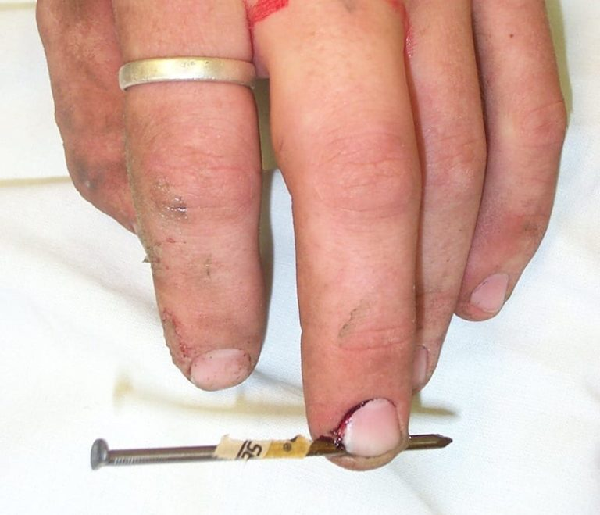

Drilling for safety.
Drills also present a range of safety concerns.
Workers using a drill must use a bit that is the correct size for the job. Using a bit that is too small may allow the bit to loosen and separate from the chuck. Using a bit that is too large can result in jamming.
The tool user should make sure the chuck is tightened down before starting the drill, be sure to use bits that are sharp and free of dust, and blow out or brush out dust from the bit if it becomes clogged from excess work. Also, grabbing a bit or chuck when turning the power on can result in burns, abrasions and other serious injuries.
Using excess force when drilling also creates problems. Users may need to be reminded to be patient with the drill and let it move forward with light pressure. Excess force results in friction, which can damage the bit, shorten the life of the motor and cause jamming.
When a bit is jammed, shut off the power, loosen the chuck so the bit separates from the chuck and use a pliers to remove the bit from the work piece.
When using a drill to remove rivets or when drilling through metal, workers should always use protective eye wear. Burrs and metal filings can fly around, causing eye injuries.
Auxiliary handles on drills are designed to provide extra stability. Workers should be reminded to firmly grasp the handles and brace the drill. As with other electrical tools, cord inspection and replacement, if needed, are essential for safety.
If using a drill equipped with a screw bit set, workers must use the correct bit for the head of the screw. Not doing so can result in the screw head becoming damaged or the user losing control.
No screwing around.
Screwdrivers are probably the most used — and abused — of maintenance tools. Never use a screwdriver as a punch, wedge, pry bar or pliers. Using the tool this way can damage it and render it useless for other jobs. If the blade is bent, the handle broken or the tip twisted and dull, the screwdriver can slip out of the slot and cause hand injuries.
One key to safety here is selecting a screwdriver tip that corresponds to the screw. Workers may need to redress the tip to keep it sharp and square instead of allowing the tip to become rounded. This condition can cause injuries from the screw slipping out of the slot. Phillips screwdrivers have less tendency to slip out due to blade design.
To enhance safety when using screwdrivers, workers should be instructed to hold they should use a screwdriver with an insulated handle. This precaution decreases the chances of a short-circuit when working on electrical equipment.
When using chisels, make sure workers redress the head of the chisel after considerable use. This prevents mushrooming, which is when the head starts to spread out. When this happens, the striking surface is compromised, and flying metal filings can cause eye injuries. Workers should wear eye protection when driving implements into surfaces.


Training.
The best way for managers to stress tool safety is through training, which should be incorporated into both lectures and hands-on instruction with group interaction. If required training is too time-consuming for managers to organize and conduct in-house, consider an outside provider.
Maintenance managers must make sure all workers have a clear understanding of how to work with both hand and power tools. Allow time for the workers to ask questions and provide feedback during the hands-on period or after the training session.
Also be sure workers help reinforce safety lessons so that at the end of the day, the tools are clean and ready for the next day’s work. Safety must be taught at a level at which all workers can understand, and it must be done frequently to successfully reinforce the lessons.
A culture of safety.
Managers trying to cultivate a safety culture can’t do it alone. It is always beneficial to have personnel who take safety seriously and can practice safety as a job in the company structure.
In many organizations, safety officers wear numerous hats, a job structure that can compromise the duty of safety personnel by taking them away from safety and forcing them to perform unrelated tasks. And in organizations where downsizing is a problem, managers should consider the benefits of working with outside experts or professionals versed in safety.
Finally, managers seeking to create a culture of tool safety in their departments may need to prompt discussions about it with the organization’s human resources department and perhaps even restructure of the safety program. The goal of these and all related actions is to give departments the resources and the opportunity to protect workers and ensure smooth facility operations.

