Evaluating Generator Maintenance RFQ’s: Lowest Cost vs. Overall Value



Bill Henderson

National Business Development Manager @ T&T Power Group | Business Development

January 25, 2024
Open Immersive Reader
When procuring generator maintenance services, organizations may opt for different evaluation methods for the bidding process. Issuing a request for quotes (RFQ) and evaluating based solely on the lowest bid is a common method that prioritizes cost above all other factors. On the other hand, a more comprehensive evaluation approach considers not only the cost but also the skill of technicians and relevant experience. This multifaceted method aims to ensure that the quality of services is not compromised for the sake of lower expenses.
Each evaluation method comes with its own set of implications for businesses. Relying on the lowest bid may result in significant upfront cost savings, which is particularly attractive for businesses with stringent budget constraints. However, it might overlook the long-term value that skilled and experienced technicians bring to the maintenance of generators, which could be crucial for the longevity and reliability of the equipment. Conversely, a multifactor evaluation acknowledges the complexities of generator maintenance and the importance of quality workmanship, potentially leading to lower overall costs in the form of fewer repairs and extended generator lifespans.

The Bottom Line
- Evaluating RFQs by lowest bid can minimize initial costs but may overlook long-term value.
- Considering technician skill and experience in RFQs can ensure higher quality maintenance.
- A multifactor evaluation can lead to better overall cost efficiency and equipment reliability.

Evaluating by Lowest Bid Only

Pros:
Cost Effectiveness
Organizations often favor the lowest bid criteria because it tends to lower costs for services rendered. The competitive nature of bidding can drive prices down, allowing for the selection of services that provide the necessary functionality at the minimal expense. This cost-saving strategy may lead to significant budgetary reductions over time, especially in long-term contracts for generator maintenance.

Simplified Selection Process
Choosing a provider based on the lowest bid simplifies the evaluation process. Decision-makers can easily compare bids based solely on price, enabling a swift and straightforward decision. This method can reduce the time and resources spent on evaluating complex aspects of each proposal, making it an efficient approach for services where the lowest cost is the priority.

Budget Control
Using a lowest bid evaluation assists in maintaining strict budget control. It sets a clear expectation for costs, thereby minimizing the likelihood of budget overruns. When coupled with clearly defined maintenance service requirements, it ensures that spending aligns with the financial planning of the organization, leading to predictable financial management without unexpected expenditures.

Cons:
Risk of Poor Quality
Evaluating quotes based solely on the lowest bid could result in the procurement of substandard services. Companies often reduce costs by cutting corners, which can compromise the quality of maintenance work performed on generators. Lower quality may lead to frequent breakdowns or a shorter lifespan for the equipment.

Overlooking Technician Expertise
A focus on the least expensive option does not consider the skill level of technicians. Maintenance of complex machinery like generators requires skilled technicians who can diagnose and rectify issues efficiently. High-skilled technicians often command higher wages, which might not be reflected in the lowest bids.

Ignoring Relevant Experience
Relevant experience is another critical factor that a lowest bid evaluation process often excludes. Providers with a proven track record in generator maintenance may provide more reliable and effective service solutions but might be disregarded if their quotes are not the lowest.

Potential Long-Term Costs
An initially low bid can translate into higher long-term costs. This can occur through the need for more frequent repairs or replacements if the quality of the maintenance is compromised. Additionally, inadequate servicing can lead to operational downtime, affecting the buyer's productivity and profitability.

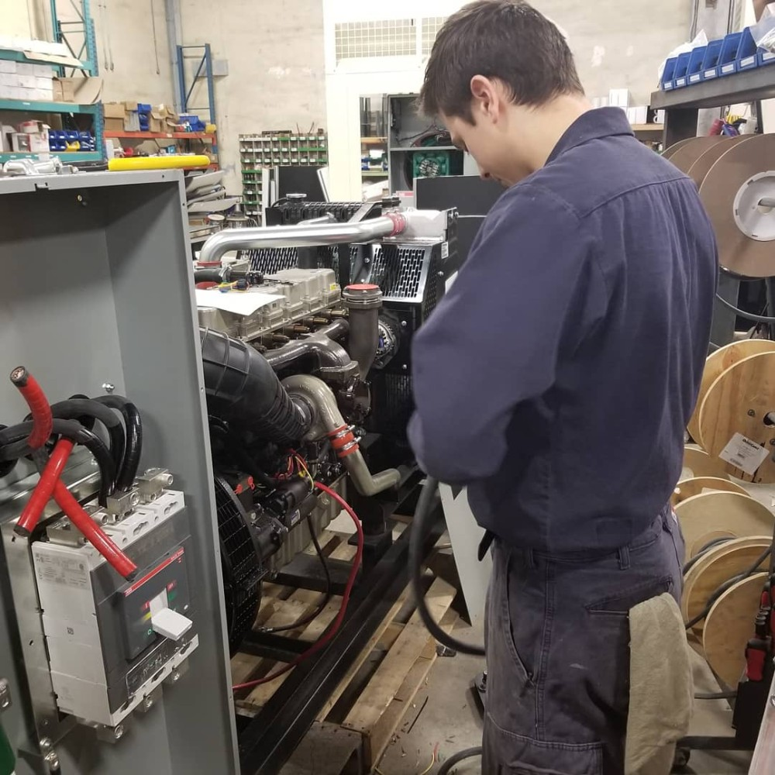
We train our technicians in our production facility and conduct field audits to ensure premim quality service.

Evaluating by a Combination of Lowest Bid, Skill of Technicians, and Relevant Experience

Pros:
Enhanced Quality of Service
By evaluating multiple factors beyond just price, organizations are likely to obtain higher quality service. Technicians' skills and experience play crucial roles in both the efficiency and effectiveness of generator maintenance. A non-monetary evaluation can identify contractors who are more likely to provide long-lasting maintenance solutions.

Balancing Cost with Expertise
It is not only cost-effective to consider the lowest bid, but also the expertise that comes with the price. A multifactor approach allows decision-makers to consider a balance between cost savings and the skill level of the service provider, ensuring they are not sacrificing quality for a reduced price.

Consideration of Vendor Track Record
Past performance and experience can be indicative of future results. A multifactor evaluation gives weight to the track record of vendors, looking at their history of reliability, adherence to safety standards, and overall customer satisfaction. Factoring in these elements can lead to a more informed and strategic selection.

Cons:
Higher Initial Costs
The combination of factors may lead to a higher bid price due to the premium placed on quality and expertise.

More Complex Evaluation Process
The process of evaluating bids based on multiple criteria can be more time-consuming and may require more expertise to assess the technical qualifications and experience of each bidder properly.

In conclusion, while the lowest bid approach may be more cost-effective and simpler, it carries risks related to quality and expertise. Conversely, evaluating bids on diverse criteria promotes adherence to industry standards, as vendors are more likely to employ certified and experienced technicians, use correct tools and parts, and follow protocols that align with regulatory requirements, resulting in compliant and dependable maintenance services.
Report this

Published by

Bill HendersonBill Henderson
National Business Development Manager @ T&T Power Group | Business DevelopmentNational Business Development Manager @ T&T Power Group | Business Development
Published • 1d

In the competitive world of generator maintenance services, the art of choosing the right provider is akin to finding a diamond in the rough. Do you go for the glittering appeal of the lowest bid or dive deeper into the richness of skill and experience?

