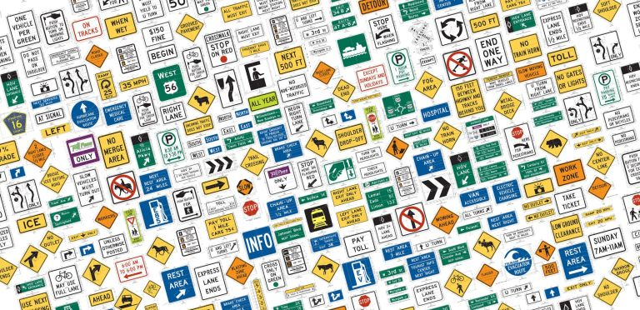
This Photo by Unknown Author is licensed under CC BY-SA

Signs of Safety

Clear and concise signs are central components of programs designed to protect facilities and workers
Designing, implementing, and maintaining an effective building signage program can be an ongoing challenge for maintenance and engineering managers. Signs are necessary to inform or direct employees, customers, and the general public while at your facility. Selecting sign materials, colors and placement can be a chore of its own without also having to comply with the many regulatory requirements. One of the more difficult categories of signage is safety signs.
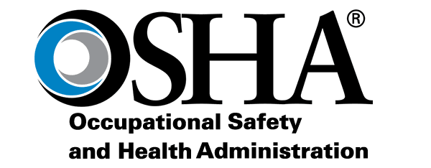
This Photo by Unknown Author is licensed under CC BY-NC-ND
Safety signs and OSHA
Safety signs are designed to provide a clear and understandable warning regarding workplace hazards. The Occupational Safety and Health Administration (OSHA) regulates many of the safety signs, markings, tags and labels required on an employer's site. Although many OSHA standards have specific signage requirements regarding size, lettering, wording, color and placement, most safety signs fall under OSHA's Specifications for Accident Prevention Signs and Tags, 29 CFR 1910.145. This standard is primarily a performance-based standard that can be non-specific or vague in many instances.
OSHA's performance-based standards generally tell employers what safety criteria must be achieved, basic rules to follow, and prohibited methods employers must not use to "perform" to the expectations of the standard. Understanding OSHA's performance-based signage criteria will assist managers in determining the selection, design and placement of safety signs.
In general, OSHA requires safety signs in any work area where failure to post a warning sign might lead to accidental injury or property damage. These signs should be classified according to their intended use. A description of each of the four main categories of safety signs and color coding requirement is as follows:
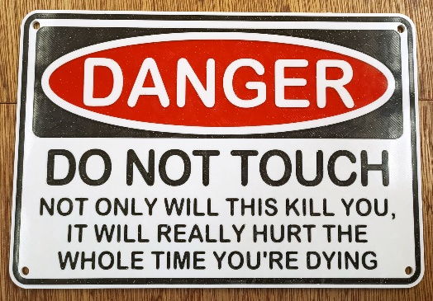

licensed under CC BY-NC
Danger signs. Facilities should limit the use of danger signs to warning employees about immediate workplace hazards. Special precautions also might be provided that inform employees of necessary steps they can take to protect themselves. These signs use red, black and white. Specific danger signs must be consistent in design throughout the facility.
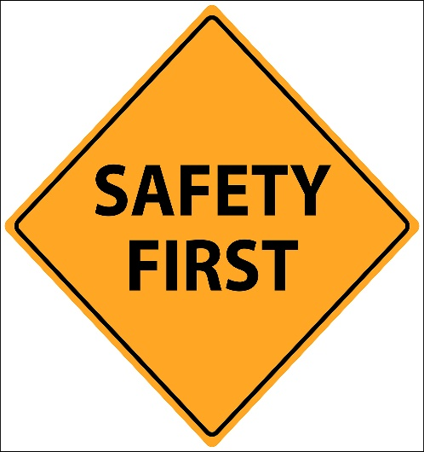
This Photo by Unknown Author is licensed under CC BY-ND

Caution signs. Facilities should use caution signs to indicate potential hazards and to caution employees against unsafe practices. These signs use a yellow background with a black panel and yellow lettering.
Safety instruction signs. The use of these signs should be limited to conveying general instructions and suggestions regarding appropriate safety measures. These signs use a white background with a green panel and white lettering.
Specific signs. The use of specific signs is mandated under specific OSHA standards. Examples include specific color coding requirements, such as red-orange for biohazards and purple-yellow for radiation symbols.
The signs themselves also must meet performance standards mandated by OSHA. Sign must have rounded or blunt comers and be free of sharp edges, burrs, splinters or other sharp projections. The ends or heads of bolts must be located so that they do not constitute a hazard to employees.
OSHA provides requirements on the nature of wording used on signs. Signs should be clear and concise and easily understood. The wording also should be accurate in fact and should make a positive suggestion, rather than a negative suggestion.
To determine if safety signs perform up to OSHA standards, managers should check to see that signs: achieve the performance criteria by communicating the safety hazard or unsafe work practice; follow basic rules on intent, color coding, case of readability, and understandability; avoid negative suggestions; and not create hazards themselves.

Signage types
OSHA has many sign, marking, tagging and labeling requirements, so determining when and where safety signs are needed requires an understanding of the OSHA regulations as they relate to a facility. Facility wide safety inspections are a good tool for identifying signage needs. Managers can organize inspections by areas or by the OSHA standards. The following is a listing of the more common signage requirements of certain OSHA standards. Refer to the complete OSHA regulations for more specific requirements.
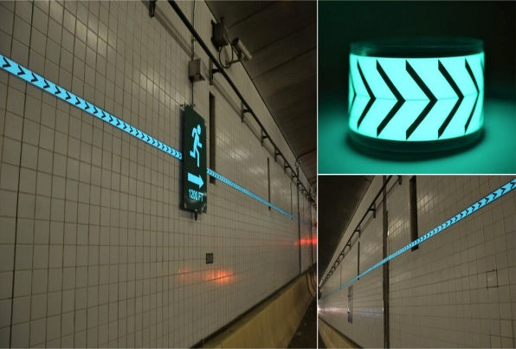

Means of egress (1910.37). Check to make sure exits, as well as doors that are not exits, are marked property. Exit signs should be distinct in color and contrast with decorations, interior finish and other signs. Every exit sign has to be illuminated internally or by a reliable sight source.
Ionizing radiation (1910.96). Radiation areas, including high-radiation and airborne radioactivity areas, must be posted with a sign bearing a caution symbol and description of the hazard.
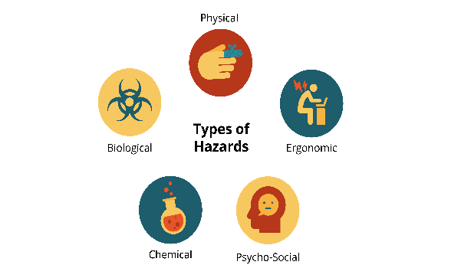
This Photo by Unknown Author is licensed under CC BY-SA-NC
Hazardous materials (1910.101 through 1910.111). Signs are required in general for compressed gases, with specific requirements for acetylene, hydrogen and oxygen. Storage cabinets for flammable or combustible liquids require signage identifying, "Flammable- Keep Fire Away."
Fire protection ( 19 10.15 7). Portable fire extinguishers should be mounted, located and identified with signage that makes them readily identifiable. Managers must make sure signs and portable extinguishers are unobstructed.
Material handling (1910.176). Permanent aisle and pathways must be marked as required by 1910.144 safety color code for marking physical hazards - with clearance signs to warn of clearance height limitations.
Toxic and hazardous substances. OSHA has developed specific health standards for more than 25 toxic and hazardous substances, and each standard has signage requirements. These signs must be posted at entrances and exits to regulated areas. Many of these materials are carcinogenic, a respiratory hazard or poisonous. A frequently cited hazard is signage required under the asbestos standard 19 10. 100 1. Asbestos warning signs are required in routine maintenance areas where employees could come into contact with asbestos-containing materials.
Bloodborne pathogens (1910.1030). A hazard sign incorporating the universal biohazard symbol must be posted on all access doors where potentially infectious materials or animals are present in a work area. Signs also are required at entrances to HIV and HBV research laboratories.
Facility specifics
Various areas of commercial and institutional facilities pose specific and unique problems for managers developing or updating a safety signage program:
- Warehouses. Managers must consider fire safety extinguishers and hoses - means of egress, carbon monoxide hazards from vehicles or heaters, compressed gases, flammable materials, spill kits, battery charging areas, and material handling.
- Compressed gas storage. Managers should focus on fire protection, storage identification formaterials such as hydrogen and oxygen, and no-smoking signs.
- Maintenance shops. Signs should address no-smoking requirements, mandatory use of personal protective equipment, and hazards that include high voltage, flammable materials and asbestos.
- Loading docks. Signs should address clearance limits, spill control, fire extinguishers, carbon monoxide and floor markings.
- Chemical-storage areas. Signage should cover no smoking requirements, fire extinguishers, spill kits, safety showers, eye-wash stations, personal protective equipment, and flammable and substance- specific warnings, including formaldehyde and ethylene oxide. Laboratories. Among the more common signage for labs are eye-wash stations and emergency showers, fire extinguishers, emergency shutoffs, fire blankets, personal protective equipment, emergency exits, eating/non-eating areas, chemical storage, compressed gas cylinders, first aid and spill kits. Managers can consult 1910.1450 for more specific chemical storage and laboratory-safety signage requirements.
- Vehicle maintenance areas. Signs should cover gasoline and flammable materials, personal protective equipment, carbon monoxide, floor markings, compressed gas cylinders, no-smoking requirements, no-oil-use requirements, fire extinguishers, welding, and exits.
A sound knowledge of OSHA is crucial for determining performance of safety signs. For safety signs to perform, managers must know their intent, make them clear and concise and make them understandable to the work force. The results will help protect the workplace from injuries and property damage.
Making Signs: An Inside Job?
The design and manufacturing of signs is big business, and it can be big money. For this reason, many managers have decided to design and manufacture various types of building signage with in-house resources.
In-house design of safety signs requires careful attention to avoid compliance problems. OSHA requires that signage color coding and symbols use the specification of ANSI Z535.2 Standard. To prepare proper signage, safety directors and maintenance managers should review specific safety standards to determine if exact wording or phraseology is required.
If specific wording is not required, design becomes more important. Remember to follow performance requirements for signs under 1910.145 as discussed in the accompanying article.
Determine the intent of the sign -danger, caution, instructional- and develop a positive message. Communicate the message clearly, concisely and understandably, and create a hazard-free sign with no sharp edge or protrusions.
Those seeking to design signs in compliance with federal, state and local regulations have an abundance of information and assistance available. Several sign associations provide guidance on sign manufacturing, materials to use, and positioning of signs.
Also, the Internet has resources - many free - that provide example signs, downloadable signs for computer sign-making programs, facility signage surveys, recommendations on materials, placement, and installation, and regulatory research. Typing "signage" into a search engine can help departments tap into these resources.
Managers can obtain comprehensive safety inspection check lists from trade associations and safety publications. The American Society of Safety Engineers (ASSE), a nationally recognized safety association, provides training, publications, as well as referrals for industry-specific safety inspections. Managers can visit its Web site. Finally, OSHA has many safety inspection resources available at its Web site.
Coordination with other departments is the final step in the safety signage program. Managers should consult with the safety officer, area supervisors, and maintenance staff to determine final design, installation and placement criteria. Signs should be placed where they are visible and unobstructed.
Lighting, maintenance, storage and other barriers should be an important consideration when selecting final sign location. It is not unusual to find supplies or equipment obstructing safety signs. Doors can open and block signs and safety equipment.
Language barriers also can hinder the safety message. Managers should review signage requirements with area departments to determine proper placement, material and installation requirements, and secondary language issues. Remember, signs that "perform" in compliance with OSHA must be visible and understood.
Safety signs can easily be incorporated into an in-house signage program. Proper design, placement and installation require research and investigation.

