
There is nothing like the peace of mind that comes with knowing a plan is in place for an emergency.

Facility Manager's Guide to Life Safety Emergency Power Standards



Bill Henderson

National Business Development Manager @ T&T Power Group | Business Development
October 20, 2023
To support those entrusted with ensuring the safety of our building occupants, the Canadian Standards Association has introduced the CSA 282-19 Emergency Electrical Power Supply for Buildings. This standard, in conjunction with other regulatory guidelines, forms a comprehensive strategy to safeguard our facilities, ensuring they remain secure and welcoming for all who enter.
The United States National Fire Protection Association (NFPA) has a similar code or standard in the NFPA 110 – Standard for Emergency and Standby Power Systems, formally adopted in 1984 with the most recent edition delivered in 2019.
As a facility manager, the implementation of a meticulous inspection and reporting system, aligned closely with the CSA 282 standard, becomes paramount. This serves as a tangible demonstration of your commitment to life safety. Its significance cannot be understated, as not only will the local fire marshal request access to the generator inspection records, but the TSSA (Technical Standards and Safety Authority) and your insurance provider will also place a keen focus on this documentation, especially in cases involving power loss to critical systems like fire pumps, elevators, and fire alarms.
The CSA C282-19, titled "Emergency electrical power supply for buildings," is a Canadian standard that outlines the requirements and guidelines for the design, installation, operation, maintenance, and testing of emergency electrical power supply systems for buildings. Here are key aspects of CSA C282-19:
- Scope: The standard applies to various types of buildings and facilities where emergency power supply is critical for life safety and essential operations.
- Purpose: CSA C282-19 is designed to ensure that buildings have reliable emergency electrical power systems in place to support critical functions during power outages or other emergencies. This includes providing power to essential equipment such as lighting, alarms, elevators, and life support systems.
- Design and Installation: The standard provides specifications for designing and installing emergency power systems, including generators, transfer switches, and related equipment.
- Operation and Maintenance: CSA C282-19 outlines maintenance requirements to ensure that emergency power systems remain in optimal working condition. Regular testing and inspections are typically mandated to ensure reliability.
- Updates: It's worth noting that CSA C282-19 is the seventh edition of this standard, and it supersedes previous editions, including those published in 2015, 2009, and 2005.
This standard is crucial in ensuring the safety and functionality of buildings during power disruptions or emergencies, making it an essential reference for engineers, architects, facility managers, and other professionals involved in building design and maintenance.

Weekly Visual Generator Inspection
Emergency standby generators should be inspected at least once each week. This is a simple visual inspection that anyone can do. It does not involve operating the generator. If your staff is uncomfortable visually inspecting the generator, have your generator service provider conduct some training to provide a level of comfort around this equipment. A twenty minute on site tutorial with staff during a service provider's regular inspection should cost nothing and will put your staff at ease working around the generator set (gen-set).
Upon arrival, take note as to whether there was power to the generator controller. It the screen is dark, the crank batteries are likely drained and need be be replaced. Call your service provider. Also make note in the log if the gen-set was found not in AUTO. The gen-set will not start if not in AUTO and this is a common mistake found on service calls for generators that fail to start in a utility failure.
If the generator was found in AUTO and not in alarm, carry on with visual inspection of gen-set.
It is good safety practice when working around the generator to put the controller in MANUAL mode to ensure the gen-set does not start during your inspection as you never know when utility power could fail prompting the generator to start.
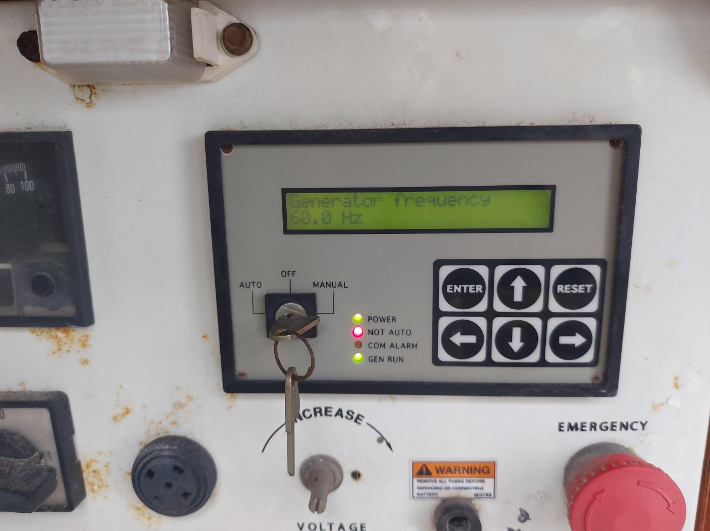
Control panel in MANUAL

Complete the following weekly checks:
1. Consumables:
- Check oil level on dipstick just as you would on your car's engine.
- Check coolant level at sight glass or plastic reservoir next to the radiator.
- Check fuel level; if natural gas, a regulator will be installed before the generator and a gauge will indicate pressure (PSI) or inches of water column (WC). Ask your service provider what the acceptable range should be for your generator; if diesel, a fuel gauge or tank float will show volume level; if propane, the tank gauge should show no more than 80% to allow for expansion
- Visually check engine, generator (alternator), fuel tank, and cooling system for leaks by simply walking around the unit
- Note all readings in the generator's logbook

2. Starter system:
- Inspect electric starter for cleanliness, mounting, and terminal security.
3. Batteries and charging equipment:
- Inspect all batteries visually
- Inspect connections for tightness and corrosion
- Inspect for cleanliness and dryness between terminals.
- Look at charger to make sure power indicator light is on
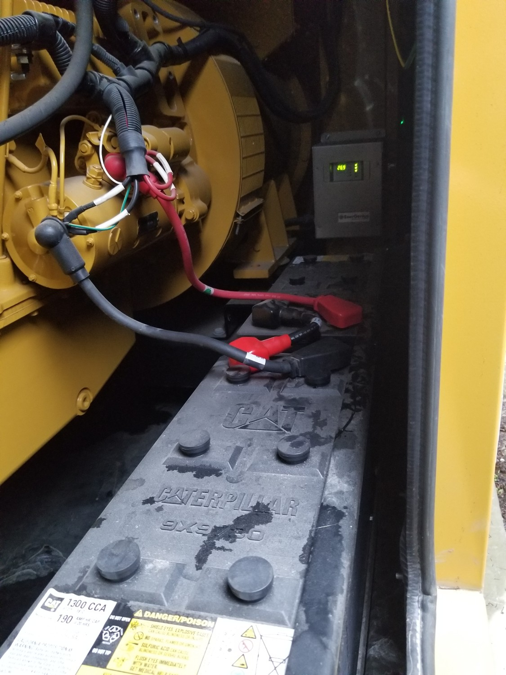
Check to make sure all connections are secure and battery charger is operating.
4. Engine:
- Block heater should be warm; feel for heat with back of hand
- Inspect fans belts proper tension and excessive wear
- Check governor control linkages and oil level (if applicable); ask service provider
- Check oil sump (pan) fuel pump, (if applicable); ask service provider
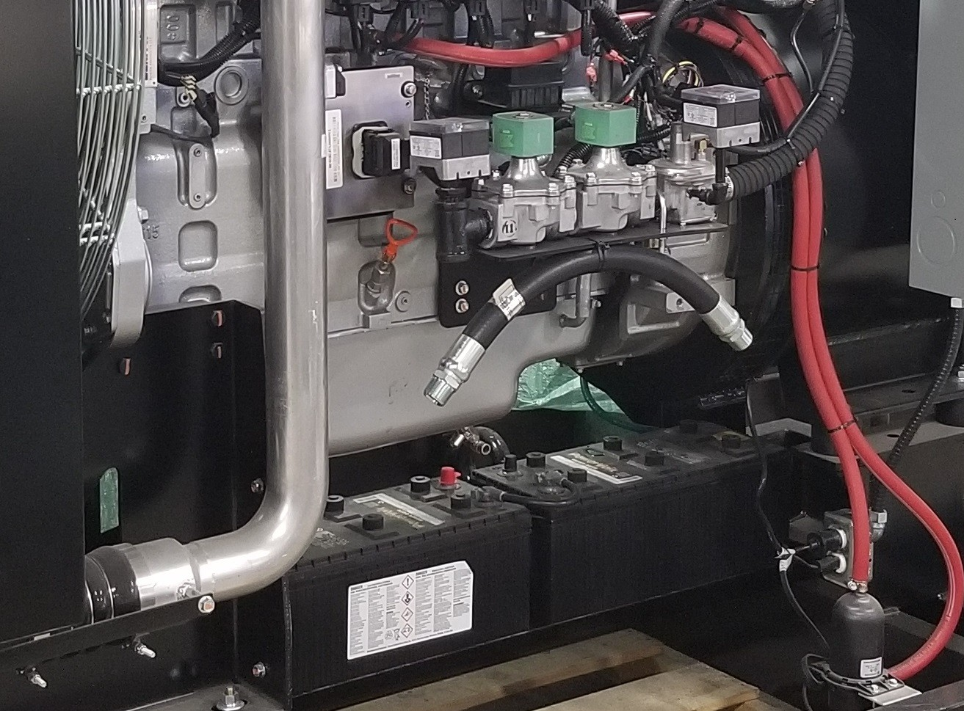
Zenith NG gen-set being assembled.
5. Control panel:
- Check integrity of panel; properly secured, water tight if out in the elements, no holes rusted through
- Ensure indicator lamps are working that should be lit
- Ensure gen-set controller is in AUTO upon arrival and when leaving
- Ensure audible and visual alarms function at fire panel; ask service provider to demonstrate how to test
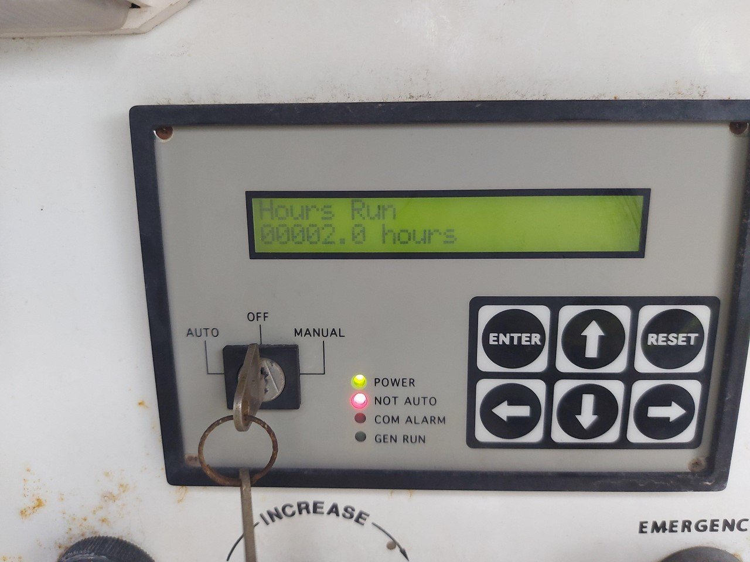
Controller has power, not in AUTO or MANUAL.

6. Inspect air (volume) control louvres to ensure proper operation; note if open or closed during inspection. A generator pushes air through the outlet damper louvres when running and draws fresh air in through the inlet damper louvres. For a visual inspection, the damper louvres would normally be closed to minimize any weather or animal intrusion.

7. Test generator emergency lighting unit(s)
8. Ensure room temperature is above 10 °C; not applicable in northern climates so you have to check to make sure the block heater is working by feeling for warmth with the back of your hand.
9. Check generator output breaker to ensure that it is turned on. (it is on when toggle is in the upper position)
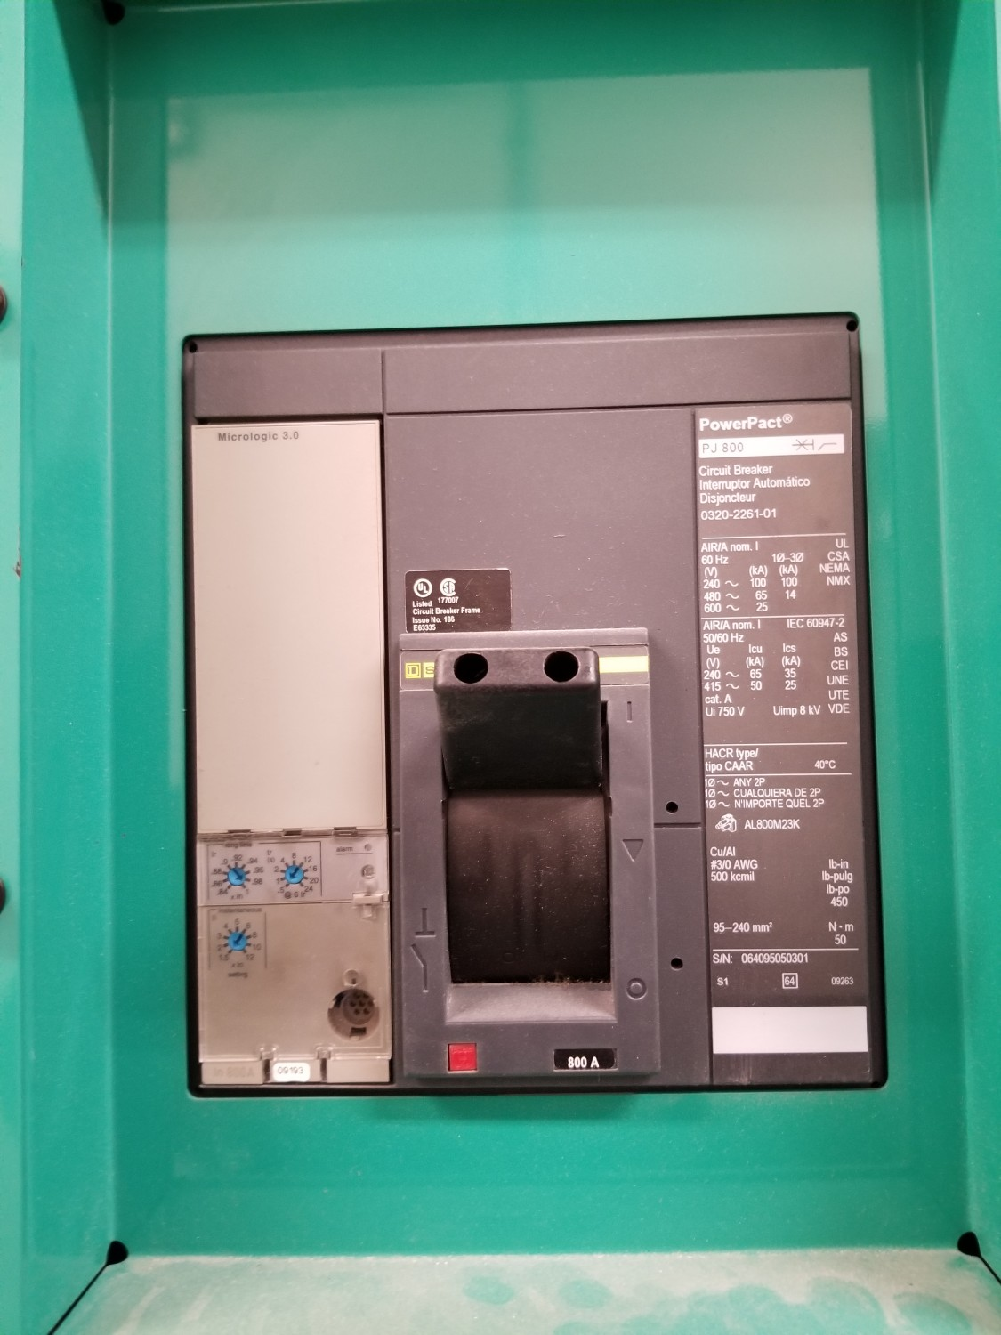
Breaker closed or in ON position.

10. Inspect generator and transfer switch room for cleanliness and accessibility to all components of the emergency system. Make note if these rooms are being used for storage or garbage that obstructs access to equipment.
11. Record all inspections, tests, and corrective actions in the log
Before leaving the generator:
Review generator controller to make sure the unit is being left in AUTO mode (ensure that the "not in auto" light is off)
Note that every generator will have a different controller depending on the manufacturer. Every controller will have a variety of indicator lights, make sure that lights indicate that the power is ON and the unit is in AUTO.

