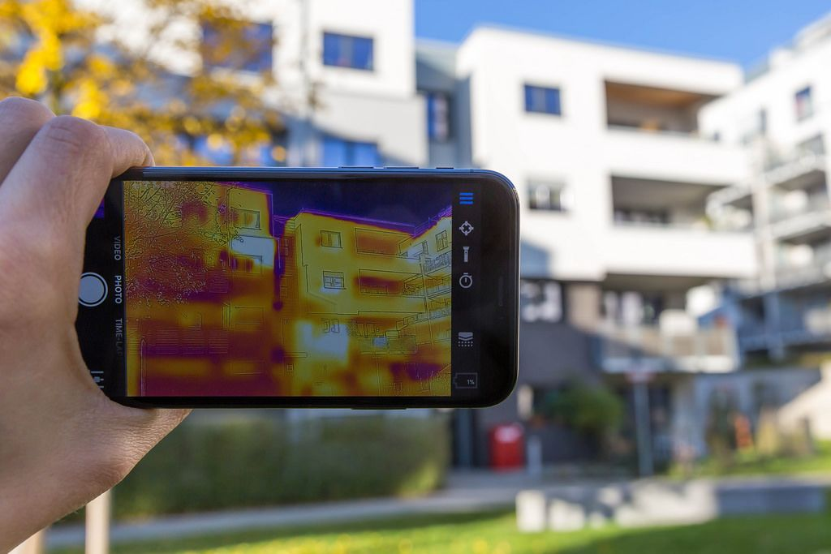
This Photo by Unknown Author is licensed under CC BY
Possibilities of Infrared Scanning
by Grant J. Eliuk and Mike Peryy

INFRARED DETECT RS / IMAGERS
Infrared detectors/imagers can be used for a variety of applications in the construction and maintenance industries. Since infrared radiation does not rely on visible light, it offers the possibility of seeing in the dark or through obscured conditions, by detecting the infrared energy emitted by objects. The detected energy is translated into imagery showing the energy differences between objects, allowing these objects to be seen. There are a great number of areas where infrared thermography can be of benefit in almost any facility. These can be broken down into several major sectors.
Condition Monitoring
- Electrical - production, transmission, distribution, switchgear, panels.
- Mechanical - motors, pumps, various rotating equipment.
- Buildings & Structures- insulation, air infiltration, roof leaks.

Process Monitoring and Control
- Refractory
- Steam Systems
- Petrochemical Processes
- Automotive Industry Process
- Metal and Plastic Processing
Quality Control and Quality Assurance
- Electronics design, verification, mass screening, diagnostics
- Mechanical Assemblies -malfunction and failure analysis
Non-destructive Materials Testing
- Cavities and Inclusions in Solids
- Composite Delamination
- Subsurface Corrosion Detection
- Moisture Detection
- Concrete Bridge Deck Delamination
Thermal Night Vision
- Security
- Surveillance
- Search & Rescue
Research and Development
- Heat Plow Studies
- Biological Studies
- Air Movement Studies
- New Product Evaluation
ADVANTAGES OF A CONDITION MONITORING SYSTEM
- Lower maintenance and production costs
- Reduced unscheduled production downtime
- Extends maintenance repair intervals
- Lower probability of catastrophic failure
- Increased personnel safety
- Reduced insurance rates
- Reduced spare parts inventory
- Unnecessary repairs minimized
- Maximize plant availability
- Maintenance or repairs can be planned for non-peak production periods
- Improved coordination of maintenance efforts
- Optimizes staff size
- Improved production quality
- Speeds up production output
- Improved communication and decision making
- Improved equipment design
- Competitive advantage
Undoubtedly there are major benefits to be derived from implementing a condition monitoring program in any facility. With electrical equipment, machinery and labor costs rising, managers, engineers and technicians alike must turn to condition monitoring technology for assistance to maintain their competitive advantage. In a survey of 557 manufacturing and process facilities that have introduced a condition monitoring program, the following average improvements were made:
- 28% increase in maintenance productivity
- 19% decrease in material cost
- 18% reduction in spare parts inventory
In addition to quantifiable cost savings, 76% of the respondents cited improved relationships between management, maintenance organizations and operations departments. These are the reasons why more and more companies are taking advantage of technology such as Infrared Thermography. Condition monitoring utilizing Infrared Thermography is a WIN-WIN situation for everyone involved.
IR/T is currently experiencing rapid growth as more and more electric utilities and industrial sectors are embracing the technology. The reason for this growth is that company personnel are understanding the benefit of this non-contact, nondestructive method. The primary benefit is to find deteriorating components prior to catastrophic failure. Thermography provides a "different set of eyes" allowing a whole new level of diagnostic aid and problem solving.
INFRARED CONDITION MONITORING
Temperature and thermal behavior of power generation and distribution equipment as well as industrial machinery and processes are the most critical factors in the maintenance of operations. Temperature is one of the first observable parameters that will indicate the operating condition of a component, and is by far the most measured quantity in an industrial environment. For this reason, monitoring the thermal operating condition of electrical and mechanical equipment is considered to be the key to any successful predictive maintenance program.
Infrared Thermography (IR/T) is a condition monitoring technique used to remotely gather thermal information for monitoring the condition of the entire electrical system from generation, distribution to end user.
Since all equipment (when operating) has a normal operating thermal signature, IR/T allows this signature to be recorded as a baseline measurement. Once this is established, IR/T over time will reveal the thermal differences deviating from the norm. This abnormally localized radiation (anomaly) can either be an over heated condition or lack of heat. This information is then reviewed and the decision is made to plot the temperature change with time and/or the repair can be initiated at the most efficient time. The information gathered can be stored and Illy analyzed, providing complete predictive maintenance capabilities.
CONDITION MONITORING PROGRAM
A condition monitoring program, properly implemented, is an important tool for modem facilities. The total maintenance cost in most plants will range from 15 to 40 percent of the total cost of goods produced. It is the single largest contributor to controllable cost in most manufacturing and process plants. It also has the largest potential for improved availability and profit in industry today.
Independent surveys indicate that North American industry spends more than $200 billion dollars each year on maintenance and that more than one third, or $60 billion, is wasted as a result of unnecessary or improper maintenance These surveys also confirm that reactive (after the machine failure) maintenance will cost an average of three times more than the same repair performed using the advance notice provided by condition monitoring techniques. The forewarning of incipient machine or system problems provided by a condition based predictive maintenance program is invaluable in saving money.
IR/T Electrical Inspections - A Brief History
The main application for thermography has always been electrical system inspections. In 1965, the Swedish Power Board began IR/T inspections. In 1976, the UK Electrical Generation Board began utilizing IR/T for predictive maintenance on their transmission lines. Canadian companies such as Ontario Hydro and B.C. Hydro also became involved with IR/T during this period.
Over the years, IR/T has proved itself as valuable tool for electrical inspections. Electrical problems manifest themselves by emitting increased heat energy. The new generation of IR scanners can easily detect and image this information. IR/T has now been implemented in virtually every major industrial setting to provide valuable information for condition monitoring and preventive maintenance.
Return on Investment
The costs involved in implementing an 11~ITT condition monitoring program are dependant on several factors. These include:
- Facility size.
- Facility type.
- Complexity of monitoring program desired. IR equipment and training either contracted out or acquired internally.
Industry in general has begun to recognize IR/T inspections as an invaluable tool. The financial savings generated by IR/T programs through increased safety, productivity and efficiency are well documented. The cost of hiring an IR inspection company is fractional compared to these savings,
Conclusion
The benefits of a properly implemented IR/T inspection program are hard to ignore. Companies hoping to maintain a competitive edge must stay current with technology. While certainly not new, IR/T is just beginning to reveal how useful it can be to all areas of industry. By reducing maintenance costs, down-time and catastrophic failure, IR/T customers will continue to enjoy a strong bottom line.

