Conserve: Recycle/at-home learning
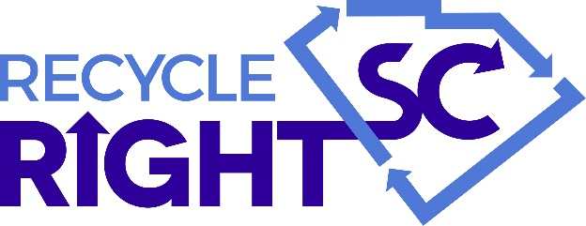
This lesson will help you and your family recycle right in your community.
Find this site: www.scdhec.gov/recyclerightsc, then answer the questions.
- What CANNOT be placed in the recycling cart/bin?
Common problem items include:
p _ _ _ _ _ _ b _ _ _, g _ _ _ _ _ h _ _ _ _ , h _ _ _ _ _ _ l _ _ _ _ _ , e _ _ _ _ _ _ _ c _ _ _ _ , d _ _ _ _ _ _ , s _ _ _ _ _ _ _ p _ _ _ _ , h _ _ _ _ _ _ _ _ h _ _ _ _ _ _ _ _ p _ _ _ _ _ _ _ and t _ _ _ o _ _ c _ _ _ _ _ _ _ _ _ .

Remember, never place your recyclables in p _ _ _ _ _ _ b _ _ _ . Return plastic bags to g _ _ _ _ _ _ s _ _ _ _ _ for recycling or donate them to f _ _ _ b_ _ _ _ for reuse.
- What CAN be placed in the recycling cart/bin?
Many common items are recyclable in most areas. For example:
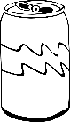
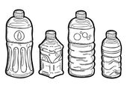

Plastic #1 and #2 bottles and jugs Cardboard Aluminum cans
By placing correct and CLEAN items in your recycling bin, recycling processing facilities are able to send cleaner product out.
How can you clean items before recycling? __________________________________
**If recyclables are not picked up at your house, you and your parents can take them to a drop-off recycling location nearest to you. To learn what recyclables are accepted near you, visit www.scdhec.gov/recycleheresc.**
Now, check which items can be recycled in your city/town (if you live in a city/town) or county (if you live outside city or town limits): paper_____ cardboard____ plastic bottles____ metal cans_____ glass containers____
- Email a fun picture of yourself to your teacher with three items that should and three items that should not be put into your recycling bin! If you don’t have a curbside recycling bin, show what items can be taken to a drop-off recycling location.

