OSHA Guidelines
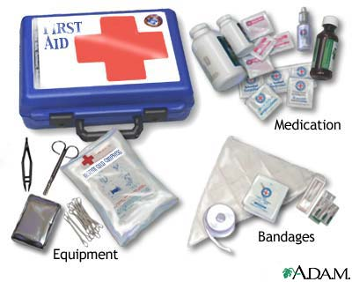

FIRST AID KITS AND SUPPLIES

OSHA CODE OF FEDERAL REGULATION 29 CFR 1910.151 (b)

Adequate first aid supplies shall be readily available.
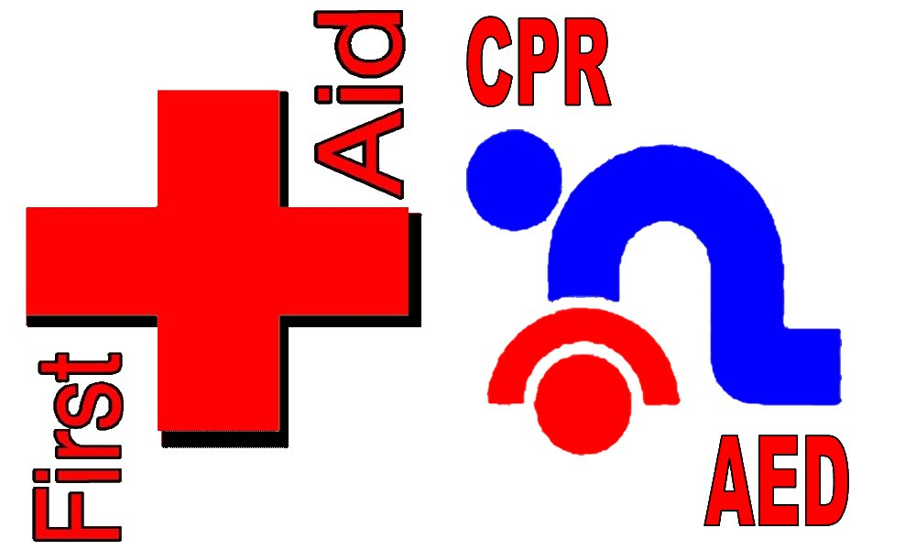

CPR AND FIRST AID TRAINING

OSHA CODE OF FEDERAL REGULATION 29 CFR 1910.151 (b)
In the absence of an infirmary, clinic or hospital in near proximity (3 minutes) to the workplace which is used for the treatment of all injured employees, a person or persons shall be adequately trained to render first aid.


BLOODBORNE PATHOGENS

OSHA CODE OF FEDERAL REGULATION 29 CFR 1910.1030 (d)
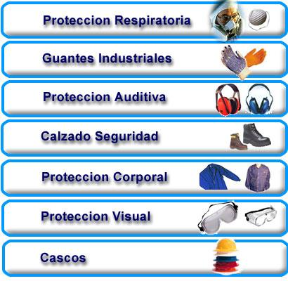
Employers shall protect their employees from the hazards of bloodborne pathogens and comply with this standard through the use of universal precautions, engineering controls, work practice controls, personal protective equipment (gloves, gowns, face shields, CPR mask, etc. ...), proper housekeeping (clean up kits, etc. ...), and handling of regulated waste.

PERSONAL PROTECTIVE EQUIPMENT

OSHA CODE OF FEDERAL REGULATION 29 CFR 1910.132 (a)
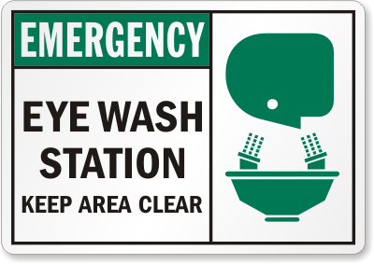
Protective equipment, including personal protective equipment for eyes, face, head and extremities, protective clothing, respiratory devices, and protective shields and barriers, shall be provided, used, and maintained in a sanitary and reliable condition wherever it is necessary by reason of hazards of processes or environment, chemical hazards, radiological hazards, or mechanical irritants encountered in a manner capable of causing injury or impairment in the function of any part of the body through absorption, inhalation or physical contact.

EYE WASH AND EYE STATIONS

OSHA CODE OF FEDERAL REGULATION 29 CFR 1910.151 (c)
Where the eyes or body of any person may be exposed to injurious corrosive materials, suitable facilities for quick drenching or flushing of the eyes and body shall be provided within the work area for immediate emergency use.

CONTINUE EYE WASH AND EYE STATIONS

OSHA CODE OF FEDERAL REGULATION 29 CFR 1910.132
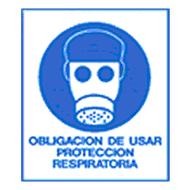
However, the employer could be cited for a violation of the general duty clause if the most reasonable predictable injury from such exposure is serious in nature, regardless if the product is corrosive or not. The information on the MSDS and/or product label demonstrates that the hazard is "recognized."

RESPIRATORY PROTECTION

OSHA CODE OF FEDERAL REGULATION 29 CFR 1910.134 (a) (2)
Respirators shall be provided by the employer when such equipment is necessary to protect the health of the employee. The employer shall provide the respirators that are applicable and suitable for the purpose intended.

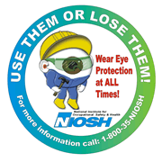
OSHA Guidelines (continued)

EYE AND FACE PROTECTION

OSHA CODE OF FEDERAL REGULATION 29 CFR 1919.133 (a)
Protective eye and face equipment shall be required where there is a reasonable probability of injury that can be prevented by such equipment. In such cases, employers shall make conveniently available a type of protector suitable for the work to be performed, and employees shall use such protectors.
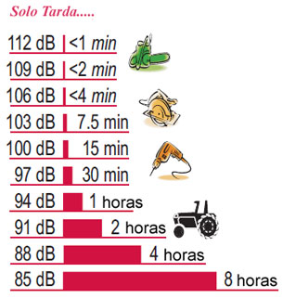
Suitable eye protectors shall be provided where machines or operations present the hazard of flying objects, glare, liquids, injurious radiation, or a combination of these hazards.

HEARING PROTECTION

OSHA CODE OF FEDERAL REGULATION 29 CFR 1910.95 (d) (i)
When information indicates that any employee's exposure may equal or exceed an 8-hour time-weighted average of 85 decibels, the employer shall develop and implement a monitoring program.

The sampling strategy shall be designed to identify employees for inclusion in the hearing conservation program and to enable the proper selection of hearing protectors.

HAZARD COMMUNICATION

OSHA ARTICLE 89, SECTION 32M (b)
The employer shall provide an employee training and education program to inform employees of the existence and content of the law; the hazard communication methods used by the employer; the right an employee may exercise under the law, and the procedure by which an employee may obtain a chemical information list and material safety data sheet.
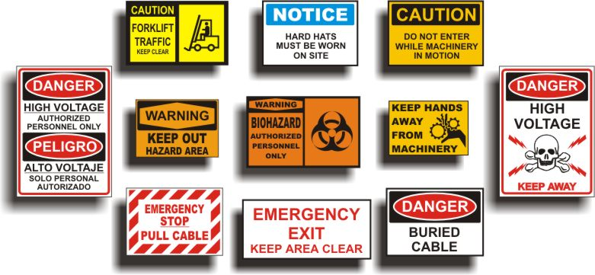

ACCIDENT PREVENTION SIGNS

OSHA CODE OF FEDERAL REGULATION 29 CFR 1910.145 (a) (1)
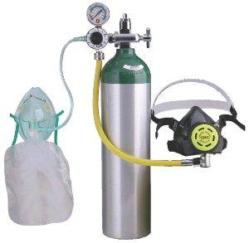
These specifications apply to the design, application and use of signs or symbols intended to indicate and, insofar as possible, to define specific hazards of a nature such that failure to designate them may lead to accidental injury to workers or the public, or both, or to property damage.

OXYGEN EQUIPMENT-EMERGENCY and (OTC) OVER THE COUNTER USE

FDA COMPLIANCE POLICY GUIDE 7124.16
Oxygen equipment intended for emergency use can be marketed for OTC distribution, but must be capable of providing a minimum flow rate of 6 liters of oxygen per minute for at least 15 minutes. The labeling for emergency oxygen for OTC use may not contain references to heart attacks, strokes, shock or any other medical condition amendable to diagnosis or treatment only by a licensed practitioner. Oxygen units providing a flow rate of less than 6 liters per minute or for a period less than 15 minutes and labeled for emergency use are regarded as adulterated and misbranded. If the units are not intended for emergency use and provide less than 6 liters/minutes or are labeled for human use for other than emergency use, such units are regarded as prescription devices.

Note: This information was extracted from the OSHA Book "29" Code of Federal Regulations, actual OSHA citations, various OSHA publications and from the FDA Policy Guidelines on "Over the Counter Emergency Oxygen Use." The information is in no way a complete record of the applicable regulations. For more detailed information, contact the PR or federal OSHA office.

