Administrative Address: Shipping/Returns Address: Canadian Address:
417 Forest St. Ste. 460 2002 Charles Ave. 1771 Robson St. Suite 1175
Kalamazoo, MI 49001 Kalamazoo, MI 49048 Vancouver, BC V6G1C9
Wholesale Division: 855-927-3066 * Customer Service: 844-802-1599
Thank You For Purchasing Our 3 Tier Plant Stand
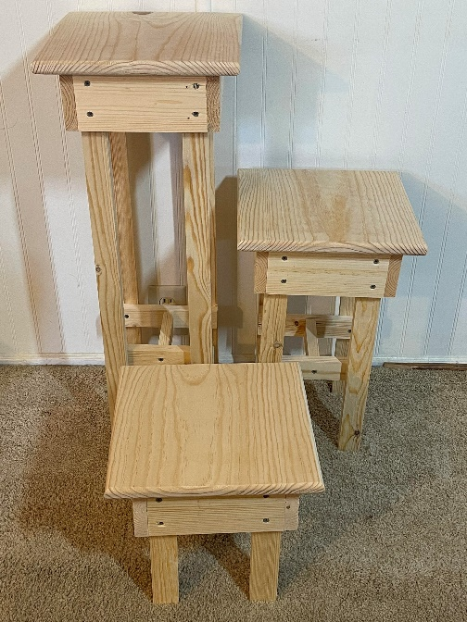
THIS IS NOT MADE FOR STANDING OR SITTING ON
STEP 1) Getting all the pieces out of the box, and there is a lot of small pieces.. You have: 2-“F” pieces; 4- “I” pieces; 12-“H”pieces; 6- “B” pieces; 6-“A” pieces; 4- “E” 27-1/2” legs, 4- “F” 17-1/2” Legs; 4- “G” 10” legs; 3- “C” Table Tops; 36- 1-1/4” Screws; 44- 1-5/8” Screws; 1- Fill It Tube.
STEP 2)Assembling the small brackets to the box base. You will need to get the four “B” boards and four “H” brackets. Using the 1-1/4” screws you will want to attach the “H” brackets to the “B” boards as shown below with about 1-3/4” gap for the legs to sit into. If you don’t have a ruler just use one of the smaller legs to use as a guide.
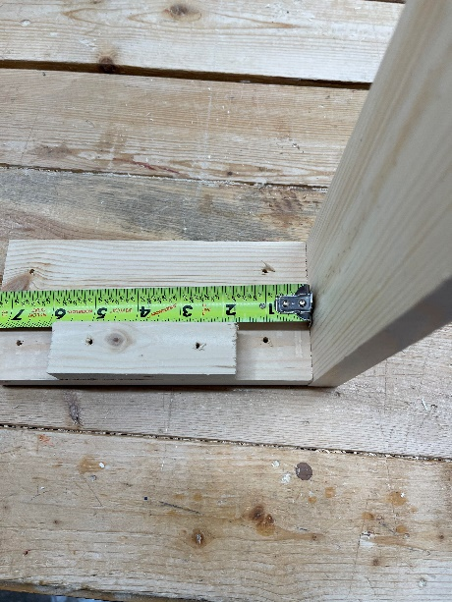 “B” “A” “H”
STEP 3) Now you need to attach the “H” brackets to the “A” boards. Just eyeball it to the middle of the board and using the 1-1/4” screw them in place.
STEP4) Now you need to make the box frame by attaching the “A” boards to the “B” boards using the 1-5/8” screws. Once you get all three box frames made, then move onto the next section. Make sure you have all the brackets on the same side on the boards.
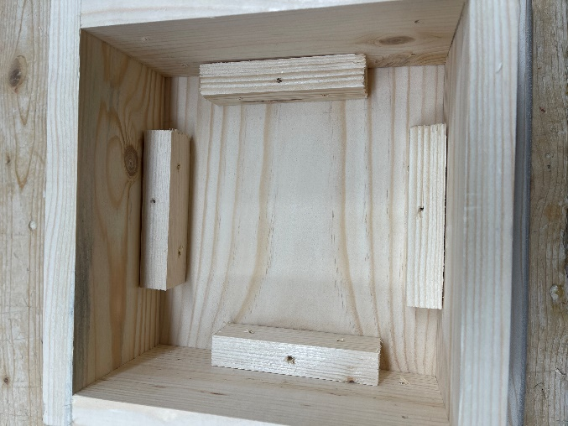 “H” “B” “A”
STEP 5) You want to set your “box” on the tabletops “C” and center the box (about 1-1/8” on all sides) then using 1-5/8” screws, screw the box down to the tabletop.
STEP 6) The legs “E”, “F”, “G” is all put on the same way, you just place them into the edge on board “B” that you attached to the tabletop and the legs should slide in and then using the 1-1/4” screws attach them to the box.
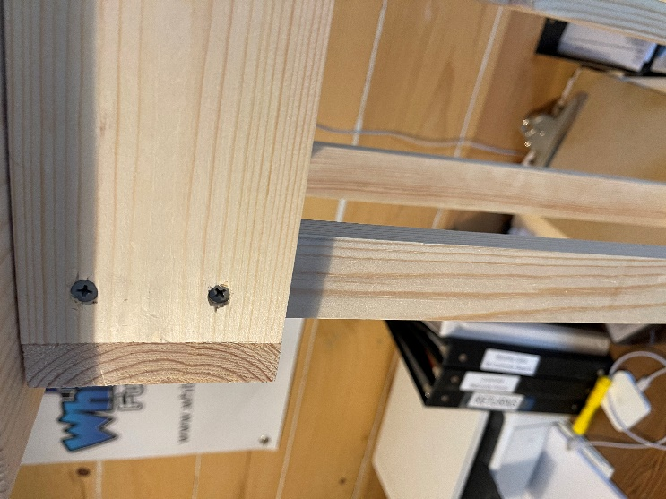 “E,F,G (depending on which tabletop you are working on)” “B”
STEP 7) Now that you have the legs attached to the three tabletop boxes, you need to attach the leg braces on the two taller ones (The small one gets no brace). Using a ruler about 6” up from the bottom of the legs you will want to attach “I” as shown below - these will go inside of the legs, and then attach “F” to “I” once you have them attached to the legs.
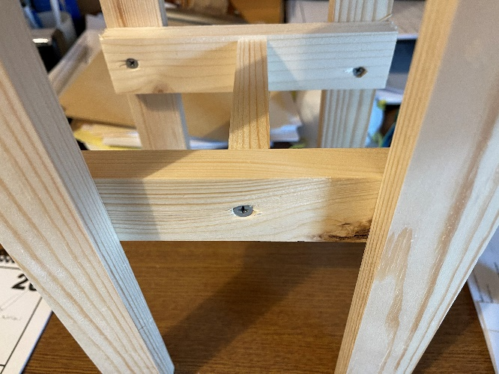 “I” “F” 