Adirondack Chair Kit
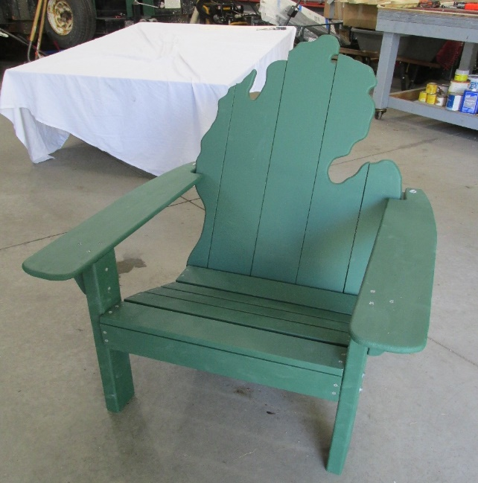

This kit contains:
ONE: Rough Sanded Chair Kit - assembly required. Paint not included.
You will need a Phillips screwdriver, two 7/16 wrenches.
All pencil marks are “General Guidelines” to help guide you through the assemble process and will be hidden almost out of sight if you’ve assembled your Adirondack Chair properly.
The chair has a weight rating of 260 pounds when properly assembled.

READ THIS GUIDE BEFORE YOU START ASSEMBLY.
This kit includes:
(7) 22 inch seat boards (2) Front Legs (2x4) (2) Armrests (1) Top back brace – 15”
(2) Leg/Seat boards (1) Bottom Back Brace 9.5” (5) Back Boards (2) ½ inch screws
(1) Back Brace (long2x4) (7) 1 5/8 inch screws (40) 1 ¼ inch screws (6) 3 inch bolts
(12) Washers (1) 3/8 x 3/4 spacer – Marked Spacer – 22 inch long
(1) 1 x ¾ spacer – marked spacer – 22 inches long
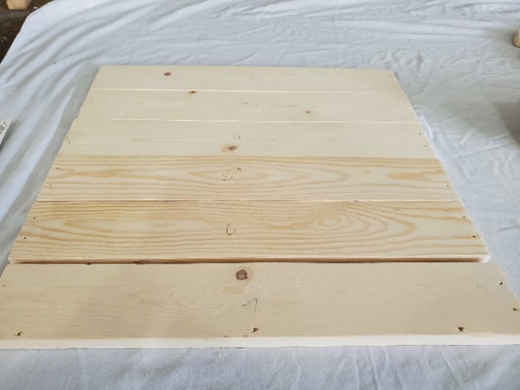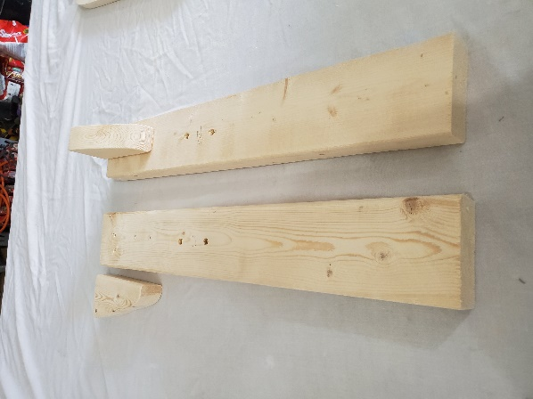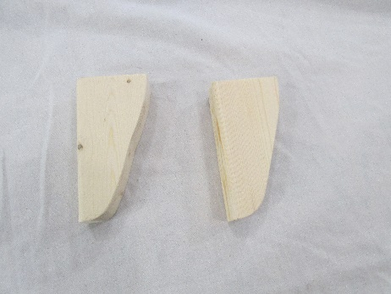
Seat Boards – 22 inches long leg Seat boards Arm Rest Handles
_____________________________________________________________________________________________
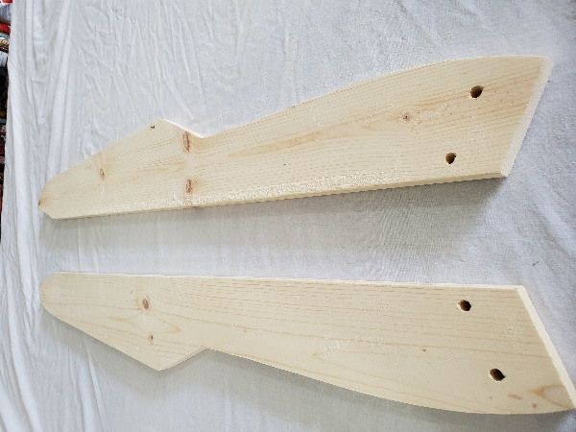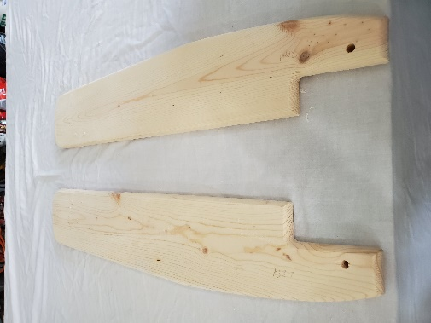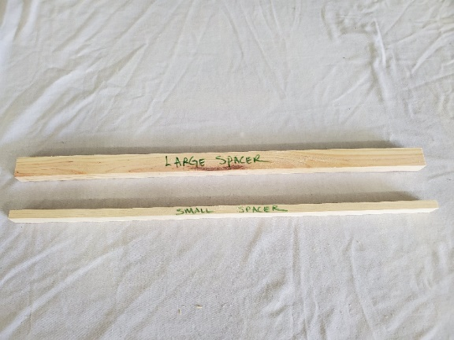
Leg/Seat Boards Arm Rests Spacers
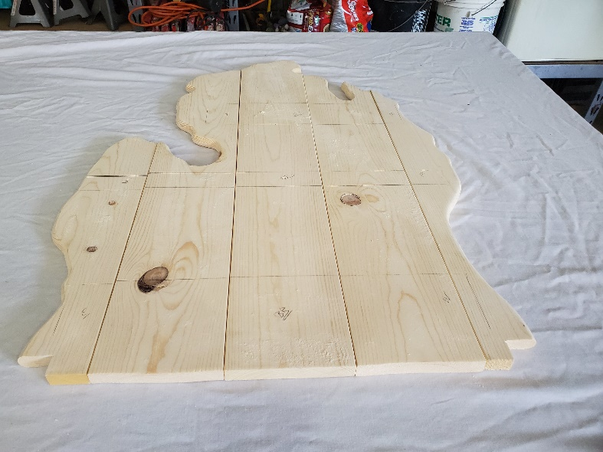
Back Boards laid out showing lines for mounting back supports. Top Brace: 1 x 15” and bottom brace 1 x 19.5; center brace 2x4 with angled edge cut

Assembly Instructions:
Remove all contents and verify you have all parts as listed above
. 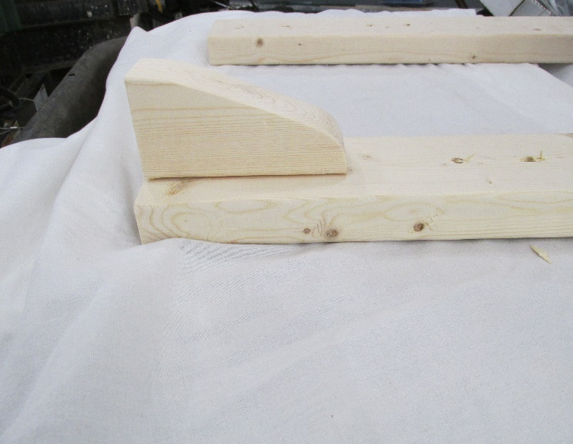
Step A) Attach the armrest handles to the top of the front legs – 2 x 4’s using (2) – 2 ½ screws. The arm rest handles should be placed flush to the top of the front legs, with bottom leg mounting holes in noted position. Use a clamp if necessary, to hold the armrest handles while you make the 2 (per armrest) screw connections. You may want to pre-drill – the armrest handles using the corresponding holes in the 2 x 4.

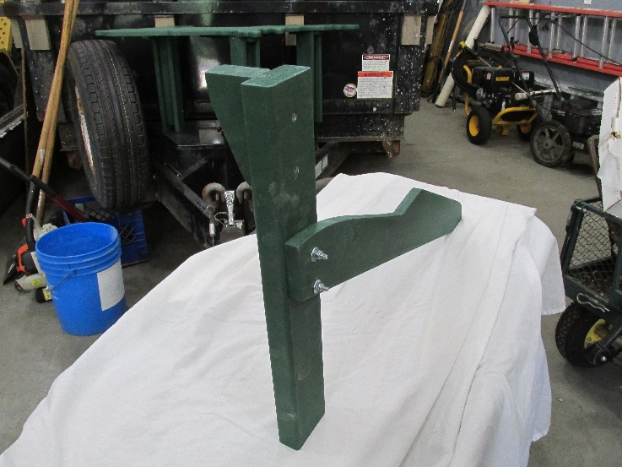
Step B) Assemble the front legs (Step A) to the leg/seat boards with (2) bolts, (2) nuts and (4) Washers on each leg. You will need to be on level ground. This picture is of the left front leg. You will have a similar assembly for the right front leg.

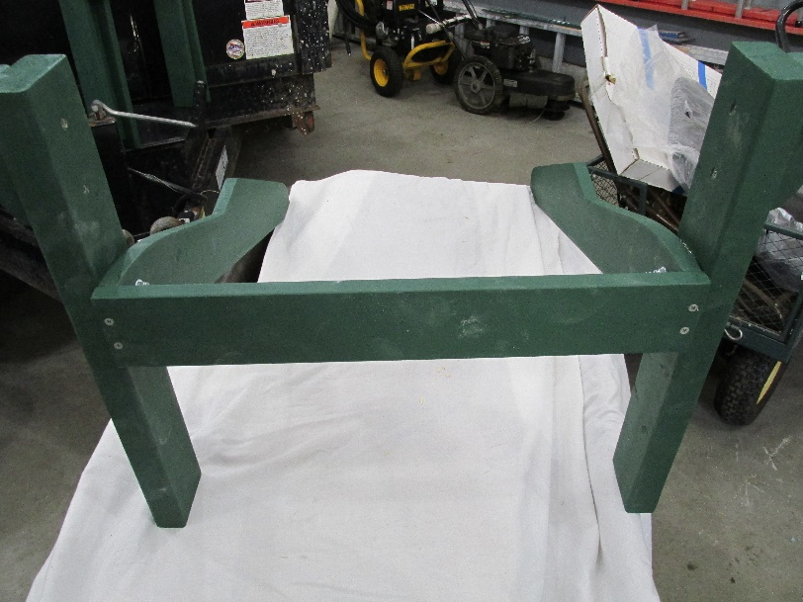
Step C: Assemble the front seat board (Marked FB). This front seat board takes (4) – 1 5/8” screws. The front seat board sets the distance of the 2 front legs. It sits between the 2 legs and mounts flush to the front ends of the leg/seat board support. You may wish to pre-drill holes into the ends of the leg/seat boards. The front seat board is considered board #1 of the 7 seat boards.

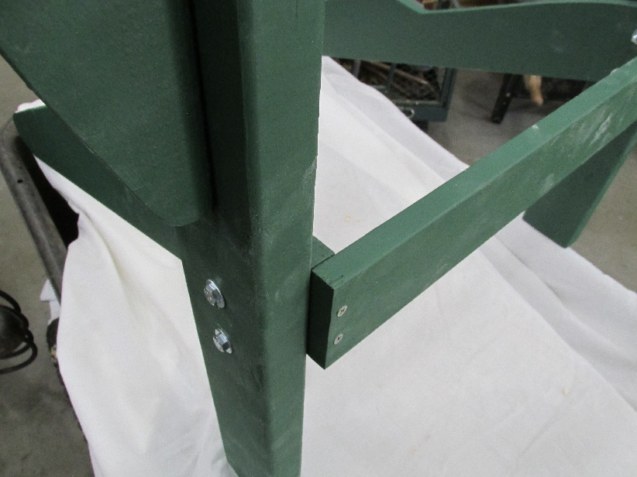

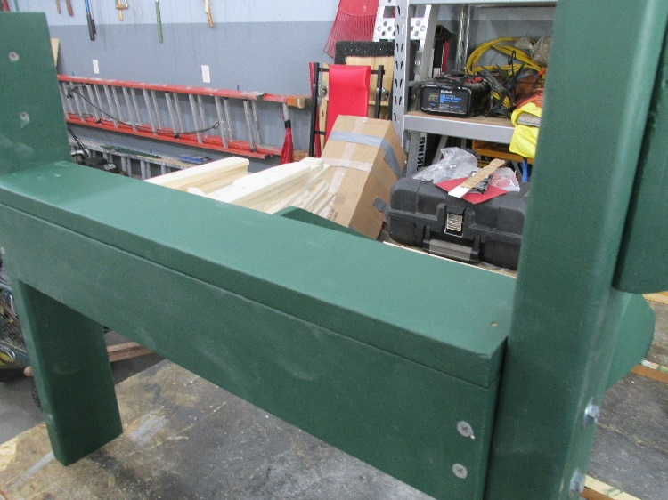
Step D) Place seat board #2 at the front edge of the front board (FB). Screw in using 1 ¼” screws

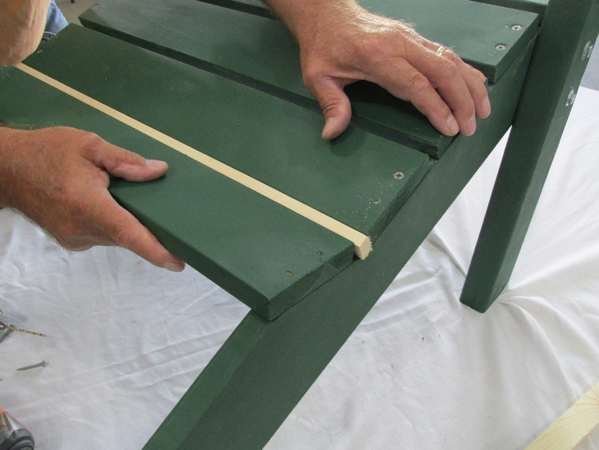
Step E) Use the small spacer (small side up – 3/8”) to space boards #2-#6. Use 1 ¼” Screws to attach these boards. Make sure the ends of the seat boards are flush with the edges of the leg/seat boards.
3/8 inch spacer

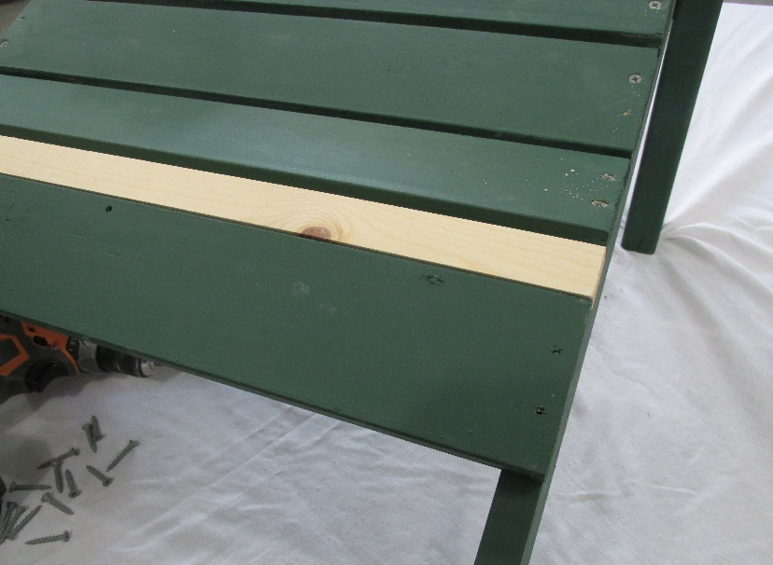
1-inch spacer
Step EE) Use the large spacer (wide side up – 1”) to set the space between seat board #6 and #7. This is where the back will fit in. Board #7 goes in the with the drill holes facing towards the front of the chair Use 1 ¼” screws to attach these boards.
#7
Front
Step F) Place the armrests with the notches at the rear and facing inward. Place the center screw only in each armrest. The arms stick out 3 ¾” from the front of the 2x4.
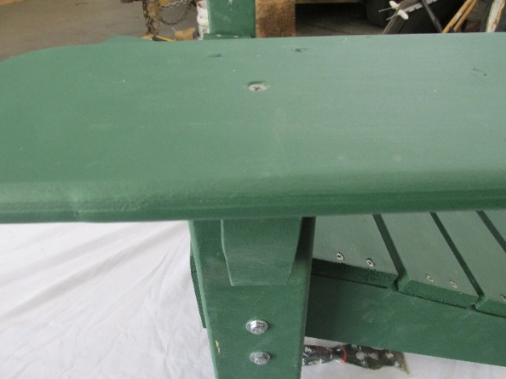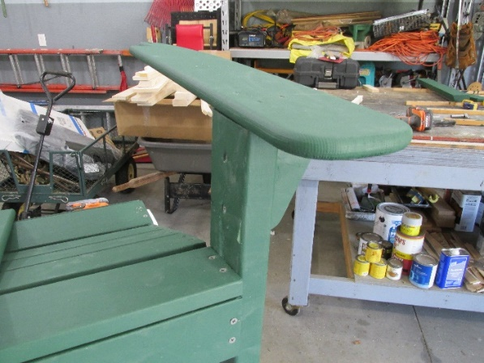
Screw should go thru center of armrest support
3 ¾”

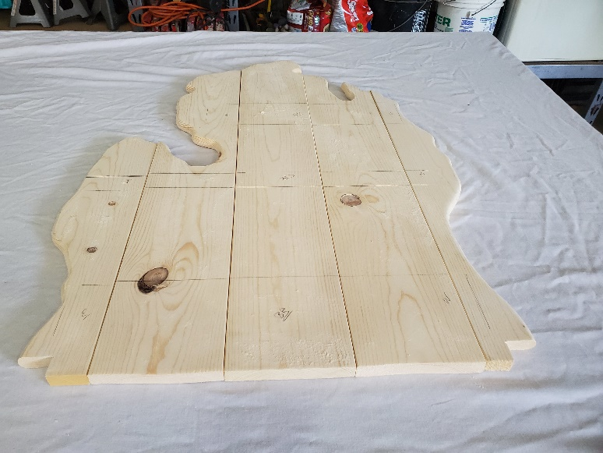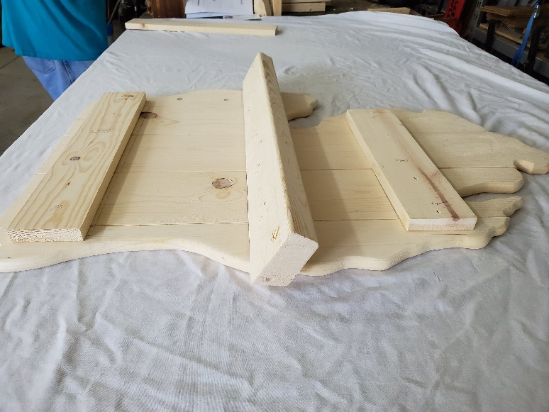
21”
12”
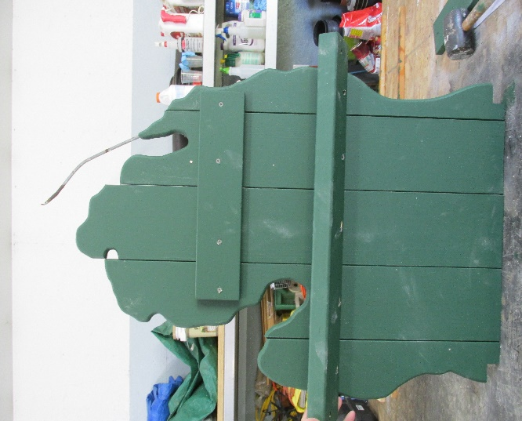
Step G) Align back boards with pencil side up. If you have painted your boards, the top brace (TB) lower edge will be placed 21” from the bottom edge. Secure with (4) 1 ¼” screws. Place the center brace (CB) lower edge at 12” from the edge. The sides of the 2x4 Center Brace should by 1 ¾” over on each side of the back of the chair. When aligned, screw in (5) 1 ¼” screws.
Ensure the center brace 2x4 is angled as noted in the picture. Do NOT attach the bottom brace (BB) at this time.
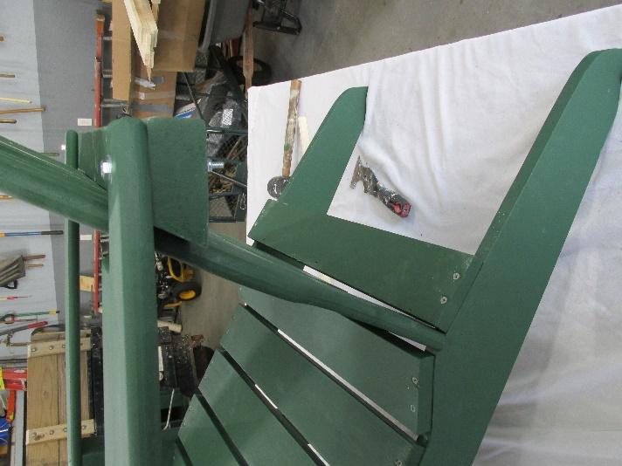
Step H) Place the back (mitten) of the chair in the opening of the seat between the 6th and 7th seat boards. Raise the seat back up until the armrests match to the center back brace and secure with 2 bolts.

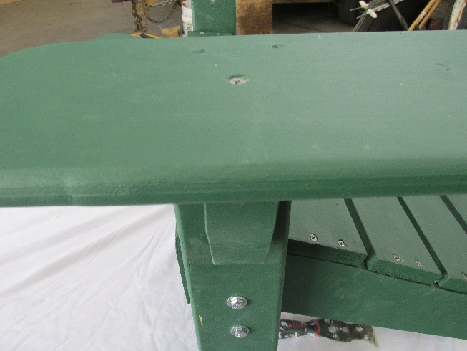
Step I) Once the back of the armrests is bolted in. Go back and secure the final 2 screws in each arm rest.
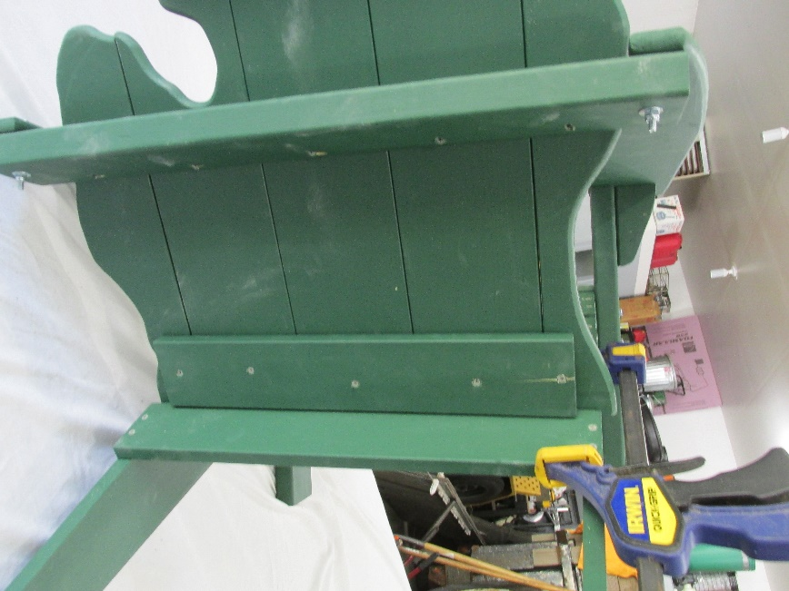
Step H) Secure the bottom brace (BB) with (5) 1 ¼” screws.
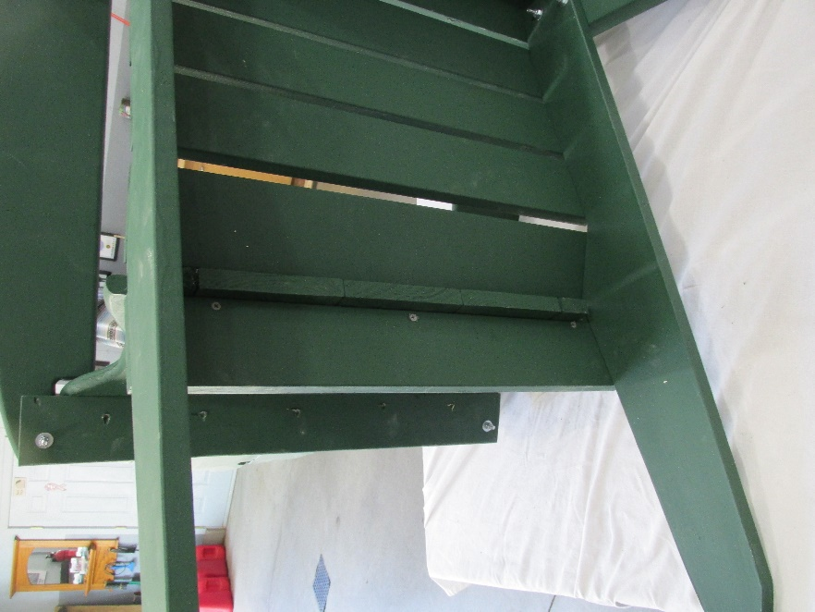
Step I) Tip the chair over and secure the back to the 7th board using (3) 1-5/8” Philips screws. You may wish to use a clamp to hold the back firmly to the board (see previous pic). These are for leveling the chair to the level surface and screwing the back to the seat. One screw may not need to be as tight as the other screws depending on how the leg/seat boards sit.

Tip the chair back to the sitting position and check your work to see if all four points are touching the level surface.

Woo Hoo!!!! You are done!

Make sure all screws and bolts are tight and the chair is securely able to hold weight BEFORE SITTING IN IT.

This chair has several sharp areas that may cause injury.

DO NOT LEAVE CHILDREN UNATTENDED ON THIS PRODUCT.
Helpful Tip:
To make your chair last a little longer; we recommend applying a thick layer of super glue to the bottoms of the legs where they rest on the ground. This will help seal out moisture and prolong your furniture product.
Warranties – If you want the FREE 3-year warranty you must go to our website: www.whitepinefurniture.com and click on the warranty page within the first 30 days of owning a White Pine Furniture product; fill out the online form, and send us your email address and phone number as these will be how you file a claim with the CPS Warranty Services.
Customer/Tech Support – If you need to contact us, just call our toll-free number 844-802-1599 and one of our support representatives will contact you as soon as possible during our normal business hours.

The Content included in this Instructions, and/or Web site has been compiled from a variety of sources and is subject to change without notice as are any products, programs, offerings, or technical information described in this instruction sheet. We makes no representation or warranty whatsoever regarding the completeness, quality, or adequacy of this material or Content, or the suitability, functionality, or operation of this material or its content. By using this direction, you assume the risk that the Content on this material may be inaccurate, incomplete, offensive, or may not meet your needs and requirements. WE SPECIFICALLY DISCLAIMS ALL WARRANTIES, EXPRESS OR IMPLIED, INCLUDING WITHOUT LIMITATION THE WARRANTIES OF MERCHANTABILITY, FITNESS FOR A PARTICULAR PURPOSE, AND NONINFRINGEMENT WITH RESPECT TO THESE WEB PAGES AND CONTENT. IN NO EVENT WILL WE LIABLE FOR ANY SPECIAL, INDIRECT, INCIDENTAL, OR CONSEQUENTIAL DAMAGES EVEN IF COMPANY HAS BEEN ADVISED OF THE POSSIBILITY OF SUCH DAMAGES.
-- OR Depending on State -- The information and content on this instruction material is provided "as is" with no warranty of any kind, either express or implied, including but not limited to the implied warranties of merchantability, fitness for a particular purpose, and non-infringement. The references and descriptions of products or services within this material are provided "as is" without any warranty of any kind, either express or implied. We are not liable for any damages, including any consequential damages, of any kind that may result to the user from the use of the materials in this material or of any of the products or services described hereon.

White Pine Furniture Company 2019-4 www.whitepinefurniture.com

