THANK YOU FOR BUYING ONE OF OUR FOOTSTOOLS
This kit contains: 2-side boards, 2-2x4 legs, 9-1-1/2”x22”boards, 2-1x1x22” boards, plus 24- 1-1/4” screws, 8- 1/5/8” screws, and a SMALL and LARGE (wider) Spacers
STEP 1) Use the 1-1/4” Phillip Screws to screw the boards as shown in these photos.
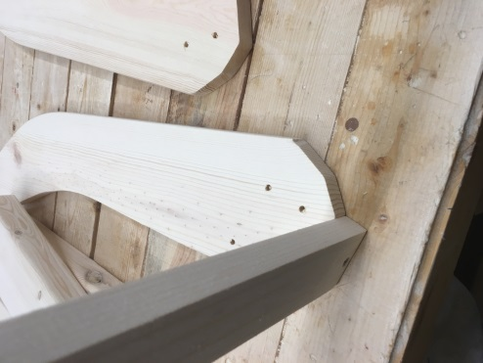 Start at this side of the footstool placing the top edge of the footboard to the first edge of the side board as shown in this photo.
STEP 2) 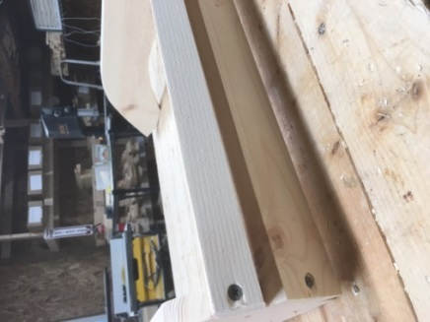 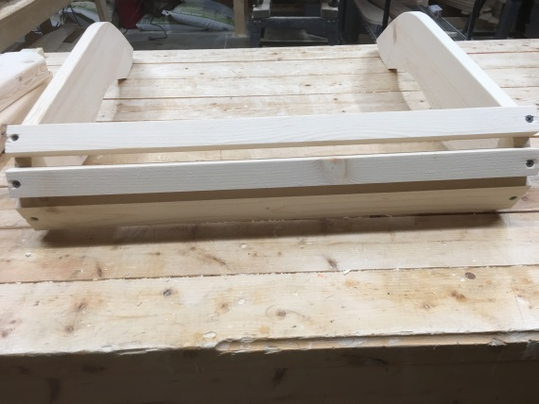 then add the TWO smaller boards to go around the front curve as shown in the above photos .
STEP 3) Using the LITTLE SPACER 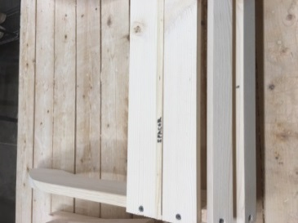 working your way backwards (the small end up – you want a ¼” gap) 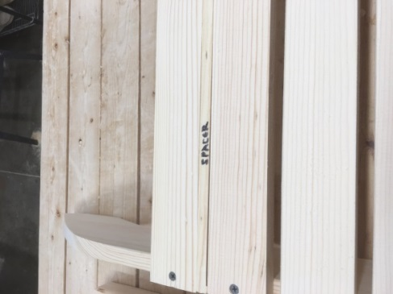 as shown in this photo.
STEP 4) When you get to the LAST TWO boards you will want to use the LARGE SPACER to give it the larger gap as shown in this photo. 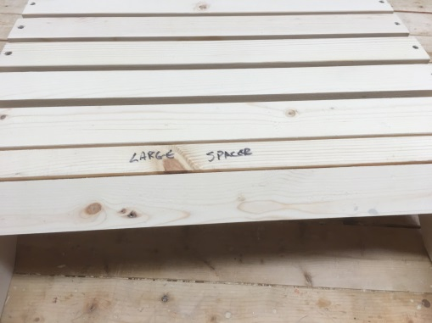 and then the final board is in place it should look like this photo….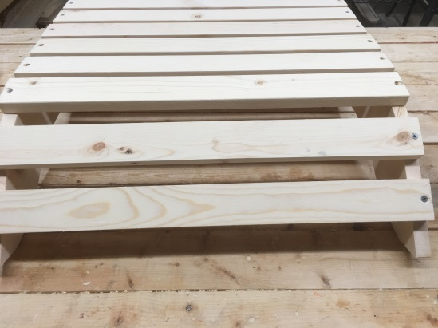
STEP 5) The 2x4 leg, the longer cut faces the FRONT of the footstool as shown in this photo below.
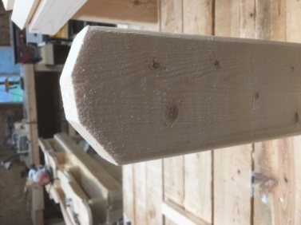 PLACE UNDER the footstool, and use the 1-5/8” Phillip screws to screw the legs to the side boards. The 2x4 legs go INSIDE the side boards.
STEP 6) At this time your footstool should be done and looks like this: 