Hallway Shoe/Boot Bench w/Rack
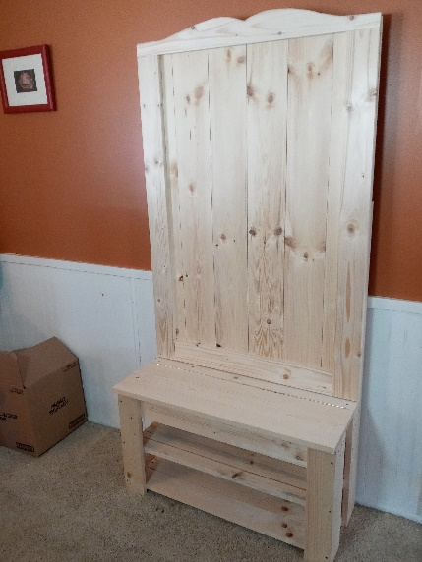
This Kit Contains:
130 – 1-1/4” Screws 2 – 2-1/2” Screws 6 – 1-5/8” Screws 4- 1x6x46 ¾” Boards (marked 2,3,4,5) 2 – 1x5.75”x 46 ¾” Boards (marked 1 & 6) 1 – Bench Top Board 10x32.5” 1 – 1x4x32.5” (HB) Board 1- piano hinge 3 – Coat Hooks (11 total) 31” boards (8) 31” boards are pre-drilled (4) 18”Legs (2) 18” Front legs NOTE:Pre-drilled holes along long edge (4) 11” braces: (2) 9.5” box ends
(3) 31 “boards with NO PRE-DRILLED holes. These are for the optional middle shelf.

Step 1: Assemble sides
Place (2) 11” braces onto (2) 18” leg boards. Use (4) 1 ¼ screws for each brace. Place one brace flush to the bottom edge of the boards and flush to the outer edges. NOTE: the tops of the legs have (6) pre-drilled holes. Place the second brace 6 5/8 “ from the bottom of the leg to the bottom of the brace. Repeat this for the other side assembly.
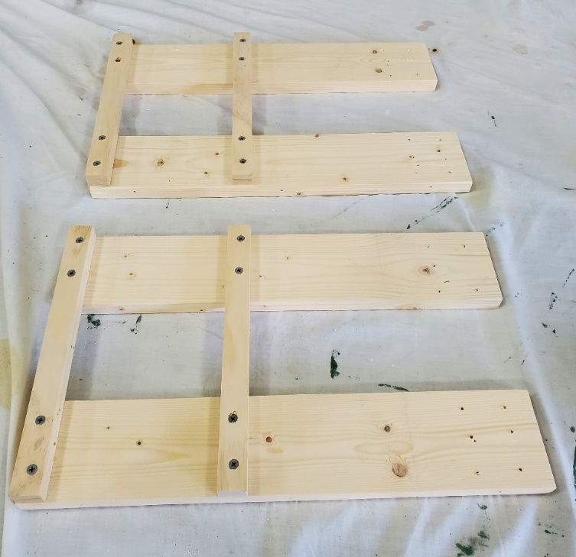
6 5/8 inches
Ensure edges are flush
Step 2: Attach front leg boards
Attach one front leg board to each of the side assemblies. These boards have (3) pre-drilled hole aligned to the long side of the 18” board. Use (3) 1 5/8 screws per leg.
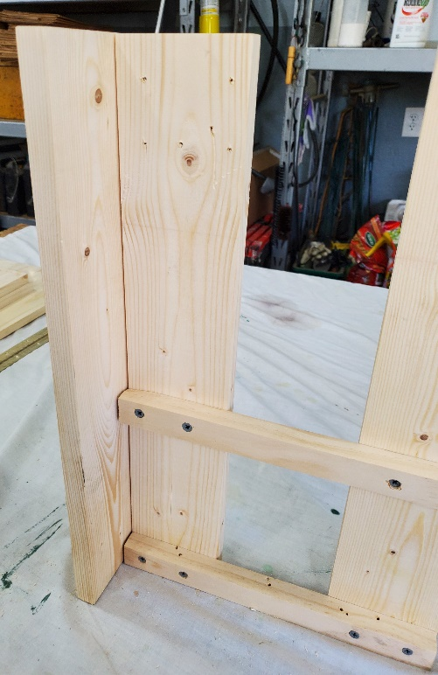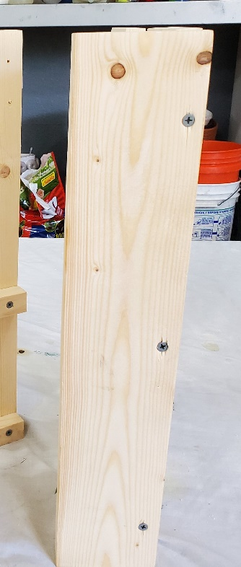

Step 3: Bottom shelf
Place (3) 31” shelf boards using (2) 1 ¼ screws on each end. Place board #1 flush to the corner, #2 placed flush to the front and then split the difference with board #3.
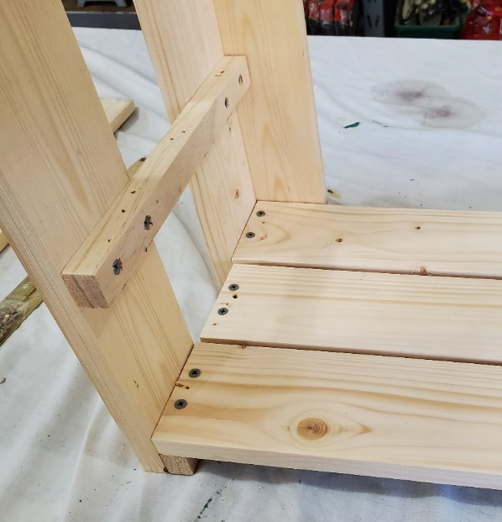
1
2
3
Step 4: Build Storage Box
Assemble box frame by using (2) 31” boards and the (2) 9.5” box end boards using (8) 1 5/8 screws. Utilize a clamp for ease of assembly.
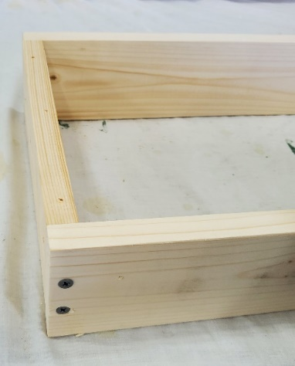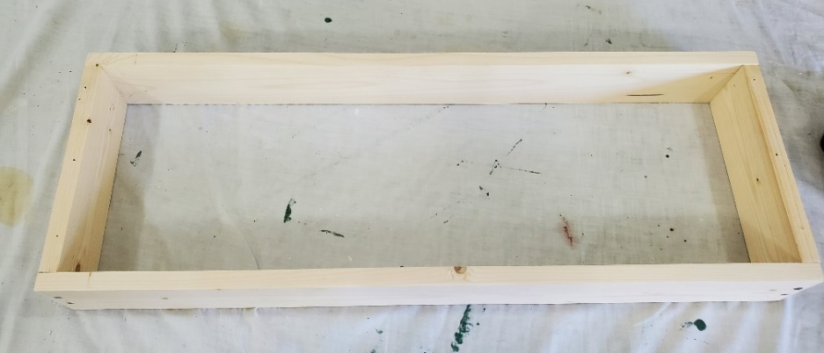
Use (3) 31” boards to create the bottom of the storage box. Secure each board with (4) 1 ¼ screws. Place boards 1 and 2 flush to the outside edges and then split the distance with board #3.
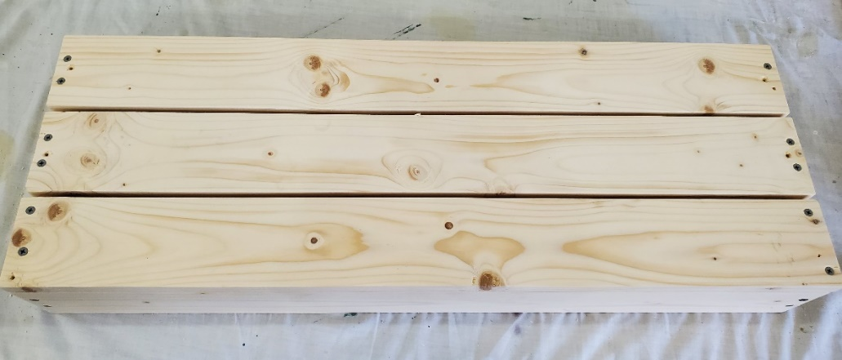
2
3
1

Step 5: Assemble box to the legs
Tip the box up onto its side and align the top of the leg assemblies flush to the edge of the box frame and attach each leg with (6) 1 ¼ screws. Assure that the box is flush to the edge of the legs.
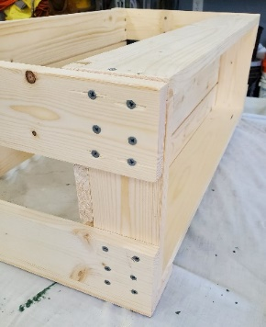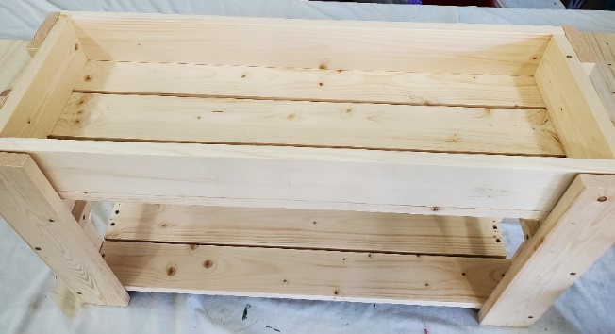
Step 6: Attach Hinge and Top seat board/Hinge Board
Stand up the unit and center the lid (seat) of the storage box on the frame. Attach the Hinge Board (HB) to the Top Lid Board (1x10) using the Brass Piano hinge. Center the hinge on the lid, secure the hinge at each end to both the lid and Hinge Board (HB) using the brass screws contained in the hinge package. Test that the hinge is operating properly and then proceed to install the remaining brass screws
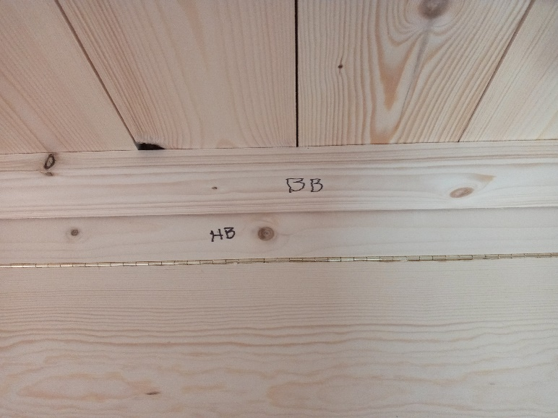 Once the piano hinge is installed then secure the Top Lid and HB to the Bench using four (4) 1-1/4” screws (two at each end)
Step 7: Optional shelf
Add the removable shelf boards to create a second shoe shelf. If you are storing boots, set these boards aside.
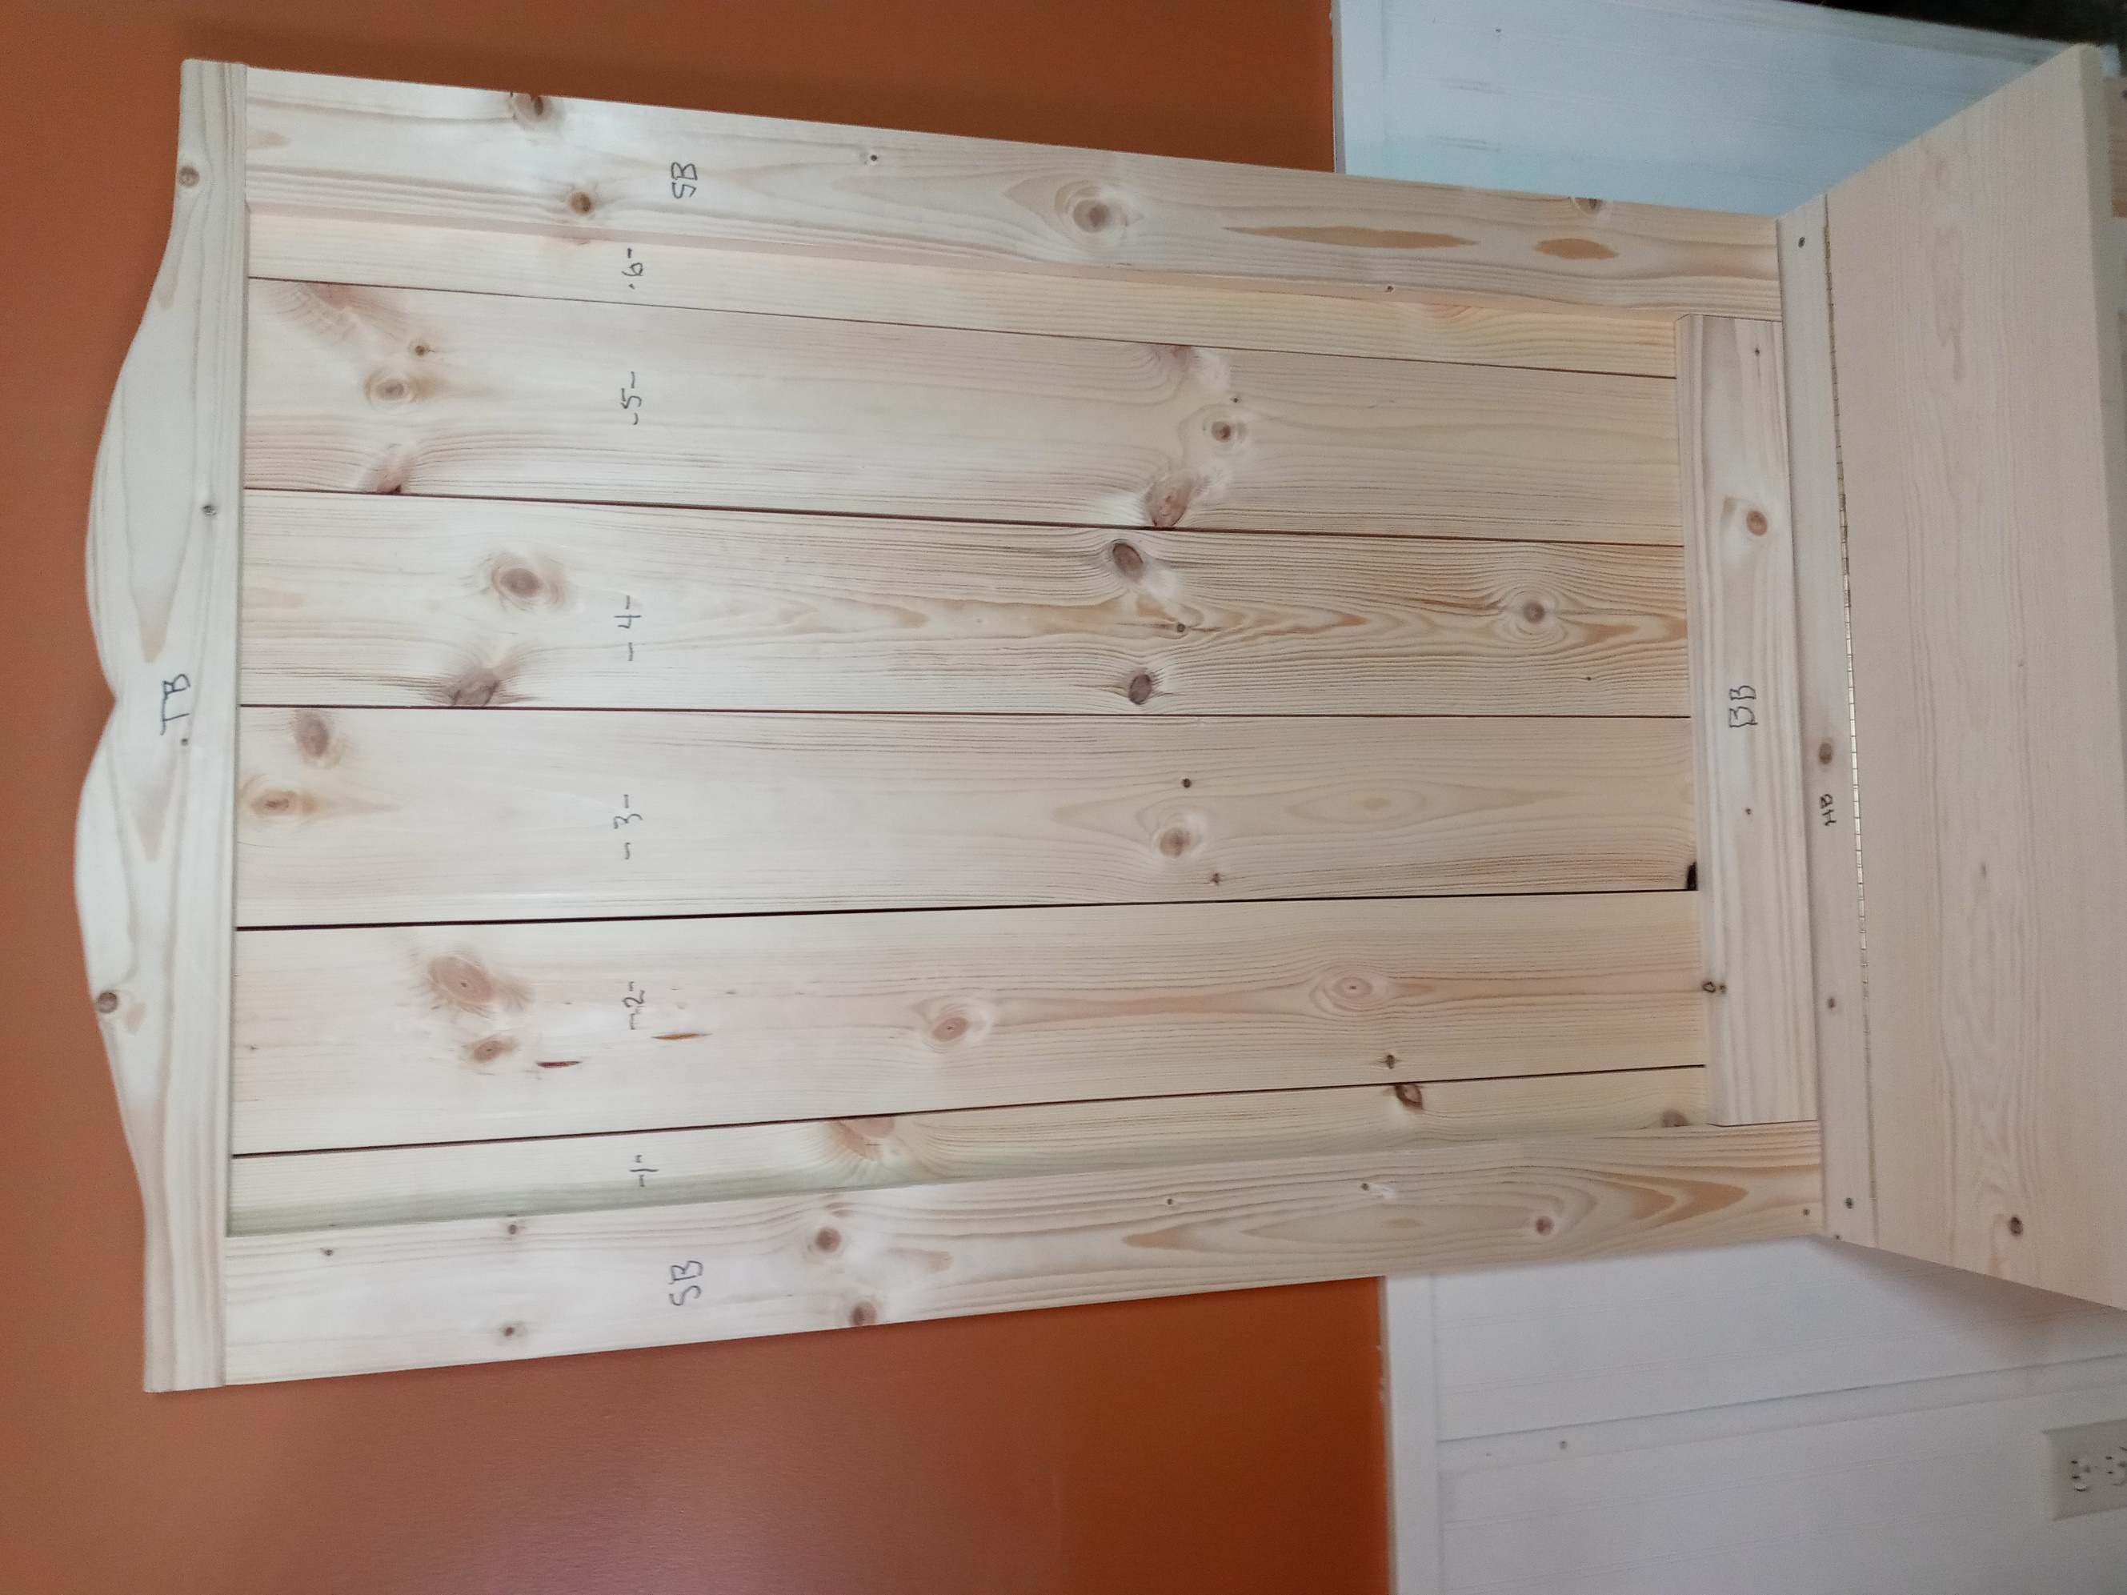
Step 8: Installing the Back Rack
YOU WILL BE DOING THIS FROM THE BACKSIDE TO
THE FRONTSIDE FACING DOWN.
- Set boards 2, 3, 4, 5 down on the table, then set board 1
on one side and board 6 on the other side. Make sure you
have board 1 and 6 screw holes on the sides facing out on
the sides as these will attach the trim (SB) boards.

- Attach the SB boards to boards 1 and 6. These SB boards
should be even with the sides of the boards 1 and 6.

- Then screw in the BB board on the bottoms of the back
boards (1,2,3,4,5,6,) and this should be even at the bottom and fit in between the two SB boards as shown above.

- Then you will need to attach the TB board (the top board with the curve side up) to the back boards (1,2,3,4,5,6)
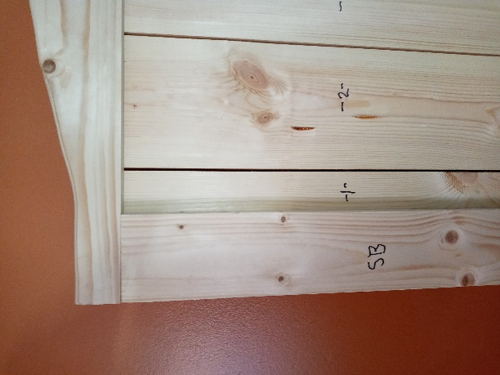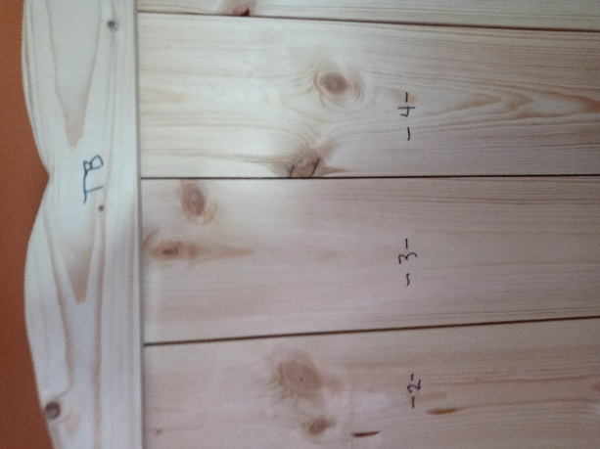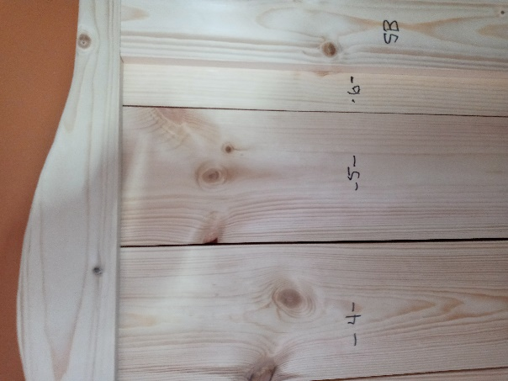

Now that the back is put together you will need to work on putting it on the hutch.

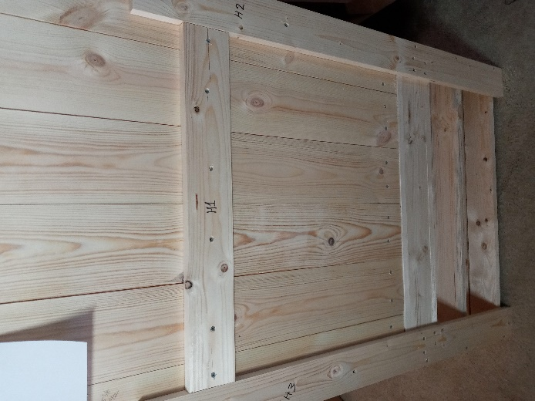 Attach H2 and H3 to the hutch THEN to attach the back rack to these two braces supports. Then screw in H1 in the middle as shown in the above photo.
- You have two 2-1/2” screws to secure it to the wall to prevent it from tipping over if there is too much weight sitting on the frontside of the bench. We recommend that you secure it to the wall through boards 2 and 5 and through the H1 board to give a secure tight fit to the wall.

- You have three coat hooks remaining to be placed on the frontside wherever you wish to place them.

ENJOY THIS CRAFT KIT FROM WHITE PINE FURNITURE

