DOG FEEDER STATION
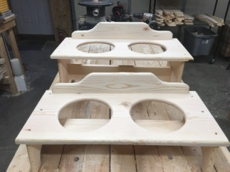
Enclosed you will find everything you need to put your pet’s doggie dish holder together. There are 12 -1-5/8 screws and you will need a Phillip screwdriver for this easy assembly. I would suggest you paint this before use.
STEP 1) Check your box to make sure you have everything. You should have:
- Dish Plate, 2-Legs (2 Small –OR- 2 Large), 1-Name Plate, 1-Brace, 12-1-5/8 Philips Screws
Assembly time: 10 minutes (painting time not included)
STEP 2) Screw four 1-5/8 screws into the legs to the brace as shown in this photo below. Assemble the bottom brace sideways for the feeders as shown here in this photo below.
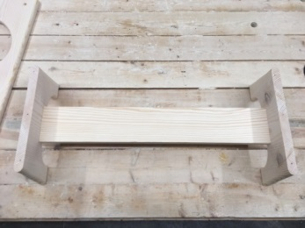 The rounded leg edges go outside..

STEP 3) Center the top plate on the legs then screw six 1-5/8 screws onto the top of the plate that holds the stainless steel dishes. 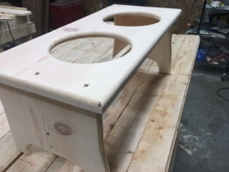
STEP 4) Using the last two remaining screws, screw in the “Name Plate” on top of the dish plate as shown in this photo .