Hallway Shoe/Boot Bench
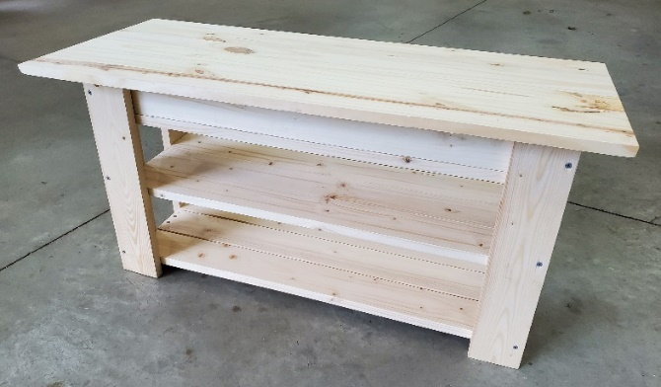
This Kit Contains:
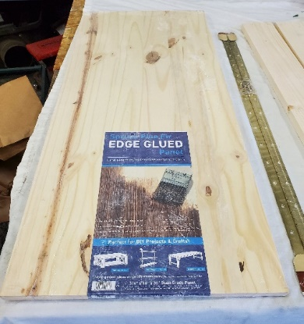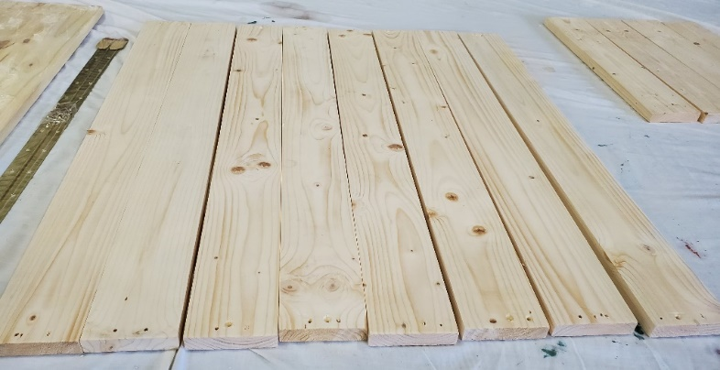
- 1x16x36” Top Lid (8) 31” shelf boards and (2) 31” boards for storage box – all pre-drilled.
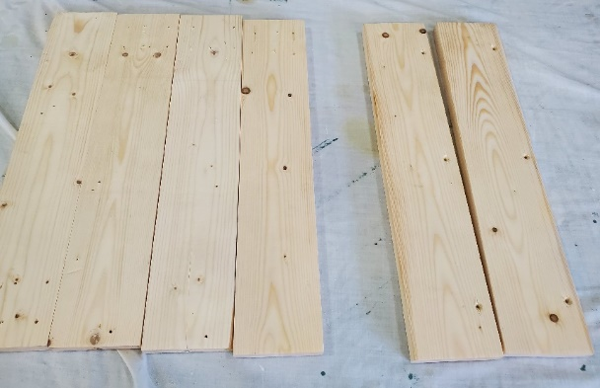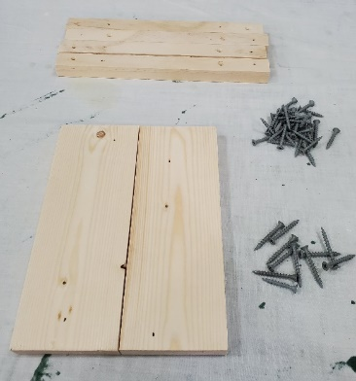

(4) 18”Legs (2) 18” Front legs – (4) 11” braces: (2) 9.5” box ends:
NOTE:Pre-drilled holes along long edge 1 1/4 and 1 5/8 screws
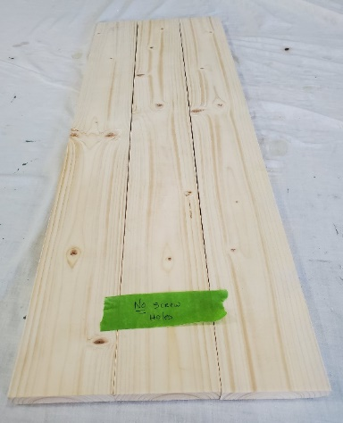
(3) 31 “boards with NO PRE-DRILLED holes. These are for the optional middle shelf.
Step 1: Assemble sides
Place (2) 11” braces onto (2) 18” leg boards. Use (4) 1 ¼ screws for each brace. Place one brace flush to the bottom edge of the boards and flush to the outer edges. NOTE: the tops of the legs have (6) pre-drilled holes. Place the second brace 6 5/8 “ from the bottom of the leg to the bottom of the brace. Repeat this for the other side assembly.
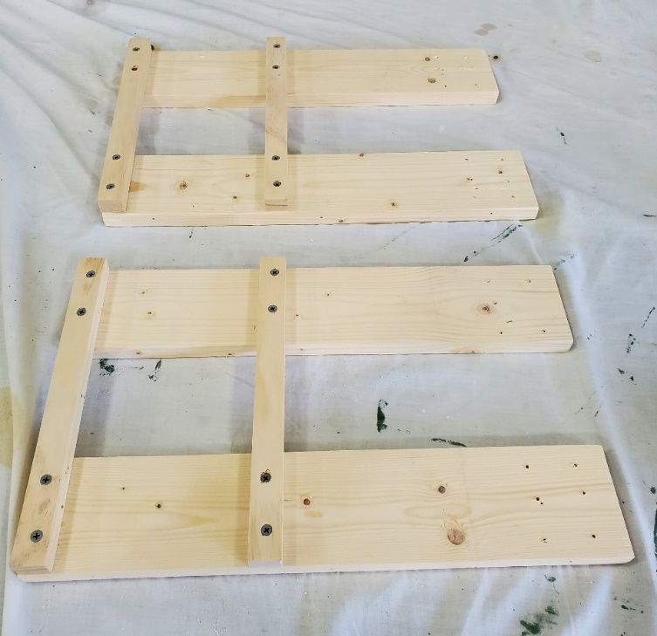
6 5/8 inches
Ensure edges are flush
Step 2: Attach front leg boards
Attach one front leg board to each of the side assemblies. These boards have (3) pre-drilled hole aligned to the long side of the 18” board. Use (3) 1 5/8 screws per leg.
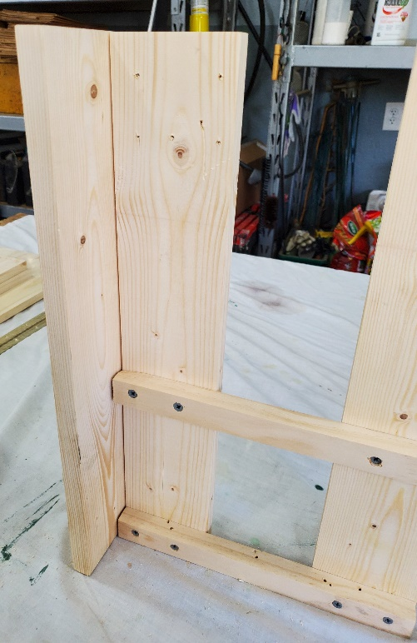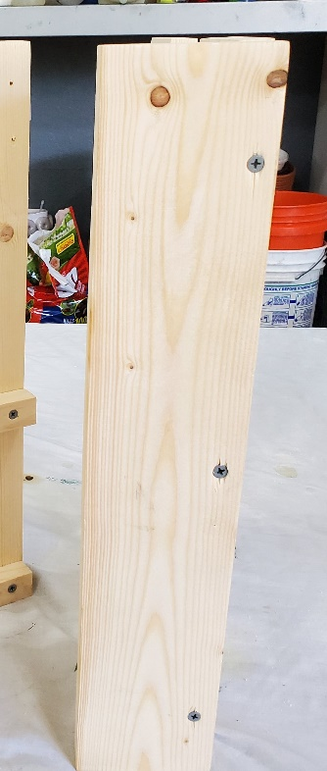

Step 3: Bottom shelf
Place (3) 31” shelf boards using (2) 1 ¼ screws on each end. Place board #1 flush to the corner, #2 placed flush to the front and then split the difference with board #3.
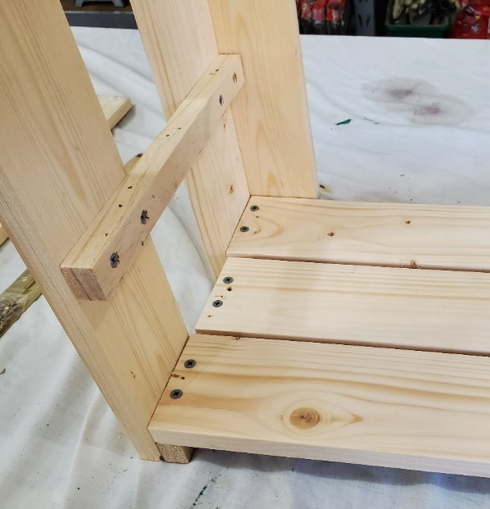
1
2
3
Step 4: Build Storage Box
Assemble box frame by using (2) 31” boards and the (2) 9.5” box end boards using (8) 1 5/8 screws. Utilize a clamp for ease of assembly.
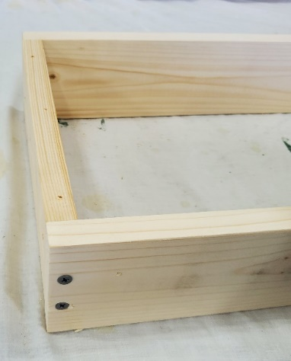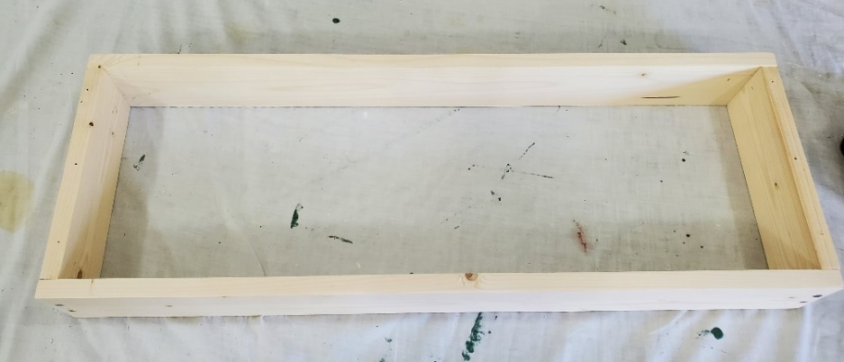
Use (3) 31” boards to create the bottom of the storage box. Secure each board with (4) 1 ¼ screws. Place boards 1 and 2 flush to the outside edges and then split the distance with board #3.
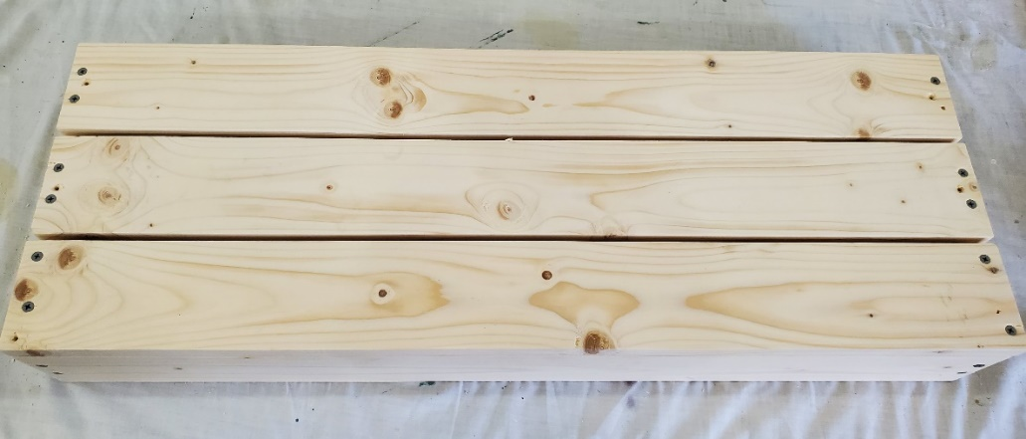
2
3
1

Step 5: Assemble box to the legs
Tip the box up onto its side and align the top of the leg assemblies flush to the edge of the box frame and attach each leg with (6) 1 ¼ screws. Assure that the box is flush to the edge of the legs.
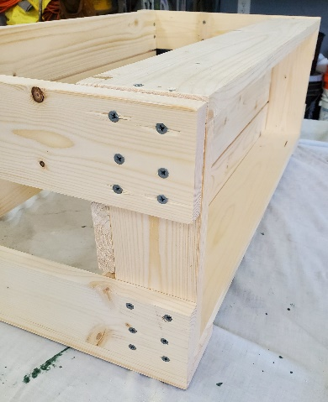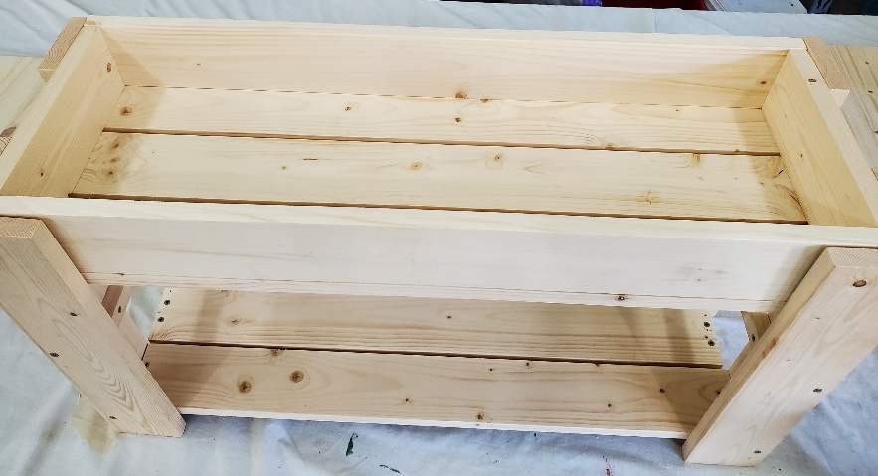
Step 6: Attach Hinge and Top seat board
Stand up the unit and center the lid (seat) of the storage box on the frame. The lid will be flush to the back edge of the box frame. The overhang will be approximately 1 5/8 “on each end. Center the hinge on the lid, secure the hinge at each end to both the lid and the box frame using the brass screws contained in the hinge package. Test that the hinge is operating properly and then proceed to install the remaining brass screws
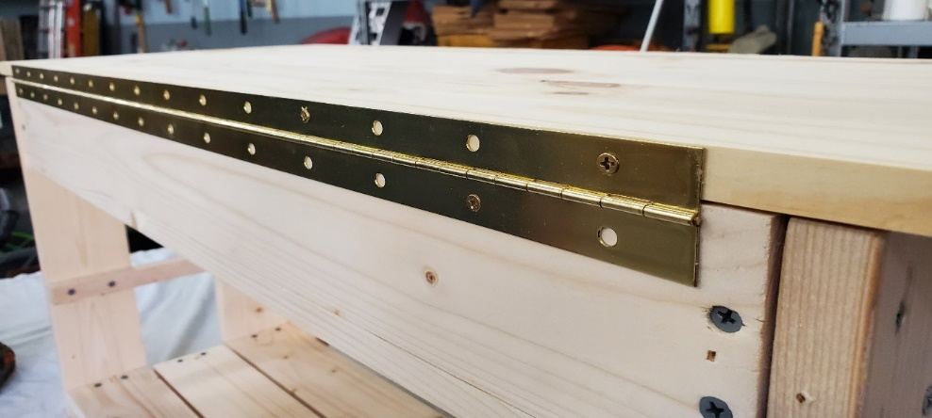
Step 7: Optional shelf
Add the removable shelf boards to create a second shoe shelf. If you are storing boots, set these boards aside.
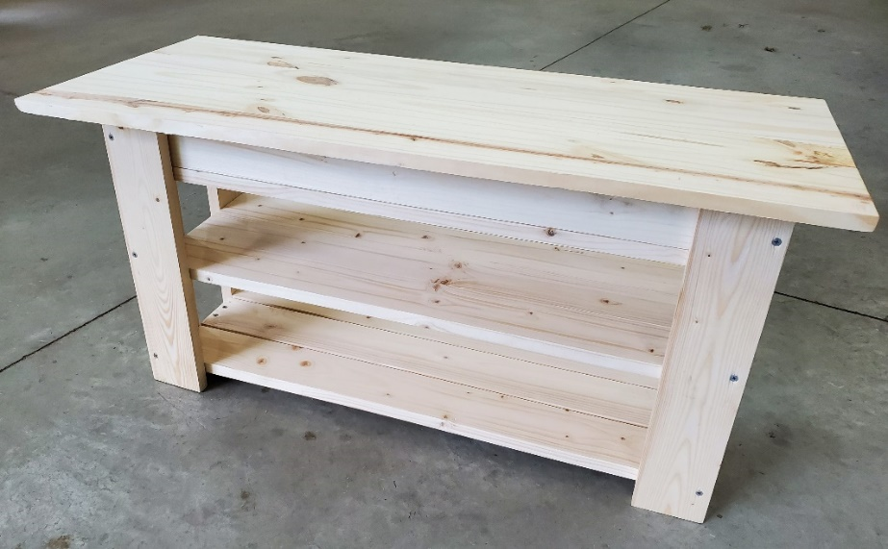
Enjoy your Hallway Shoe Seat!

