Thank You for Ordering a Laptop Faux Drawer Desk
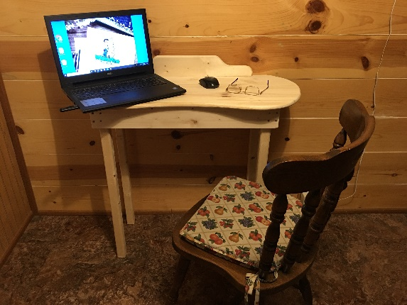
In this box you will find all the hardware assembly and parts as your Console Table comes unassembled. 20 – 1-1/4” screws, 32- 1-5/8” screws. You will need a screwdriver and a level.
BRACKET ASSEMBLY: You will need to screw the 6 brackets to the base boards using a 1-5/8 screw per bracket as shown in the below photos. The Base boards are: 2- long 1x4’s with four drilled holes on each end, and 2 - 14” (short) boards that have four holes pre-drilled.
Center the brackets on the short boards on one side of the board as shown in this photo. Then evenly space the longer brackets on the long boards making sure you leave room for the legs to be placed in.
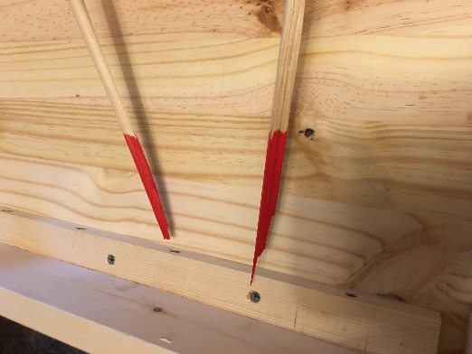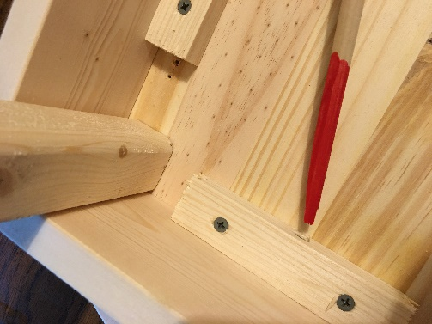
The brackets hold the base assembly to the tabletop plate
BASE ASSEMBLY: You will need to screw the base together using 8 1-5/8” screws. The brackets on the boards hold the base to the top plate. Once you have made the base, center it on the top plate and attach it with the 10 1-1/4” screws. The faux drawer goes in front when you assemble the base to the top plate.
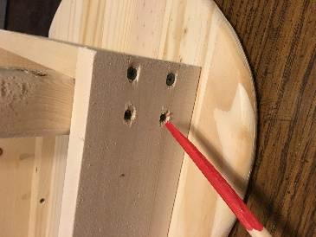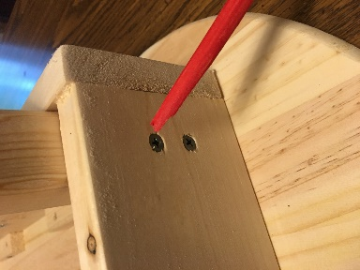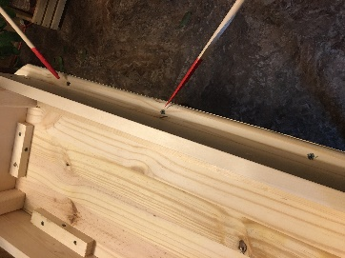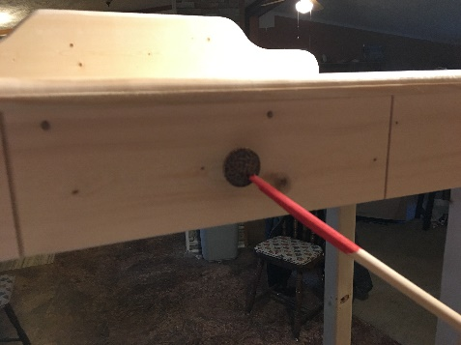
LEG ASSEMBLY: Make sure you have the legs tight against the wood so your table will not wobble and use a level to make sure they are straight up and down. Screw each leg using four 1-5/8” screws to the attached section of the table (See photo 1 and 2 above)
BACK PLATE ASSEMBLY: with the final three 1-5/8” screws, screw in the back plate to the desktop. Now we have heard back from some people where they found they liked the desk without the back plate, so this is an option for you. (See photo 3 above)
FAUX DRAWER KNOB: Your Laptop faux drawer comes with a know to give the appearance there is a drawer in front. There is NO DRAWER – really its just fake for looks! Screw the knob on after placing the shorter screw in the backside of the board and tighten. Remember, the knob goes to the outside front of the desk along with the grooves in the wood. (See photo 4 above)
THE DESKTOP: Your desktop has been pressured-glued together and with the bracket assemble will securely hold the base assembly to the desktop and will give you a multi grain look when you stain it.
Turn the table over, and it’s ready to finish off. Just a note, some people like to paint/stain the console table prior to assembly, just remember where the lower brace goes when you do, do this.

