Magazine Rack Table Instructions

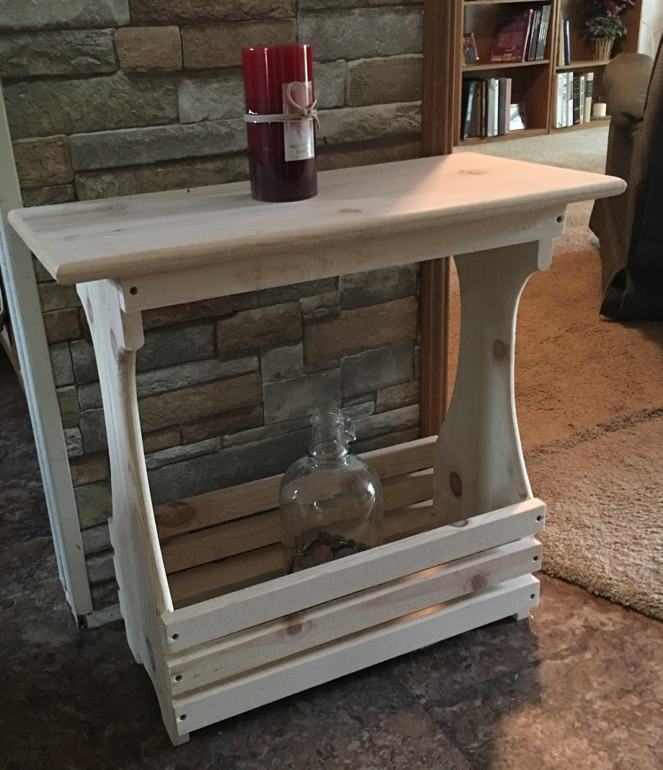

Place the two sides together as shown here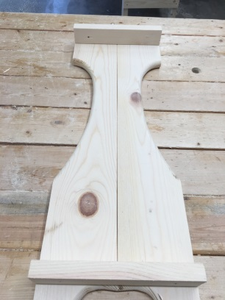 screwing in the two brackets 8” long on each side of the table sides as shown in the above photo. The brackets are to go different SEE PHOTO
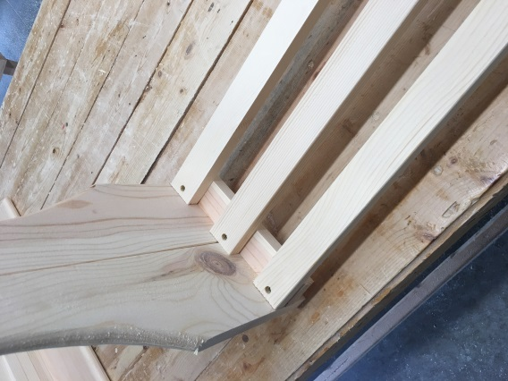 Then add the three bottom boards 18” long boards to the lower portion of the legs as shown in this step photo.
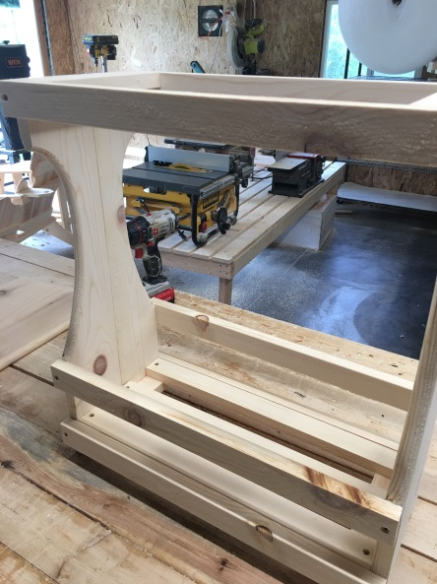 Then add the eight rails 19-1/2” as shown in the photo. The bottom rails go at the base of the 8” bracket to cover it up. The top rails cover up the top brace, One side rail goes on the bottom then one up above but below the curve of the side rail then center the center one, so you should have three side rails per side.
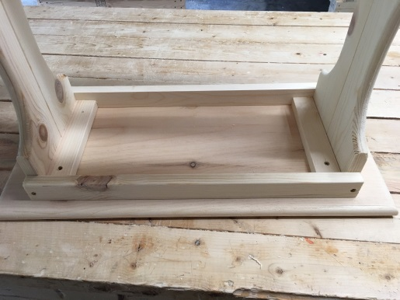 Set it upside down on the top, center it on the top before screwing it down.

