Administrative Address: Shipping/Returns Address: Canadian Address:
417 Forest St. Ste. 460 2002 Charles Ave. 1771 Robson St. Suite 1175
Kalamazoo, MI 49001 Kalamazoo, MI 49048 Vancouver, BC V6G1C9
Wholesale Division: 855-927-3066 * Customer Service: 844-802-1599
Thank You for purchasing our 4Ft. Planter Box
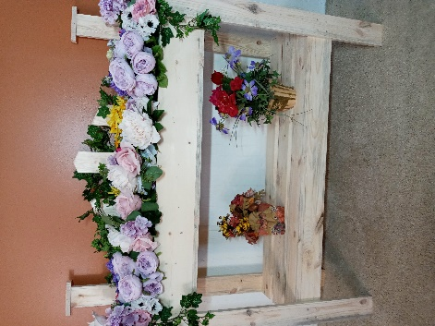
Box Assembly
STEP 1) We will start first with the assembly of the upper box, the 1x6x48, you have four sides. Using the 1-5/8” screws, screw the two long 1x6 boards into the “T” marked 1x6 boards. This will form a box. Make sure you leave the one with all the markings (A,B,C) to the outside so you will be able to attach the fencing boards.
STEP 2) Now that you got the box made, now you will need to make the bottom of the box. There are two 1x4x48 boards marked “W” and then get ONE 1x4x48 “R” and the two “G” boards. This is form the bottom as shown below, using 1-1/4” screws.
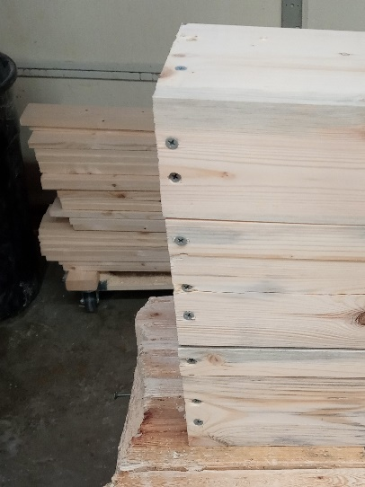 “W” “G” “R” Make sure the side holes on “W” are on the outside of the box as these also screw into the side boards on the front and back.
STEP 3) Placing the small brackets “BR” at 16” and 32” on the bottom of the box. Screwing these on the “W,G,W” boards. Center them on the bottom to strengthen the bottom.
Now that the planter box is made you need to move on to making the bottom shelf.
STEP 4) You will need to get two short 1x4 boards marked “S” and two 1x4x48 boards marked “R” and using the 1-5/8” screws, screw these together to form your bottom shelf.
STEP 5) You now need to assemble the three remaining “R” 1x4x48 to the box with 1-1/4” screws.
ASSEMBLY of the LEGS
STEP 6) The “BL” is for the back legs and the bottom shelf goes 9-3/4” from the bottom of the shelf to the ground, use 1-1/4” screws and the planter box goes 12” down (36” mark) on the back legs only.
STEP 7) Attaching the front legs “FL” the front legs go even with the planter box top, and the bottom shelf goes 9-3/4” from the ground. Use 1-1/4” screws to attach these legs.
STEP 8) Attaching the back leg headers “TP” to the tops of the 1x4x48 back legs by using 1-5/8” screws.
STEP 9) Attaching the Fencing on the backside of the back of the 1x6x48 that is marked. “A” goes in the middle, then you have “B” then “C” working down both sides of “A”. Shown by the pencil marks on the 1x6.
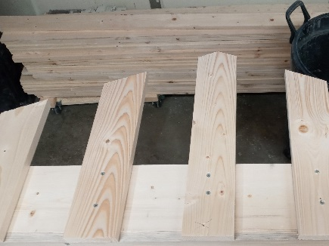 “A” “B” “C” 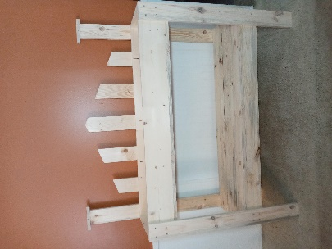
You have just finished your Planter Box. Enjoy many years with your White Pine Furniture.

