The Rounded Footstool
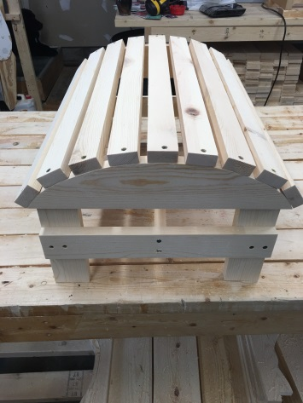
STEP 1) You need to remove all the woodworks from the box as shown below.
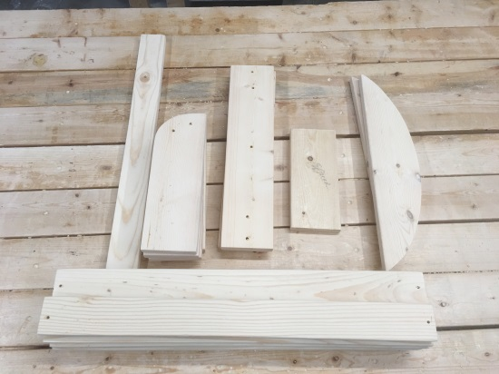
STEP 2) You will need to set out two of the four legs and the cross beam (has five holes drilled in it). Using the 1x4 spacer on the bottom of the legs – this will give you your measurement from the ground to the cross beam as shown below.
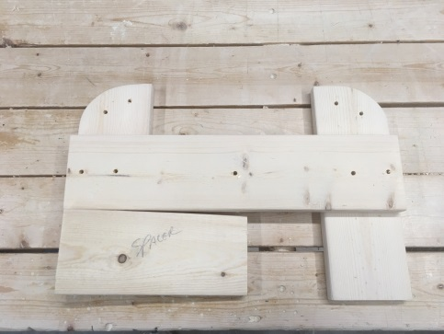
STEP 3) screw in the four 1-1/4” screws on each side of the footstool from a level surface making the cross beam and legs – two sets, a left and right sides of the footstool.
STEP 4) Adding the upper plate to the cross beam and legs as shown below.
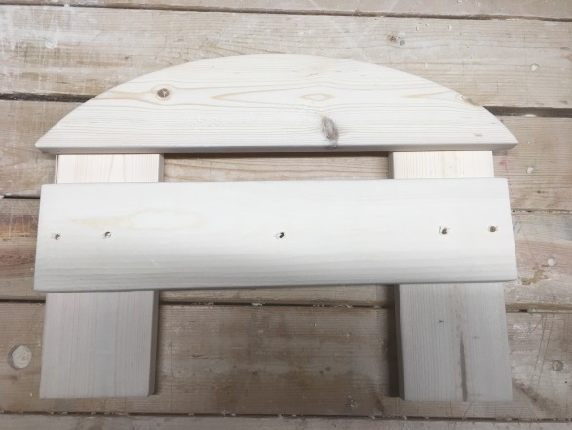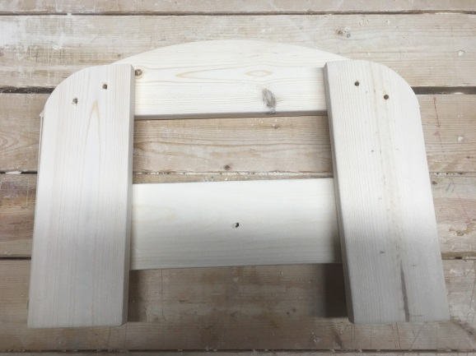
STEP 5) You will find one board that has no holes in it, this is the board you want for the center brace and use the two 1-5/8” screws to attach this to the cross beams. This cross brace goes inside the legs as shown in the below photo.
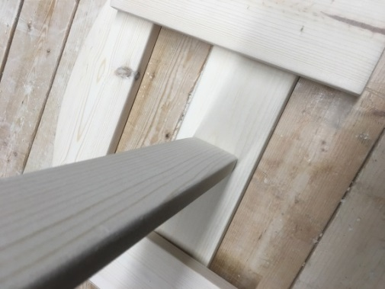
STEP 6) Attaching the upper rails to the upper plates. Start from one side and work your way around the top. Use the thin spacer (¼” gap) to gap between the boards. I would start on one side, then work back and forth from side to side attaching the railings using the thin spacer.
.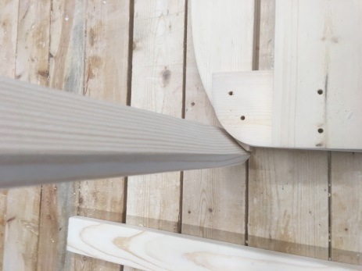 Finished look 