THANK YOU FOR BUYING A TOT CHAIR
Empty the box out and you should have everything like it shows in this picture 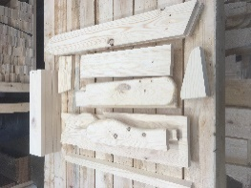 Start assembling the chair find the 1x4 spacer to use as a guide and the (UR) and (LEG) pieces as shown in this photo 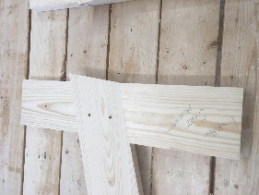 align the bottom of the LEG to the UR board as the tip of the LEG board will overhang to the side of the UR as shown in the above photo. Screw in ONE screw to hold it, then set this up on a level area and screw in the other screw tight along with tightening the first screw.
Do both UR and LEG just make sure they are opposite as the first one you did. 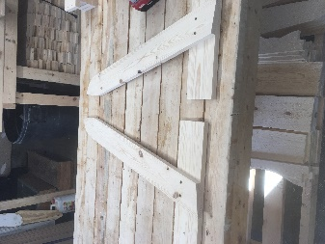 Then fasten the front board on as shown here 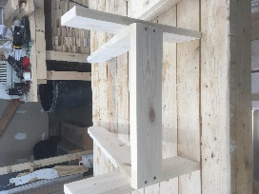 then attach the seat boards (1-3) using the small spacer in between the boards as shown here 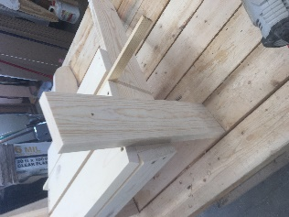 Between the 3rd and 4th board use the larger spacer to set the last seat board (4) into place 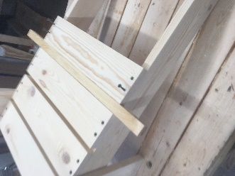 and your chair should look like this now… 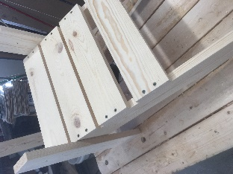 Once this is done, attach the armrests, arm handles (cutouts on the arms go facing in) and back support as shown here. 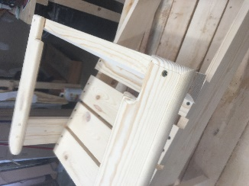 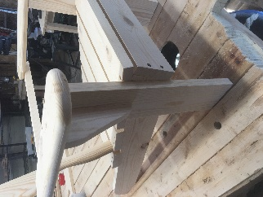.. Now you can start putting the state back on and screwing in the braces on the back. 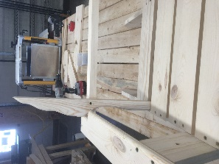 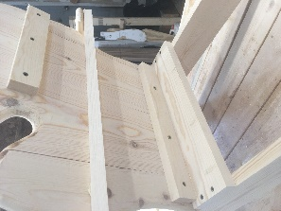 Then turn the chair upside down and screw in board 4 to the lower back brace as shown here 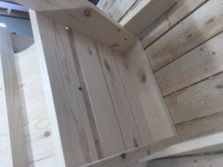 Make sure all the screws are tight before allowing your child to sit in this chair. 