The TOT Helper Stool
After you empty out the box of all the parts, you will need a Phillip Screw Driver to assemble this item.
You will want to remember to “mirror” the sides. Make sure to keep the braces INSIDE of the four legs.
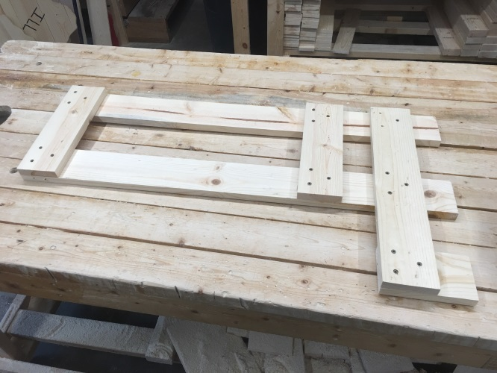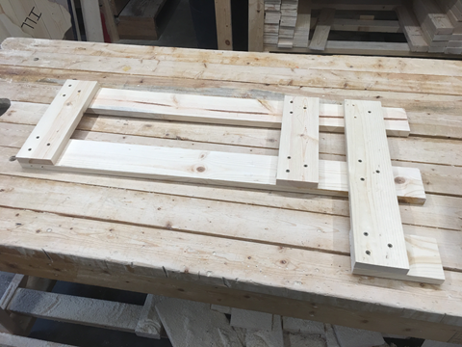
Align brace markings Brace 1, 2 ,3 in the patter shown above. This makes the foundation for the two steps and side rails and assemble.
To place the steps together you will want to leave about ¼” of an inch over the foundation of the first step board as marked on the first step board.
Then do the same on the first step board of the second step for a ¼” overhang. Then attach the second board of the first step with a gap in the middle. We put about a ¾” gap between these two boards. On the second step you will want to place the first one, then the third one and then center the second board in the middle, evenly spacing between both step boards.
Attaching the upper front brace: The grooved piece goes down giving the child a little extra room to crawl under it and get up to the second step.
