MICHIGAN UPPER PENINSULA TABLE
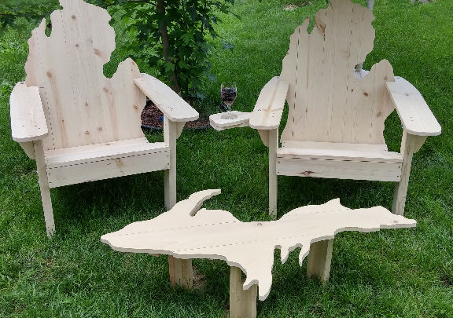
INSTRUCTIONS
THIS TABLE IS NOT MADE FOR SITTING ON..
IT WILL NOT HOLD HUMAN WEIGHT.

This kit contains: ONE: table – assembly required Screws, Legs, Braces, SIX (6): Pieces You will need a Philips screwdriver.
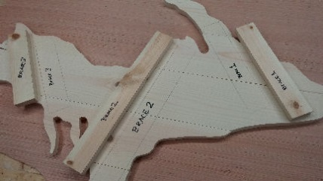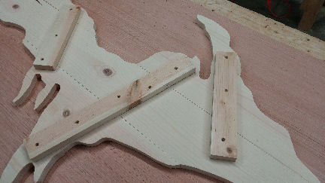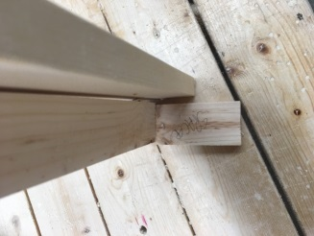
STEP 1)
Remove all contents from box. have three unassembled legs with inserts, four braces, six pieces of the Upper Peninsula, and Philips Screws along with these instructions.
STEP 2)
Turn the table over so it is laying down on your table/floor with the topside (the routed) side down and the black markings facing upward as shown in photo 1.
STEP 3)
Screw in the braces (B1, B2, B3, B4) as shown in photo 2 covering up the black marker.
STEP 4)
LEG assembly: You will need to attach the center of the legs to the leg posts as show using the spacer see photo 3. Attached the legs to the braces as pencil marks to show you where they go on the braces.
STEP 5)
Screw in the legs SECURELY..
Turn over the table and its ready for use.
THIS TABLE IS NOT MADE FOR SITTING ON.. IT WILL NOT HOLD HUMAN WEIGHT.
This table is only for setting your drinks on, and that’s about it…
Your table is made out of white pine or red cedar, to make it last for years; I personally recommend using SPAR outdoor polyurethane or an exterior paint.
If you are a Veteran – We THANK YOU for your service!
Warranties
The Content included in this Web site has been compiled from a variety of sources and is subject to change without notice as are any products, programs, offerings, or technical information described in this instruction sheet. We makes no representation or warranty whatsoever regarding the completeness, quality, or adequacy of this material or Content, or the suitability, functionality, or operation of this material or its Content. By using this directions, you assume the risk that the Content on this material may be inaccurate, incomplete, offensive, or may not meet your needs and requirements WE SPECIFICALLY DISCLAIMS ALL WARRANTIES, EXPRESS OR IMPLIED, INCLUDING WITHOUT LIMITATION THE WARRANTIES OF MERCHANTABILITY, FITNESS FOR A PARTICULAR PURPOSE, AND NONINFRINGEMENT WITH RESPECT TO THESE WEB PAGES AND CONTENT. IN NO EVENT WILL WE BE LIABLE FOR ANY SPECIAL, INDIRECT, INCIDENTAL, OR CONSEQUENTIAL DAMAGES EVEN IF COMPANY HAS BEEN ADVISED OF THE POSSIBILITY OF SUCH DAMAGES.
-- OR Depending on State --
The information and content on this instruction material is provided "as is" with no warranty of any kind, either express or implied, including but not limited to the implied warranties of merchantability, fitness for a particular purpose, and non-infringement. The references and descriptions of products or services within this material are provided "as is" without any warranty of any kind, either express or implied. We are not liable for any damages, including any consequential damages, of any kind that may result to the user from the use of the materials in this material or of any of the products or services described hereon.

