Thank You for Ordering Our Coffee Table and End Table Set Kit
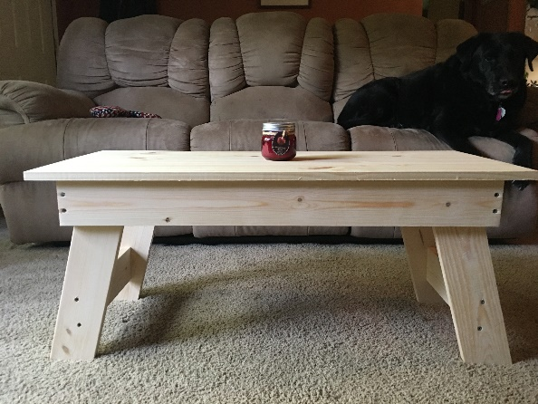 CL A B C
In this box you will find all the hardware assembly and parts as your kit comes unassembled. 16 – 1-1/4” screws, 44- 1-5/8” screws. You will need a screwdriver and ruler. (CL=Coffee Table Legs, EL= End Table Legs, B= Base Board – Coffee Table with holes, C= Side Base Board – Coffee Table, A= Leg Brace – All, D= End Table Base Boards with holes, E= End Table Side Base Board)
COFFEE TABLE ASSEMBLY:
BRACKET ASSEMBLY: You will need to screw the 2 brackets to the base boards using a 1-5/8 screw per bracket as shown in the below photos. The Base boards (B) are: 2- long 1x4’s with two drilled holes on each end, and 2” (short) boards that have no holes pre-drilled.
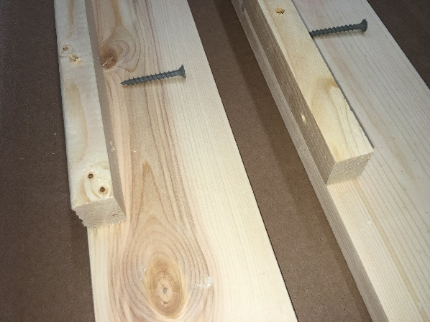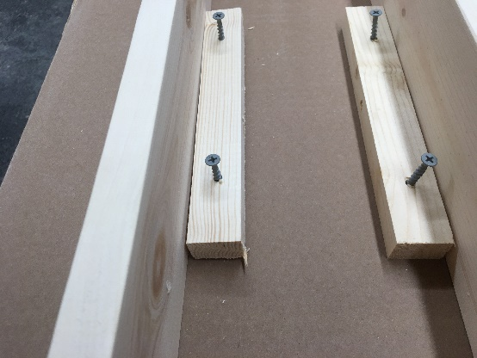
The brackets hold the base assembly to the tabletop plate.
COFFEE TABLE BASE ASSEMBLY: You will need to screw the base together using 8 1-5/8” screws (B screws to C). The brackets on the boards hold the base to the top plate. Once you have made the base, center it on the top plate and attach it with the 16 1-1/4” screws.
LEG ASSEMBLY:
Screw each leg (CL) using four 1-1/4” screws to the attached section of the table base (B) at the angle cut. The legs touch the short board base assembly but do not screw them to this board only to the long boards (B). Then you will want to attach the leg braces(A). Align with the holes in the middle of the legs and level off. This is a good place to use your ruler to get the same height on each leg.

END TABLE ASSEMBLY:
You will need to screw the base together using 8 1-5/8” screws (D screws to E). The brackets on the boards hold the base to the top plate. Once you have made the base, center it on the top plate and attach it with the 16 1-1/4” screws.
LEG ASSEMBLY:
Screw each leg (EL) using four 1-1/4” screws to the attached section of the table base (D) at the angle cut. The legs touch the short board(E) base assembly but do not screw them to this board only to the long boards(D). Then you will want to attach the leg braces(A). Align with the holes in the middle of the legs and level off. This is a good place to use your ruler to get the same height on each leg.

