Thank You for Ordering a Console Table

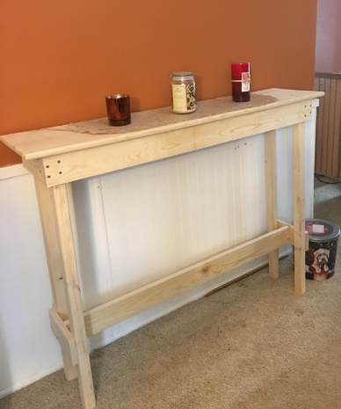

In this box you will find all the hardware assembly and parts as your Console Table comes unassembled. 16 – 1-1/4” screws, 44- 1-5/8” screws. You will need a screwdriver and ruler.

BRACKET ASSEMBLY: You will need to screw the 8 brackets to the base boards using a 1-5/8 screw per bracket as shown in the below photos. The Base boards are: 2- long 1x4’s with four drilled holes on each end, and 2 - 9” (short) boards that have four holes pre-drilled.

(**DO NOT USE THE short boards with SIX HOLES** – these go to the leg bracings.)

Center the brackets on the short boards on one side of the 9” board as shown in this photo. Then evenly space the longer brackets on the long boards making sure you leave room for the legs to be placed in.

The brackets hold the base assembly to the tabletop plate.

BASE ASSEMBLY: You will need to screw the base together using 8 1-5/8” screws. The brackets on the boards hold the base to the top plate. Once you have made the base, center it on the top plate and attach it with the 16 1-1/4” screws.

LEG ASSEMBLY: Assemble the legs and lower brace. Make sure you have the legs tight against the wood so your table will not wobble.

Screw each leg using four 1-5/8” screws to the attached section of the table, then using a ruler, depending on the height you wish the leg brace to be – we recommend eight inches high from the floor to the bottom of the braces, using four 1-5/8” screws for each side. These brackets go on the outside of the legs as shown in the photo above.

With the remaining four 1-5/8” screws attach the center brace/bracket to the leg brackets. Turn the table over, and it’s ready to finish off. Just a note, some people like to paint/stain the console table prior to assembly, just remember where the lower brace goes when you do, do this.

This table should not be placed in a high traffic area, as it may tip over/wobble if bumped or if it’s improperly assembled.

It is not recommended for use to hold a TV on.